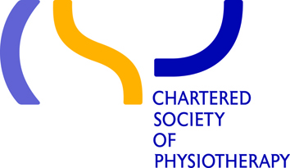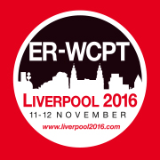

Hope to see you in Liverpool for the ER-WCPT congress 2016
Advancing physiotherapy – demonstrating value and impact
Now the summer is over, the 4th European Physiotherapy Congress in Liverpool is fast approaching! On the 11th and 12th of November you can have the chance to hear some of Europe’s leading physiotherapists and academics share their knowledge and research on some of the hottest topics in physiotherapy.
With five themes running through congress, there’s something to interest everyone!
- Policy, strategy and influencing
- Research, education and practice
- Practice in a digital age
- Responding to changing population needs
- Public health, prevention and social care

You can access the full programme here
This congress is not just a great CPD opportunity; it’s also the perfect place to network with national and international peers and colleagues from all areas of physiotherapy. To help network there is an ‘ER-WCPT & WCPT Future Network Workshop’, specifically for students and early career professionals, as well as an ‘Entry into Practice’ discussion panel and debate.
Liverpool is the perfect city to relax after a busy day at congress. It’s a very friendly city with hundreds of trendy bars and restaurants that won’t break the bank, a great way to unwind and socialise.
Costs for students to attend the congress are £120.83 (plus VAT) for a two-day ticket and £91.67 (plus VAT) for a one-day ticket.
Click here to buy ticket for congress and for more information about the congress, visit www.liverpool2016.com

