Direct line: +44 (0)20 7306 6642  Email: coles@csp.uk |  | 14 Bedford Row  London WC1R 4ED  Tel: +44 (0)20 7306 6666  Fax: +44 (0)20 7306 6611  Textphone: +44 (0)20 7314 7890  www.csp.org.uk  Patron Her Majesty The Queen

Dear CSP Student Member

CSP 2016 STUDENT ELECTIONS

I am writing to encourage you to think about standing for election for the CSP next year. Any CSP subscribing student member who will still be a student in the academic year 2016/2017 is eligible to stand for election to Council and/or CSP committees. I hope that members from all the universities will offer themselves as candidates. Previous students elected to these positions have said that the experience they gained was incredibly valuable to show to future employers when applying for physiotherapy posts. Please note that Alternates are required for all candidates.

The 7 positions available are:

- student representative on CSP Council
- student representative on CSP Industrial Relations Committee
- student representative on the Education Committee
- student representative on the Professional Practice & Service Delivery Committee (PPSD)
- Wales representative on the Student Executive Committee*
- Scotland representative on the Student Executive Committee*
- Northern Ireland representative on the Student Executive Committee*.

*Students applying for one of the country seats on the Student Executive Committee MUST be studying at a university in the country they wish to represent.

The term of office for the CSP Committee places lasts for one year from the SEC meeting in April 2016 until the equivalent meeting in April 2017. The term of office for the Council place will be one year from the CSP AGM November 2016 to the AGM October 2017.

Information on the election process is given below, and details on the vacancies are attached. If your nomination is successful, you will be invited to attend a training session on Monday 11th April at CSP Headquarters in London. The Student Executive Committee (of which you will be a member) will meet on

12 November 2016 at Physiotherapy UK in Liverpool & 2nd Dec 2016 (at CSP)

Expenses for all meetings - travelling (standard class rail, economy air or public transport rate) and subsistence expenses will be reimbursed by the CSP

Will I be able to get time off from my studies?
HEIs are usually very co-operative in granting leave of absence for their students to attend meetings, but you may think it appropriate to have a word with your programme leader before you finally decide to stand for election.

Commitment needed for the roles:

- The student Council representative will be expected to attend the four Council meetings as well as three Student Executive Committee meetings a year
- The Standing Committee student representatives will be expected to attend their three specific committee meetings as well as three Student Executive Committee meetings a year
- The three country representatives will be expected to attend the three Student Executive Committee meetings a year. It is also hoped that they will also attend the four CSP country board meetings a year as the student representative.

Can I stand for more than one seat?
You may nominate yourself to as many of the vacant seats as you wish – however, if you are elected to Council this will take precedence over the other seats, and election onto one of the standing committees will take precedence over the Student Executive Committee seats.

What are the regulations for the elections?
Candidates, their alternates and their twelve proposers must be student members of the Society for the current academic year. A nomination form, can be downloaded from the website http://www.csp.org.uk/membership/students/your-voice . Your completed form (including signatures of your alternate and twelve subscribing student members) must be received at the Society by 12 noon on Monday 15 February 2016. Nominations shall only be valid when received at the office of the Society. A scanned or facsimile transmission shall be valid but the original form must be received at the Society within two working days i.e. by 12 noon on Wednesday
17 February 2016

What else do I need to do?
It is worth checking that all twelve sponsors have valid membership numbers for 2016. The membership number requested is your CSP student membership number which can be obtained from the CSP Enquiry Handling Unit (enquiries@csp.org.uk). Optional spaces for two additional sponsors have been left so that you have a safety margin. It is important that your nomination papers are completed accurately as invalid forms will be rejected without further reference. All candidates will be notified of the status of their nomination after the closing date.

What about my election address and photograph?
Your election address (limited to 500 words) and photograph must be returned with your completed nomination form. Any size photograph can be scanned in - it doesn't need to be passport size. You may use any style for your election address – you may want to consider what you have achieved and what you hope to do for your colleagues by joining Council, a Standing Committee or the Student Executive Committee. Previous examples can be provided by the Chief Executive's office.

What happens then?
If there is more than one candidate for a seat there will be an election (by law the Council place has to be by postal vote). Information about candidates and how to vote will be e-mailed to all students and on the Student iCSP. The election will begin on the 29 February 2016 and close 4pm 22 March 2016.

The single transferable vote system will be used and the detailed rules to be adopted will be in accordance with the practice of Electoral Reform Society, the independent scrutineer. The results will be available shortly afterwards and candidates will be informed by telephone or email as soon as is administratively possible. The results will also be published on the website and formally announced at the 2016 Annual General Meeting.

Can I campaign?
You will need to think about how to make yourself well known to other students. You may want to consider whether you would like to cavasss them at university or you could ask to go along to a CSP student regional meeting in your locality (details about these can be provided by Jamie Carson CSP Students’ Officer. You could seek the help and support of your friends to spread the word and generally raise your profile among students nationally. You could also use the discussion forum on the student network of iCSP (interactive CSP – the CSP’s electronic network) to find out what the issues are which most concern students, whilst stating at the same time how you feel you can contribute to solving them. Rules about canvassing for candidates are enclosed, and you should consult the CSP if you require clarification.

If there is any further information you need, please do not hesitate to get in touch with the CSP Students Officer (Jamie Carson, 020 7306 6603, carsonj@csp.org.uk) or the Chief Executive’s Office (Sally-Ann Cole 020 7306 6642, coles@csp.org.uk).

Yours sincerely
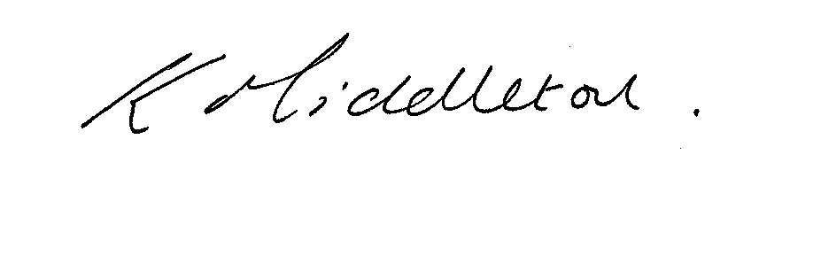

Professor Karen Middleton CBE FCSP MA
Chief Executive
Chartered Society of Physiotherapy
(Visiting Professor, Leeds Metropolitan University)

January 2016

