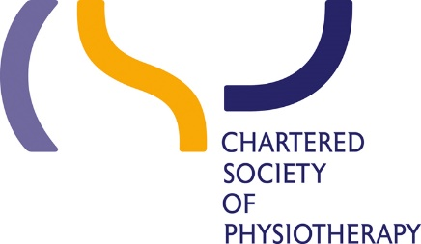

14 Bedford Row

London WC1R 4ED

Tel **+44 (0)20 7306 6666**

Fax **+44 (0)20 7306 6611**

Email [**enquiries@csp.org.uk**](mailto:enquiries@csp.org.uk)

[**www.csp.org.uk**](http://www.csp.org.uk)

**Patron**

Her Majesty The Queen

Peter Lauener

Interim Chief Executive and Accounting Officer

Student Loans Company

100 Bothwell Street

Glasgow

G2 7JD

[peter_lauener@slc.co.uk](mailto:peter_lauener@slc.co.uk)

26/03/2018

Dear Mr Lauener,

I am writing to highlight concern about errors apparently made by the Student Loans Company (SLC) that have resulted in some second- and third-year physiotherapy pre-registration students receiving loan overpayments this academic year. It appears this error has affected hundreds of physiotherapy students across ten universities.

Our student networks report that many students queried the overpayment of loan monies at the start of this academic year, but that SLC staff confirmed to them that these overpayments were correct. As a result, this loan funding was accepted in good faith and became part of their financial planning.

I understand that SLC are intending to disrupt additional funding to these students as a remedial response, in order to recover the overpayment that these students received. This course of action is unacceptable and our student networks report delayed or halted access to continued funding is pushing them into financial hardship and personal distress, with some now considering dropping out of their studies. We are also hearing of students waiting up to six weeks to have their SLC hardship applications processed, without a guarantee of receiving support.

Students reasonably require planned funding across the year in order to meet their financial commitments such as rent, food and necessary transport. It is unacceptable to disrupt this through errors and confusion caused by SLC, adding unfair financial stress to a time when students should be focusing on academic success and preparing for their future career. In light of the current NHS workforce shortages, these additional barriers to recruitment could have a far-reaching impact on the delivery of our health services.

In recognition of the error on SLC’s part, I therefore urge you to use existing overpayment policies to seek agreement with the Education Secretary not to recover these funds.

I am aware that SLC is managing new arrangements for healthcare students’ access to standard student loan arrangements, following the shift away from the NHS bursary for first-year BSc students in 2017/18. During the preparation for this shift following the 2015 comprehensive spending review decision, we alerted government departments and arms’ length bodies to the risk of errors or poor service arising for students still subject to the previous NHS arrangements, and highlighted the imperative of ensuring that these students continued to receive an effective, efficient service.

In this context, I ask for the publication of a root-cause analysis, identifying how this error has occurred, and how it can be avoided in the further run-out arrangements for NHS-funded students.

Yours sincerely,

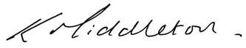

**Professor Karen Middleton CBE**

Chief Executive