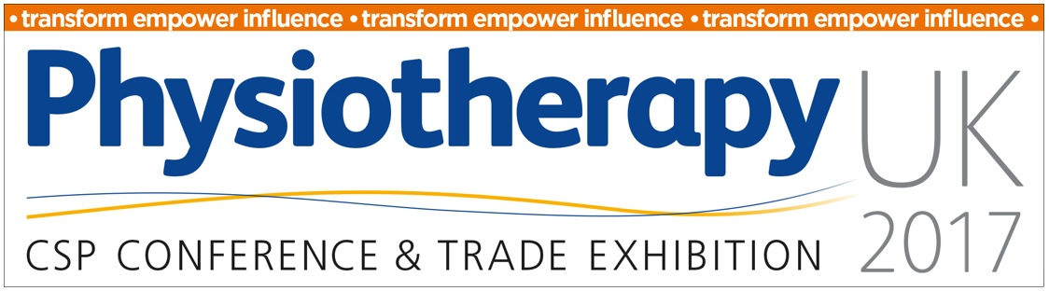
Student poster abstract submission form
Return your completed submission to physiotherapyuk@csp.org.uk by 5pm on 31st July 2017.
For further guidance please refer to the abstract submission guidelines at www.physiotherapyuk.org.uk

Title of abstract
(maximum 20 words)
Details for presenter | Full name  Organisation/institution  City  Country
Details for co-author 1  (if applicable) | Full name  Organisation/institution  City  Country
Details for co-author 2  (if applicable) | Full name  Organisation/institution  City  Country
Details for co-author 3  (if applicable) | Full name  Organisation/institution  City  Country
Details for co-author 4  (if applicable) | Full name  Organisation/institution  City  Country
Details for co-author 5  (if applicable) | Full name  Organisation/institution  City  Country
Relevance to Physiotherapy UK 2017 themes  (please highlight all which you feel are applicable) | - Evidence matters  - LEAD: Leadership, Exploration, Advocacy and Development  - Our Digital Movement  - Your service, your improvement
Please explain how your submission fits with the chosen theme?
(maximum 50 words)

Methodology  (please select one) | Qualitative  Quantitative  Clinical Audit  Service Evaluation  Systematic review
Brief biography of presenting author
(maximum 150 words)
Has or will this research be published or presented at another national or international meeting prior to Physiotherapy UK 2017?
(maximum 50 words)

Was this work reviewed by an ethics committee*? | Yes / No

If yes, please name the committee and/or state reference number

If no, please state this and how you have upheld the ethical principles in your work (maximum 500 words) as kindly put together by Prof. Julius Sim (2015) and outlined below.*
Abstract – Main Content
(Maximum 500 words)
Purpose
Research reports: What was the major reason for undertaking the project?
Special interest reports: What is the main reason for sharing your activity via a special interest report?
Any secondary objectives?

Methods
What principles, methods / methodological approaches, materials did you use?

Results
What were your main findings from your analysis?
Conclusion(s)
What have you concluded from the study? What are your suggestions for future work?
Implications
What are the implications of the project?
How will the results be translated into physiotherapy practice / management / education / policy?
Three key words
Up to three words that describe your work and reflect at least one of the programme themes.

Funding acknowledgements
Please acknowledge all funding sources that supported your work. If the work was unfunded, please state this.

No images, tables or graphs are permitted.
References are not required

*Ethical review
If you are undertaking research in health and social care, independent ethical review is a legal requirement. We expect each author to have abided by the requirements of their country/organisation. UK guidance can be found via the Health Research Authority:
http://www.hra.nhs.uk/research-community/before-you-apply/determine-whether-your-study-is-research/

Ethical principles Prof. Julius Sim (2015)
http://www.physiotherapyuk.org.uk/2017/ethical_principles.

Abstracts will be included in the conference proceedings and must follow the structure above.

