Advisory Structure Review: call for evidence
Questionnaire for a public sector organisation or service that needs clinical input

Introduction

The Minister for Health and Social Services has asked the Chief Medical Officer to review the health advisory structure; this includes the groups highlighted in the diagram below.
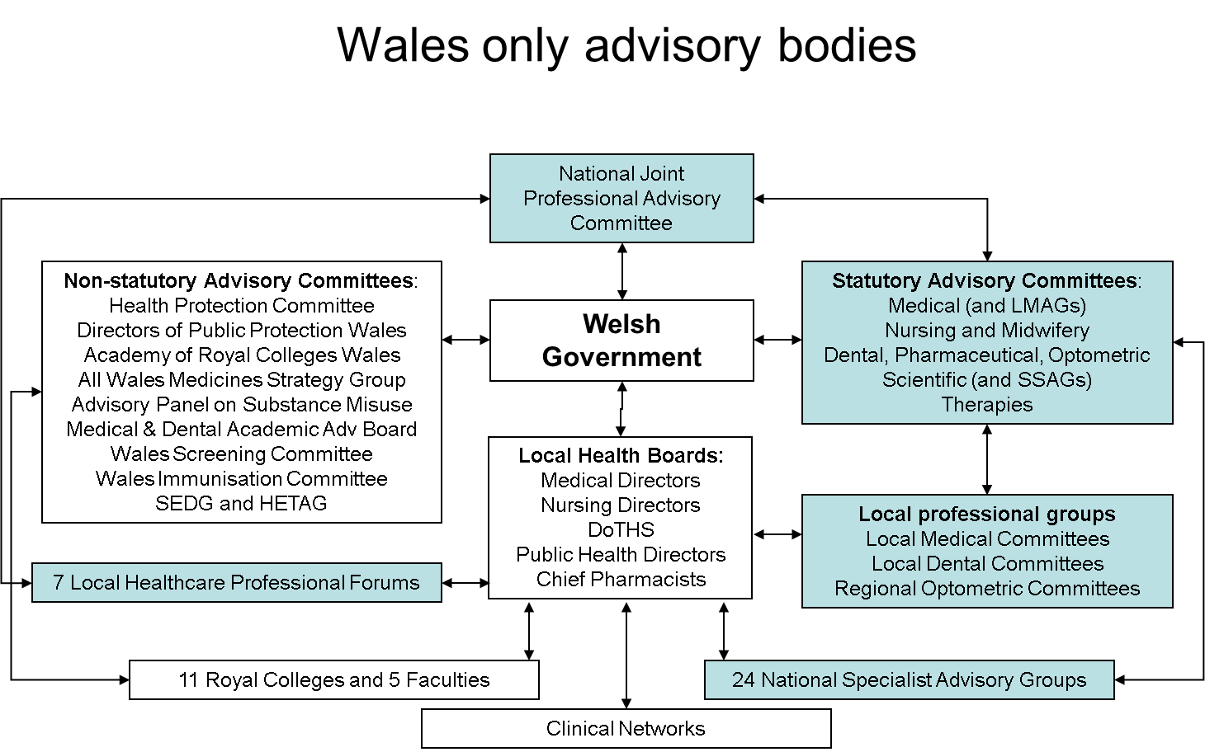

The review will consider:

- The Welsh Government’s requirements for clinical professional advice
- NHS Wales’ requirements for clinical professional advice
- Overlap and duplication between the different advisory groups
- Cost effectiveness and resource implications
- Flexibility of the model to support changing drivers, utilise new ways of working and drive forward service improvement and delivery plans
- Identifying, recruiting, developing and utilising clinical leaders
- Creating greater synergy by developing a joint NHS and WG advisory structure
- A cost-benefit and risk analysis of reforming the current structure

The first phase of the review is a three month call for evidence between January and April 2014. Please submit your response to the OCMO Mailbox by 1st April. Entries after this date may not be considered. Once the evidence has been reviewed, a summary report will be published.

Your evidence about the advisory structure

If you could design a new advisory system for the Welsh Government and NHS Wales, what would it look like? Please draw your structure (you can attach a separate file if you wish), describe its form and function, and the reasons it would be an improvement on the current system.
Multi-professional advisory groups

Multi-professional
Patient Pathway

(small number with task and finish sub-groups)

ADVISORY
NHS

Key Groups
Exec Directors

DELIVERY
Welsh Government
Royal Colleges
Professional Bodies

ADVISORY
DELIVERY GROUPS
Professions
Drs & Dentists
Nurses & Midwives
Therapies Diagnostics
Pharmacy and Optometry

ADVISORY

Uni-professional and Service Advice
(STATUTORY)

UK ADVICE

WALES ADVICE

Multiagency/
Professional
Advice

Delivery leads
Networks
Additional notes on the diagram

The CSP, within this diagram, notes the importance of both uni-professional and multi-professional advice. As services integrate, there will also be the need to consider multi-agency advice.

The diagram identifies the importance of Welsh Government receiving advice but also looking to the NHS to deliver. Any new arrangments must be clear on responsibility for advice but also clear on responsibility for delivery. There will be a range of different groups meeting from within the NHS with the Strategy Drivers within Welsh Government. Clarity around their function and thus form must be clear to all and there should be no overlap.

Multi-professional must be just that in order to ensure that this advice is not dominated by the medical profession. Whilst it is important to ensure medical involvement, both Welsh Government and the NHS in Wales needs to be able to draw on strong muti-professional/multi-agency advice.

There should be a timescale for review of all groups to ensure they are meeting their terms of reference.

Q What type of clinical input does your service or organisation require?
The CSP and CSP Welsh Board require the opportunity to provide direct ‘professional’ advice to Welsh Government. This needs to be via a formal ‘statutory’ body so that professions are required to provide advice but also via informal channels, for example, ‘ad hoc’ meetings with civil servants as required.

The CSP does make a distinction between advice from the profession and advice from the Welsh NHS (the service). There may be pressures on service delivery that will bring forth a different view from clinicians than that provided by the professional body. Welsh Government needs to be aware of the full range of ‘professional advice.

Whilst the service advice will concentrate on NHS delivery, the advice from professional bodies and their Boards will include the full range of their professions, so encompassing education, undergraduate, the independent and third sectors and retired practitioners.

The CSP also sees the importance of committees having a ‘statutory’ status, requiring that they are involved in consultation and that they are required to provide advice to Government when it is requested.

The CSP considers that advice is required via 2 distinct routes:
Professional groupings – eg Therapists committee
Multi-agency groupings – eg Delivery Planning (patient pathway) committee

The profession notes the current 24 National Specialist Advisory Groups and considers that these will need to change. These Groups need to be multi-agency and provide the opportunity to develop links across health, social care, the independent and third sector where it is appropriate. Physiotherapy would be a profession that would expect to contribute to a range of the multi-agency groups and the profession would expect some of the delivery planning (patient pathway) groups to be led by therapists such as physiotherapists.

CSP Welsh Board and the CSP as the professional body would provide input and support to the physiotherapists representing the profession on the professional and multi-agency groups.

Do you think there is overlap or duplication in the existing advisory structure? Please explain your answer.
Yes.

Currently the Statutory Advisory Committees and the NSAGs overlap in some of the work they undertake. There is also overlap with the 7 Local Healthcare Fora The CSP considers this is because there is lack of clarity around the roles of the various groups. It is also unclear what the role of the National Joint Professional Advisory Committee should be. The danger with the current structure for the make-up of this committee is that it ends up being medically dominated.

There needs to be a distinction between the delivery aspects and the professional advice (both from professional bodies and from the service). Who is driving delivery? Where do they obtain their professional (professional bodies and service) advice?

What are the major strengths of the current structure?
The statutory nature of the profession specific advisory committees is the main strength. Having statutory advisory committees in place ensures that professions advise and provide information to Government when it is required, but equally, that Government is required to involve professions in its work.

What are the major failings of the current structure?
The CSP considers the structure has become complicated, with the addition of a range of new groupings. The profession is unsure of the relationships between some of the groups – for example, the NSAGs reporting to Statutory Advisory Committees and to Local Health Boards. This is not the experience of the CSP profession.

Equally, the profession has little experience of the advice from the 7 Local Healthcare Professional Forums.

The CSP questions the role of the Local Professional Groups (which in the diagram appears to be only contractor professions). Could these groups link with, and become part of the Statutory Advisory Committees?

The profession lastly questions the usefulness of the National Joint Professions Advisory Committee.

Can you see gaps in the current structure?
The gap in the structure is the lack of explanation on the role and relationships of the different groupings. Clarity is needed around which groups are advising and which groups are driving delivery.
How do you think clinicians should engage with the Welsh Government?
Clinicians should be encouraged to engage with Welsh Government in a range of ways and through a range of media:
- Through professional bodies
- Through advisory groups (professional and speciality)
- Through networks and delivery groups
Providing opportunities to develop strategies and not just be consulted at the end is important for clinicians. Clinicians need to be involved in shaping the future development of services, both nationally and locally.

How do you think clinicians should engage with NHS management and Boards?
NHS Managers and Boards need to consider how they obtain their professional and service advice currently? How do they involve clinicians in service review and development. What opportunities are there for leadership? Experience from the service reconfiguration and activities to involve clinicians may provide some valuable feedback on how clinicians and clinical leaders were involved in the process.

In order that we may contact you for further information, please provide the following details.

What is your name and day-to-day professional role?
Philippa Ford – Public Affairs and Policy Officer for the Chartered Society of Physiotherapy
What is your group and what position do you hold?
Responding on behalf of the Chartered Society of Physiotherapy (CSP) and the CSP Welsh Board

By e-mail: fordp@csp.org.uk
Or phone: 029 2038 2429

