Fellowships 2023

Fiona Beckerlegge MCSP

A Fellowship is awarded to Fiona Beckerlegge for her outstanding and sustained commitment to international development work in advancing paediatric disability services. Over the last 20 years Fiona has worked in international healthcare settings working with vulnerable children and communities growing community-based inclusion and development organisations and personnel with expertise in paediatric physiotherapy, providing solutions to some of the most significant social and environmental challenges facing populations.
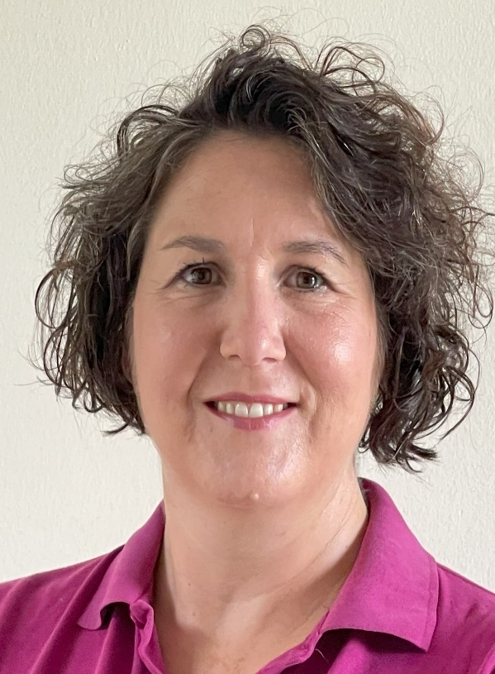
Fiona’s practice embodies the Chartered Society of Physiotherapy's (CSP) vision. Throughout her physiotherapy career, she has focused on the need to gain and promote an understanding of impairment and disability, its causes, impacts and prevention. Her overarching aim has been to transform the health and well-being of children with disabilities and their communities.

Arriving in Uganda as a sole paediatric UK physiotherapist for one child, Fiona identified the nationwide lack of services, where 13% of children live with a developmental disability. Cultural stigma means that over 90% of this marginalised group never attend primary school. In 2013 Fiona founded the Kyaninga Child Development Centre (KCDC) in Uganda and since then has built the centre into a thriving non-profit organization that now employs 78 staff, of whom 23 are

AHPs, within multidisciplinary teams and has helped over 6000 local children access physiotherapy rehabilitation across 7 Ugandan districts.

Fiona’s enthusiasm, dedication and clarity of vision have led to improvement and growth in paediatric services in Uganda, including a pioneering educational and mobility services with significant outreach across Uganda and internationally.

The Educational Hub of the Centre incudes the Inclusive Model School; the Professional Development Centre delivers an outreach educators' programme; a Street Business School for female caregivers, improving their financial independence and family well-being and the KCDC Mobility services provide free, terrain-suitable mobility equipment made from local, sustainable, repairable materials.

Fiona became a Social Innovation in Health Fellow at Makerere University, Uganda in 2017 and was also the regional winner of Uganda’s National Social Security Fund (NSSF) Torch award social responsibility initiative, which seeks to recognise individuals and institutions making a positive impact on communities. Fiona is also a 2016 East Africa Fellow of the ‘Unreasonable Organisation’ a global community of entrepreneurs who scale solutions to some of the most significant social and environmental challenges of our time.

Fiona continues to work as a Chartered Physiotherapist in Uganda and this Fellowship marks an outstanding contribution to the profession.

Dr Doreen McClurg MCSP
A Fellowship is awarded to Dr Doreen McClurg for her outstanding and sustained commitment to advancing pelvic health physiotherapy and continence locally, nationally and internationally. Over the last 14 years Doreen has created a body of work drawing together key aspects of the non-surgical management of incontinence and pelvic floor dysfunction and played a leading role creating a career path for other allied health professionals to follow through her work in this specialist area in clinical practice, research, educational and leadership spheres.

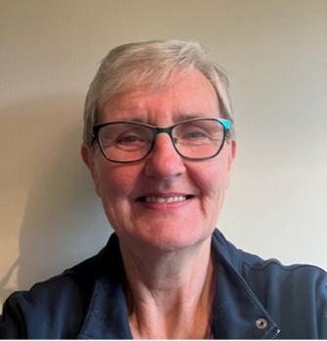
Clinically Doreen’s sustained contribution to pelvic health practice has directly impacted those living with chronic disabling and stigmatised conditions including the learning disabled, those with mental health conditions, children, people with Parkinson’s Disease and Multiple Sclerosis, care home residents and those with bladder and bowel dysfunction. Doreen has been a champion for embedding research into practice, dedicated herself to providing high quality evidence for physiotherapy treatments in regular clinical practice.

Doreen was an early advocate for advanced practitioner roles in pelvic health and she has consistently provided a voice for physiotherapy through robust research in challenging areas including mesh for prolapse, perioperative physiotherapy in prolapse surgery and bladder and bowel function in neurology. Doreen has provided physiotherapy expertise to the initial

Transvaginal mesh implant review in Scotland. Doreen’s involvement on the review group ensured physiotherapy was subsequently recognised in
the published recommendations following the Cumberlege Report in 2020.

In her role as a Researcher, Doreen has created a highly respected body of research practice with numerous publications directly impacting on evidence-based practice in pelvic health and continence care. Doreen has been a Principal Researcher and research collaborator for over 12 years. In 2012 she was appointed a Professor of Physiotherapy and Pelvic Floor Rehabilitation at Glasgow Caledonian University. Doreen has been a respected reviewer for journals such as Multiple Sclerosis, Neurourology and Urodynamics, Obs and Gynae, Age and Ageing, BMJ.

Doreen has provided sustained academic and clinical guidance and expertise at policy level through her involvement with the Health Technology Assessment and Guideline Development programmes at NICE. She has also had a role as a peer reviewer for the Overview of Cochrane Systematic Reviews in Conservative interventions for urinary incontinence.

Doreen has devoted her time to numerous organisations on a voluntary basis because of a firmly held belief that education in physiotherapy matters, and her encouragement and support to physiotherapists at every stage of their career has benefited many. Despite the demands of her many roles, Doreen remains approachable and is always keen to help others learn and progress their own path. Many PhD students have been guided through the challenge by Doreen. Doreen has also been an inspiring leader, undertaking key leadership roles throughout her career - as Chair of the Association for Continence Advice (2009-2012), Chair of POGP (2013-2016), Chair Physiotherapy Committee of the International Continence Society (2014-2019) and Topic Advisor of the NICE Guideline published in 2021 (NG210). In these roles she has exerted considerable influence in a multidisciplinary national and international sphere for the role and importance of physiotherapy in pelvic floor dysfunction and pelvic health.
Doreen has recently retired from the profession and this Fellowship marks an outstanding contribution to the profession.

Dr Carol McCrum MCSP

A Fellowship is awarded to Dr McCrum for her outstanding and sustained commitment to evidencing and advancing clinical practice for people with axial spondyloarthritis (SpA) locally, nationally and internationally. This has been achieved at a clinical and policy level through extensive engagement with NICE. Collaboration with multi-professional musculoskeletal practitioners, service-users and charities and widespread dissemination has achieved a reduction in delays to diagnosis for people with axial SpA and access to optimal, evidence-based care.

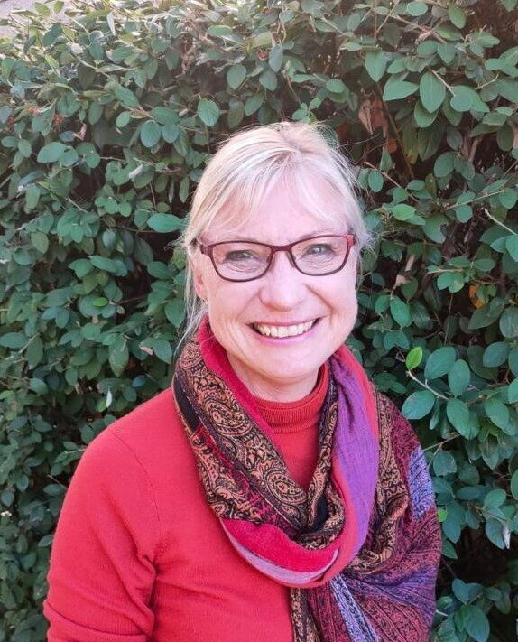
Carol was appointed as one of the first musculoskeletal consultant physiotherapists in 2005 and over the last 17 years has championed the consultant role and supported others to achieve this level. In recognition of her leadership in clinical practice and service delivery she was awarded an honorary fellowship from the Musculoskeletal Association of Chartered Physiotherapists (MACP). As a mentor she has inspired many others to gain promotion, undertake research and pursue a career as a clinical academic. Carol is founding Co-Chair of the UK Rheumatology Physiotherapy Clinical Interest Group, established as the first subgroup of the MACP in 2021.

Carol has had longstanding involvement with the CSP and the Council for AHP Research. She was a member of the CSP Research and Development Committee and has sat on numerous working groups. Her work with the Australian Physiotherapy Association has impacted referral pathways internationally

Organisation as a member of their Rheumatoid Arthritis Guideline Development Group and Rehabilitation Stakeholder Group.

Carol is a steadfast supporter of patient organisations. In 2020 she presented to the NASS-led All Party Parliamentary Group on axial SpA on the evidence base for hydrotherapy care. The report from that meeting led to a Parliamentary Question and meeting with the Health Minister to discuss NHS hydrotherapy services. She supports efforts to promote healthcare professional and patient education and awareness and further research with organisations including the National Axial Spondyloarthritis Association, Psoriasis and Psoriatic Arthritis Alliance and Versus Arthritis.

Carol was a member of the NICE Guideline Development Group and Quality Standards Committee for the diagnosis and management of Spondyloarthritis and is a topic advisor for the NICE Centre for Guidelines. As a NICE Ambassador and Fellow she has extensively disseminated and implemented NICE guidance through publications, charity newsletters, study days and workshops as well as national and international presentations. Her work has been embedded in the national spine pathway and has also impacted undergraduate and post-graduate programmes, co-authored the UK Rheumatology Physiotherapy Capabilities Framework and contributed to Health Education England musculoskeletal and advanced practice curricula, and championed capabilities for assessment and screening for inflammatory conditions.

Catherine Pope MCSP

A Fellowship is awarded to Catherine Pope for her outstanding strategic and inclusive leadership of physiotherapy and allied health professionals at local, regional, national and international levels. She has made a substantial and sustained contribution to raising the profile of physiotherapy in mental health (MH), influencing clinical and policy agendas. Catherine is passionate about integrating mental and physical approaches for people with MH problems and has achieved huge impact driving cross-organisational service improvements in physical and mental health services.
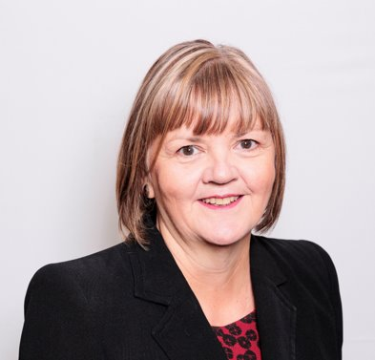
As Chair of the CSP Council from 2015-18, she instigated and led a major review of the CSP’s governance arrangements. The new governance structure was implemented in April 2018, resulting in a much more streamlined and accountable Council and committee structure, impacting how the whole profession is governed and led.

Catherine has held leading roles in the Chartered Physiotherapists in Mental Health (CPMH) professional network for over twenty years, including Chair from 2001 to 2004. She led a national campaign to promote and safeguard the role of physiotherapists within mental health. This resulted in the inclusion of physiotherapy within Department of Health (DH) policy documents and on national mental health advisory committees. Catherine sat on the DH Mental Health Allied Health Professions Advisory Group. As President for CPMH she represented the UK at the launch of the International Organisation of Physical Therapists in Mental Health, a subgroup of World Physiotherapy, developing the role of physiotherapists in MH internationally.

In various roles within the CSP Catherine has demonstrated outstanding leadership. She led the development of a CSP publication about commissioning mental health services and demonstrating the contribution of physiotherapy to integrated services for health and wellbeing. In 2011/12 she led the review of CSP Standards of Physiotherapy Practice. In a regional representative role, she developed a physiotherapy mentorship programme to facilitate leadership development. This was extended to other health care professionals in collaboration with East Midlands Leadership Academy. From 2018 she has been Chair of the CSP Pension Trustees requiring leadership and facilitation of some difficult choices in a very challenging economic climate for pensions.

Catherine has a journal publication about integrating mental and physical approaches which has also underpinned CSP national guidance, Recovering Mind and Body: a framework for the role of physiotherapy in mental health and wellbeing.

Catherine was AHP Director for Nottinghamshire Healthcare NHS Foundation Trust for ten years. Key achievements in this role included the development of an AHP Strategy, 3 AHP consultant posts and 4 AHP independent prescribers and an IT-based Outcome Measures Framework for AHPs. She has led the development and reorganisation of care pathways for older people which are inclusive of people with dementia and a service specifically for people of working age with dementia, creating increased employment opportunities.

Distinguished Service Awards 2023
Catherine Jenkins MCSP

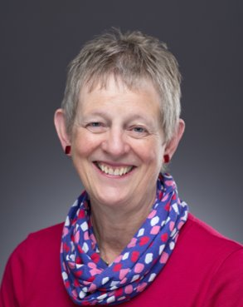
Catherine Jenkins is awarded a Distinguished Service Award for her service to paediatric physiotherapy and the Association of Paediatric Chartered Physiotherapist (APCP) in the field of postural management. In particular, for her innovative designing of products to support postural management, maximise function and enable participation. Catherine has supported training courses over many years and funded Awards for innovation in paediatric physiotherapy. She has donated equipment to PhysioNet, a UK based charity, ensuring that marginalised children have access to vital disability equipment.

Catherine has set up a company, Jenx, that designs and manufactures specialist postural management equipment. The postural support equipment developed has changed beliefs and care in settings where disability was often stigmatised. Catherine has ensured that her company develops equipment that supports therapists to implement research findings into everyday practice. Jenx was the first company in the UK to offer postural management training courses to therapists, focussing on the importance of early intervention and 24 hour postural care. From 2003 until 2018 hundreds of therapists and therapy assistants attended training courses provided free of charge.

Through her company, Catherine funded the Jenx Award in partnership with the APCP and National Association of Paediatric Occupational Therapists. Over 17 years more than 100 therapists or therapy teams received funding to take forward their innovative ideas in product design. In addition, she sponsored the APCP Annual Conference for many years and has supported over 50 therapists physiotherapists to access paediatric training courses.

Catherine supports the charity Physionet, donating equipment which can be refurbished and sent to low and middle income countries. She has also helped to raise the profile of PhysioNet.

Dr Jenny Tinkler MCSP

Dr Jenny Tinkler is awarded a Distinguished Service Award in recognition of over 40 years outstanding service to the field of Learning Disability (LD) and her vast contributions to the Association of Chartered Physiotherapists for People with Learning Disabilities (ACPPLD). She has played a key role in promoting the speciality of LD across the wider profession, influencing the quality of physiotherapy delivered for people with LD. Jenny has achieved impact at a multidisciplinary clinical and service delivery level, especially in relation to postural management for people with profound and multiple learning disability (PMLD).

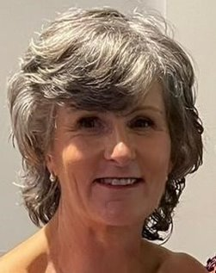
Jenny has been an active ACPPLD member since the late 1980’s, initially on a regional committee and on the National Executive Committee since 2003, serving as Chair since 2011. Her leadership, enthusiasm, motivation, clinical acumen and kindness have inspired a whole generation of LD physiotherapists. She has raised the profile of the specialism of LD across many sectors, in particular, through her leadership of a campaign to support physiotherapists in all specialities ‘So your next patient has a Learning Disability’.

Jenny has dedicated her career to improving the lives of adults with PMLD, she has a particular interest in 24 hour postural management. Through research and clinical practice, she has demonstrated the importance of 24 hour postural management in maintaining body symmetry in people with PMLD and the positive impact this has on their lives. She has delivered numerous training sessions to physiotherapy and nursing undergraduates, health and social care staff in day and residential services and private organisations.

In the early 2000’s Jenny completed a Masters in Advancing Practice which led to the development of a unique Postural Management Service.

in her Trust in the North East of England, for which she won a highly commended award for service improvement. The posture management service is still running today which is testament to her tireless efforts to advocate on behalf of people with PMLD and to ensure sustainability of service delivery. The success of the service has encouraged physiotherapists and occupational therapists to explore options for developing similar services in their geographical areas.

Jenny’s professional doctorate research developed a national best practice framework and recommendations for physiotherapists to deliver 24 hour postural management for adults with PMLD. She has delivered workshops to share learning and explore how LD physiotherapists across the UK could implement her findings into their local practices.

National Honours 2023
Roma Bhopal MBE
Beverley Harden MBE
Sally Orange MBE

