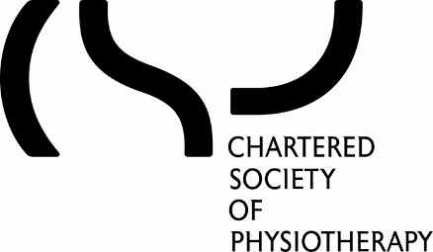

CSP CONFLICT OF INTEREST POLICY

Purpose

- CSP Council and Committee members will follow this policy and strive to avoid any conflict of interest between the interests of the CSP on the one hand, and personal, professional, and business interests on the other. This includes avoiding actual conflicts of interest as well as the perception of conflicts of interest.

- In their role as CSP Council and Committee members, members have an overriding duty to act in the best interests of the CSP. They should put the CSP’s interests before any other personal or professional interests.

- This policy aims to protect the integrity of the CSP’s decision-making process, to enable members and other stakeholders to have confidence in the organisation’s integrity, and to protect the integrity and reputation of those serving as Council or Committee members.
Examples

- Examples of conflicts of interest include:
- Finance, Risk and Audit Committee and Council decisions around whether membership fees should be increased, given that all Council members and most Committee members are also CSP members
- A Council member also holds a key role on a Professional Network (PN), where the PN is bidding for increased funding or a change in CSP policy.
- A Council member is also a charity trustee of the CSP Charitable Trust or CSP Members’ Benevolent Fund, and Council are making funding decisions.
- A Council member who has shares in a business that may be awarded a contract to do work or provide services for the CSP, is a director, partner or employee, or related to someone who is (a “connected person”).
- A Council member who is being considered by Council for a CSP award or appointment to another body e.g. a CSP Fellowship or appointment to the CSP Pension Trustee Board.
Disclosure and Register of Interests

- Upon appointment, each Council and Committee Member must make a full, written disclosure of interests, such as relationships and posts held, that could potentially result in a conflict of interest. This written disclosure will be kept on file (the CSP’s “Register of Interests”) and will be updated as appropriate. Members will be asked to review their entry in the Register of Interests annually.
Declaring interests in meetings and required action

- Council and Committee Members who identify an actual or potential risk of bias upon reading papers for Council or a committee should alert the Chair to this ahead of the meeting and discuss how it can be managed for the decision by the Chair at the meeting.

- The conflicted member should declare any conflict of interest at the beginning of a Council or Committee meeting or before the discussion of the item itself. These declarations and the Council and Committee Members’ actions that follow will be recorded in the minutes.

- If a Council or Committee Member has any interest in the matter under discussion, which creates a real danger of bias, that is, the interest affects them, or a Connected Person, more than the generality affected by the decision, they should declare the nature of the interest and withdraw from the room.

- Sometimes all or most Council or Committee Members may have a general interest (affecting all or most CSP members) in in an agenda item, which does not create a real danger of bias, but might reasonably cause others to think it could influence their decision. In this circumstance they should declare the nature of the interest, but may remain in the room, participate in the discussion, and vote if they wish.

- If there in any doubt about the application of these rules, the Council or Committee Member should consult with the Chair of Council and Head of Governance.

- This policy supplements good judgment, and CSP Council and Committee Members should respect its spirit as well as its wording.

Adopted: March 2018, amended by Council 19 September 2019

A “connected person” is a child, parent, grandchild, grandparent, brother, sister, spouse or civil partner of the Council or committee member or any person living with the Council Member as his or her partner.

