

CSP Welsh Board Newsletter

March 2022

Meeting held virtually 31.03.22

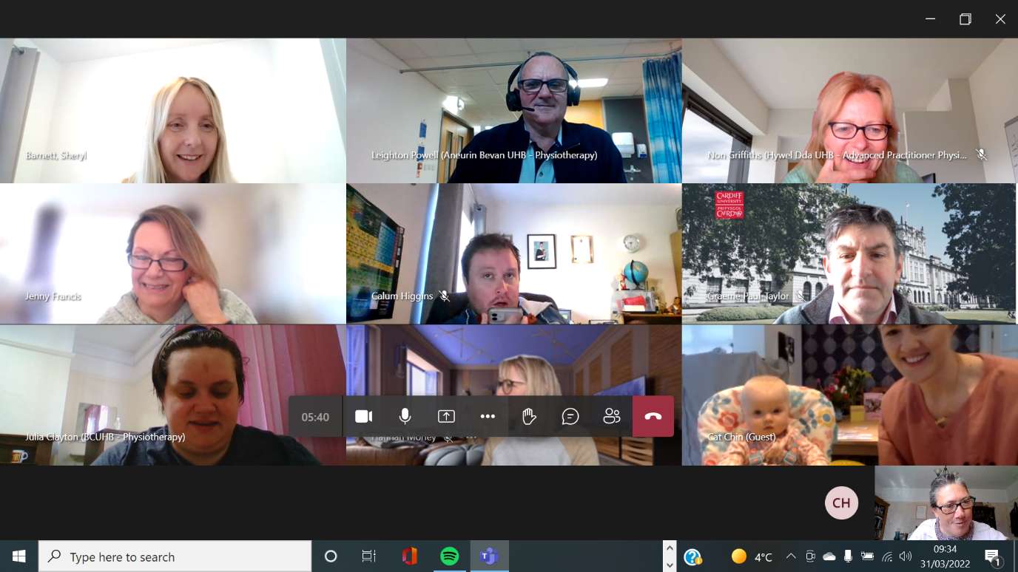

Spot the #tinycspwelshboardmember

Headline messages from the meeting – key issues for CSP members and action points

**Update on Senedd and Welsh Gov issues**

CSP Officers have been busy at the Welsh Political Spring Party Conferences. These have provided a useful opportunity for the CSP to influence on a range of key issues, particularly growing the workforce and the importance of rehabilitation.

**For Note.**

**Bringing the Environment and Sustainability into Physiotherapy Education** – with Jill Morgan, Senior Lecturer, Cardiff University

*CSP Welsh Board had an excellent presentation from Jill.

<https://www.csp.org.uk/documents/bringing-environment-sustainability-physiotherapy-education>

*Check out this PowerPoint which includes crucial information and links to useful posters and data.

*Environmental Physiotherapy Agenda 2023 have just launched 2 new posters (links in the PowerPoint).

*Have you checked out PhysioDeclares on twitter? - @physio_declares

If you want more information – contact Jill [morganj63@cardiff.ac.uk](mailto:morganj63@cardiff.ac.uk) **For Action.**

**For Action! Have you seen the new CSP Campaign Resources for Strengthening?**

**‘STRONGER MY WAY’ -** [**https://www.csp.org.uk/campaigns-influencing/campaigns/stronger-my-way**](https://www.csp.org.uk/campaigns-influencing/campaigns/stronger-my-way)

**This hub provides resources for clinicians and patients. Clinicians looking for evidence base and training resources/opportunities. Patients will find videoclips, information in a range of formats. It’s excellent! Check it out!**

**Ideas wanted on the future of PhysioUK**

Hannah Morley, CSP Professional Advisor in Wales, updated the Board that PhysioUK is not taking place this year and time is being taken to review what is the best approach for the future.

“How does the CSP support evidence-based practice? How does the profession get members research active?”

If you have ideas – Hannah would like to hear from you! [morelyh@csp.org.uk](mailto:morelyh@csp.org.uk)

**For Action.**

**CSP Welsh Board Objectives 2022** have been agreed and signed off.

To see them follow <https://www.csp.org.uk/documents/csp-welsh-board-objectives-2022>

*Lookout for an event for members in July on ‘Stronger My Way’ using strengthening.

*Lookout for a zoom meeting in June if you are a private practitioner.

#workingforourmembers

**For note.**

**Newly Qualified Physiotherapists in Wales – results of the survey 2022**

Huge thanks to Charlotte Hamilton-White who has undertaken a survey of newly qualified physios in Wales. This provides useful insight to experience transitioning from student to registered physio. Lots of info coming out of it but anxieties around respiratory competencies for ‘on-call’ was a key response.

**Lots of great resources out there!** Check out….

**ACPRC resource**

<https://www.acprc.org.uk/Data/Resource_Downloads/competence_questionnaire.pdf>

and **this app is amazing too!** <https://www.oncallbuddy.co.uk/>

plus

There's a **great new grad hub** with loads of info and resources <https://www.csp.org.uk/networks/new-graduates>

**For information and support.**

**Adam Morgan (SNO) –** updated Board on a range of ERUS issues including pay talks and continuing difficulties with loss of physiotherapy work spaces.

Board raised concerns about mileage allowance, particularly in the current climate – this is very much on the agenda for the Wales Partnership Forum.

**For note.**

**Are you a CSP member?**

**This newsletter provides some useful resources and feedback – but if you were a member of the CSP you would get so much more! The CSP is there for physios, support workers and students. If you are not a member… why not? Join the CSP now!** [**https://www.csp.org.uk/join-csp**](https://www.csp.org.uk/join-csp)

**For Action.**

**Update from the Welsh Allied Health Professions Committee (WAHPC)**

Non updated the Board on the 2 big drivers for WAHPC in 2022

1) Progress the work of the AHP Framework Programme. Welsh Government now have a Programme Team in place along with a Governance Structure. Physiotherapist Gethin Harries has become the AHP lead for Rehabilitation and is keen to link with services across Wales.

2) Progress the work on Primary & Community Care especially on the accelerated Primary Care Cluster development and community infrastructure.

**(WAHPC Continued…)**

**Welsh Board will be having a workshop in June to look at developments in Health and Social Care across the UK, the progress to develop Primary and Community Care and the National Clinical Framework in Wales – watch this space!**

**How will all this impact on CSP members in Wales and the services we deliver?**

**For more detail contact Non Griffiths** [**non.griffiths2@wales.nhs.uk**](mailto:non.griffiths2@wales.nhs.uk)

**To note.**

**Lots of fantastic resources for CSP Associate Members!**

Are you accessing all the resources on the CSP Website?

<https://www.csp.org.uk/networks/associates-support-workers>

@CSPWales team is supporting the development of the Support Worker voice within Wales.

Have you seen the CSP’s short film? #ThinkingDifferently

<https://www.csp.org.uk/networks/associates-support-workers/thinking-differently-about-support-workers>

**To use and share.**

**The CSPRA has refreshed the CSP’s Retirement Pack**

<https://www.csp.org.uk/publications/retirement-pack>

Do you know any members who are retiring soon? Are you considering retirement?

This publication is really useful!

**For information and sharing.**

**Keeping in touch with CSP Welsh Board and the CSP**

Are you following **@CSPWales** on twitter?

Are you following the ‘team CSP Wales’ officers on twitter?

**@CalumCSP** – Calum Higgins, Public Affairs and Policy Manager for Wales

**@AdamM_CSP** – CSP Senior Negotiating Officer for Wales and West Midlands

**@HannahMorleyNHS** – CSP Professional Advisor in Wales

**@CSPHayley** – Campaigns and Regional Engagement Officer for Wales

**@JennyFrancis88** – CSP Administrator in Wales

**@physiospilz** – Alice Spilsbury, ERUS Organising Officer for Wales and West Midlands

Are you signed up to receive regular CSP bulletins? Make sure your details are up to date on the CSP website and you have signed up to all the i-CSP bulletins you want to receive. There’s loads of valuable information and peer support that you can tap into from the CSP and i-CSP from other members that you link with via networks.

Living and working in Wales, you will be part of the Wales network – and you will receive the regular ‘Wales regional bulletin’.