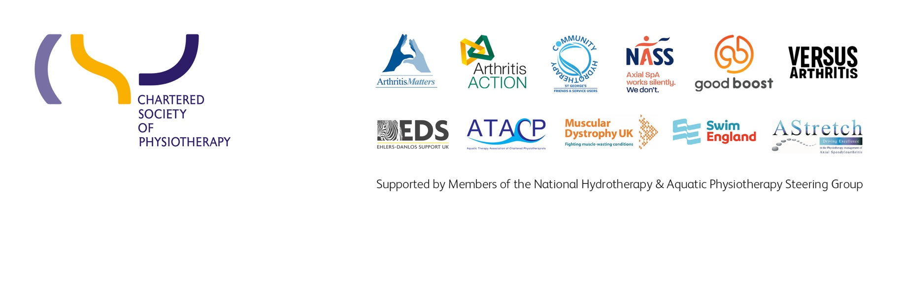
Insert date
Suggested title: Re-opening our Hydrotherapy Pool & the benefits to our patients
Dear
I am writing to you on behalf of (insert organisation/ department name) to request that our Hydrotherapy pool is re-opened and to highlight the importance of aquatic physiotherapy services in supporting the local population to manage long-term conditions as well as acute rehabilitation following surgery or injury.
Why is aquatic physiotherapy important?
Aquatic physiotherapy differs from other water-based exercise such as swimming or aqua aerobics because it involves prescribed exercises completed in a warm, accessible hydrotherapy pool with a physiotherapist. This type of therapy follows clinical assessment and the identification of clinical objectives. It is often applied as part of an integrated team approach.
The benefits of performing physiotherapy in a hydrotherapy environment are numerous for key patient groups. The key differences compared to land based physiotherapy are the physiological benefits of heat and hydrostatic pressure and apparent weightlessness due to the buoyance of the water. Specifically, the modality of aquatic physiotherapy can -
- reduce muscle spasticity
- reduce pain and swelling/oedema
- enable new skills to be learnt in an unencumbered environment
- make movement easier- allowing for exercises and activities to be carried out that cannot be achieved on land allowing for more rapid progress
- maintain essential skills for function and independence- such as standing balance and walking
- enhance cardiovascular response to exercise
- enhance fitness and wellbeing- in an environment which is enjoyable and motivating for people of all ages, physical and cognitive abilities
Aquatic physiotherapy is beneficial for people with a range of long-term conditions including:
- Parkinson’s
- Ankylosing spondylitis (AS)
- Rheumatoid arthritis
- Hypermobility

- Multiple sclerosis
- Fibromyalgia
- Cerebral palsy

It is also used to optimise rehabilitation of people who have had joint replacements, strokes, brain injury, deconditioning due to periods in ITU/illness and many common musculoskeletal conditions.
Furthermore, it can be used to enrich people’s quality of life, health and wellbeing in life limiting or palliative conditions.
Axial spondyloarthritis- a case in point-
Whilst it is acknowledged that some patients can gain equal benefit from land based exercises it is our most complex patients who are at highest risk of deterioration without aquatic physiotherapy.
This is the case for many of the 220,000 suffers of axial spondyloarthritis in the UK. The NICE guideline for spondyloarthritis in over 16s (2017) advises that aquatic physiotherapy should be utilised to reduce pain and maintain or improve function for people with axial spondyloarthritis.
Prompting self-management
Aquatic physiotherapy allows people to develop skills to self-manage their condition, maintain a good quality of life and reduce dependence on long-term medication. If a patient is able to effectively self-manage by having access to aquatic physiotherapy this reduces their attendance at GP and secondary care services, which is beneficial to both the patient and the healthcare system.
The National Axial Spondyloarthritis Society (NASS) have a library of patient reported outcome measures (PROMs) and testimonials providing evidence of the positive benefits of aquatic physiotherapy. The document on this link, provides evidence of benefit https://nass.co.uk/wp-content/uploads/2019/07/Save-Our-Pools.pdf
One quote from a patient diagnosed with axial spondlyoarthritis:
“I have ankylosing spondylitis, fibromyalgia, degenerative spinal disease, osteoarthritis in various places, osteopenia and shoulder issues. Aquatic physiotherapy is the only exercise I can do. I am potentially getting a hip replacement soon, but my other problems will remain so I really need this.”
The Long Term Plan (LTP) - access to rehabilitation and social prescribing
The NHS Long Term Plan for England aims to improve access to community rehabilitation and increase uptake of life long physical activity through social prescribing. Patient access to aquatic physiotherapy fulfils this ambition through the provision of effective rehabilitation treatment and enabling patients, who would otherwise struggle to exercise on land, to increase levels of physical activity in the water.
Infection control measures for re-opening
In re-opening to help our patients, we would ensure that the following infection control measures are put in place- in line with IPC, ATACP and PWTAG guidelines:
(insert infection control measures).

We would also like to highlight that many aquatic physiotherapy services across the country have successfully re-opened after completing appropriate risk assessments
and ensuring these infection control measures are followed.

One such example is at Amersham Hospital in Buckinghamshire where they opened a new upgraded hydrotherapy facility. As well as increasing the size of the pool, accessibility for patients was improved with new safety measures, a new ceiling hoist and a lower ceiling to allow for better air temperature regulation and energy efficiency. The improvements have enabled the physiotherapy team to offer more variety of aquatic therapy techniques to more patients at Buckinghamshire Healthcare NHS Trust.
We would appreciate an opportunity to meet with you to discuss re-opening in more detail and agree timescales for this as soon as possible. We are concerned that the patients who rely on aquatic physiotherapy and whose symptoms and conditions are worsening all the time that the hydrotherapy pool is closed, need an assurance that the pool will resume its services soon.
Upon re-opening, we would like to invite you to visit the service, where you can see for yourself the huge benefits our patients experience with access to aquatic physiotherapy. It will also give you a chance to meet our team so that you can learn more about how aquatic physiotherapy contributes to improved patient outcomes and benefits the system.
Kind regards

Insert signature

