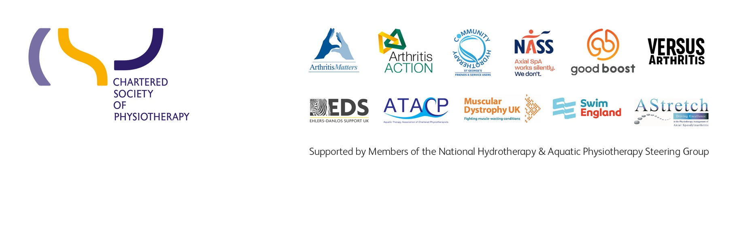
Insert date

Suggested title: The importance of aquatic physiotherapy to our patients

Dear

I am writing to you on behalf of (insert organisation/ department name) to highlight the importance of our aquatic physiotherapy services in supporting the local population to manage their long-term conditions as well as acute rehabilitation following surgery or injury.

We would like to invite you to visit our aquatic physiotherapy service, where you can speak to members of the team and experience the positive impact of this vital service in optimising our patient’s recovery and long-term management.

Why is aquatic physiotherapy important?
Aquatic physiotherapy differs from other water-based exercise such as swimming or aqua aerobics because it involves prescribed exercises completed in a warm, accessible hydrotherapy pool with a physiotherapist. This type of therapy follows clinical assessment and the identification of clinical objectives. It is often applied as part of an integrated team approach.

The benefits of performing physiotherapy in a hydrotherapy environment are numerous for key patient groups. The key differences compared to land based physiotherapy are the physiological benefits of heat and hydrostatic pressure and apparent weightlessness due to the buoyance of the water. Specifically, the modality of aquatic physiotherapy can –

- reduce muscle spasticity
- reduce pain and swelling/oedema
- enable new skills to be learnt in an unencumbered environment
- make movement easier- allowing for exercises and activities to be carried out that cannot be achieved on land allowing for more rapid progress
- maintain essential skills for function and independence- such as standing balance and walking
- enhance cardiovascular response to exercise
- enhance fitness and wellbeing- in an environment which is enjoyable and motivating for people of all ages, physical and cognitive abilities

Aquatic physiotherapy is beneficial for people with a range of long-term conditions including:
- Parkinson’s

- Ankylosing spondylitis (AS)
- Rheumatoid arthritis
- Hypermobility
- Multiple sclerosis
- Fibromyalgia
- Cerebral palsy

It is also used to optimise rehabilitation of people who have had joint replacements, strokes, brain injury, deconditioning due to periods in ITU/illness and many common musculoskeletal conditions.

Furthermore, it can be used to enrich people’s quality of life, health and wellbeing in life limiting or palliative conditions.

Axial spondyloarthritis- a case in point
Whilst it is acknowledged that some patients can gain equal benefit from land based exercises it is our most complex patients who are at highest risk of deterioration without aquatic physiotherapy.

This is the case for many of the 220,000 suffers of axial spondyloarthritis in the UK. The NICE guideline for Spondyloarthritis in over 16s (2017) advises that aquatic physiotherapy should be utilised to reduce pain and maintain or improve function for people with axial spondyloarthritis.

Prompting self-management
Aquatic physiotherapy allows people to develop skills to self-manage their condition, maintain a good quality of life and reduce dependence on long-term medication. If a patient is able to effectively self-manage by having access to aquatic physiotherapy this reduces their attendance at GP and secondary care services, which is beneficial to both the patient and the healthcare system.

The National Axial Spondyloarthritis Society (NASS) have a library of patient reported outcome measures (PROMs) and testimonials providing evidence of the positive benefits of aquatic physiotherapy. The document on this link, provides evidence of benefit https://nass.co.uk/wp-content/uploads/2019/07/Save-Our-Pools.pdf

One quote from an Axial Spondlyoarthritis patient:
“I have ankylosing spondylitis, fibromyalgia, degenerative spinal disease, osteoarthritis in various places, osteopenia and shoulder issues. Aquatic physiotherapy is the only exercise I can do. I am potentially getting a hip replacement soon, but my other problems will remain so I really need this.”

The Long Term Plan (LTP) - access to rehabilitation and social prescribing

The NHS Long Term Plan for England aims to improve access to community rehabilitation and increase uptake of life long physical activity through social prescribing. Patient access to aquatic physiotherapy fulfils this ambition through the provision of effective rehabilitation treatment and enabling patients, who would otherwise struggle to exercise on land, to increase levels of physical activity in the water.

Your visit

We look forward to welcoming you on your visit. Please let us know your availability and the team will be happy to answer your questions and allow you to see first-hand why aquatic physiotherapy is a vital service for now and the future.

Kind regards
Insert signature

