Names and roles | Tara O'Leary, MSK Outpatient Physiotherapist | 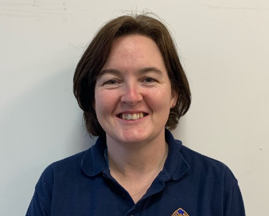
Organisations | Great Western Hospital NHS Foundation Trust
Placement overview

We are a busy MSK Outpatient department who offer placements throughout the year for 4 students at any one time from 3 different universities. I am the clinical educator lead with no caseload of my own but have support from several other members of the team who assist with supervision one or two days a week each whilst maintaining their own caseloads. The students each have their own individual caseload which rolls over to the next student on placement from their university however, they also see some patients in pairs learning from and feeding back to each other. A typical day for a student who is mid-placement will see them have their own patients to see face to face (or via telephone or video currently) independently but seeking advice as needed from myself, a colleague or another student. They will also be observed by an educator with one of their patients, and may observe a fellow student giving feedback to them or jointly problem solving. There will also be a training session which, having received this training in their first week, this student will now be expected to deliver to the other newer students under supervision. They will also gain experience from more senior colleagues with occasional mornings of shadowing.
Supervision:
Face to face
Remote learning/long armed supervision
Peer
Whole team supervision

Lessons learnt:
1. How much the students enjoy and benefit from working as a team and learning with and from each other.
2. How my clinical practice has improved despite not having as much direct patient contact due to the increased clinical reasoning and teaching I engage in with my students.
3. That our profile as an employer has improved by providing a placement where the students feel they are really valued and prioritised.
Top tips for others:
It took a lot of planning and adjustments with the first couple of cohorts of students to see that students at different stages of learning had the right balance of patients, and that patients who need longer treatment were not passed between multiple students. It has definitely been worth the effort as the feedback from students and quality of learning has been great.

Date submitted: April 2021

