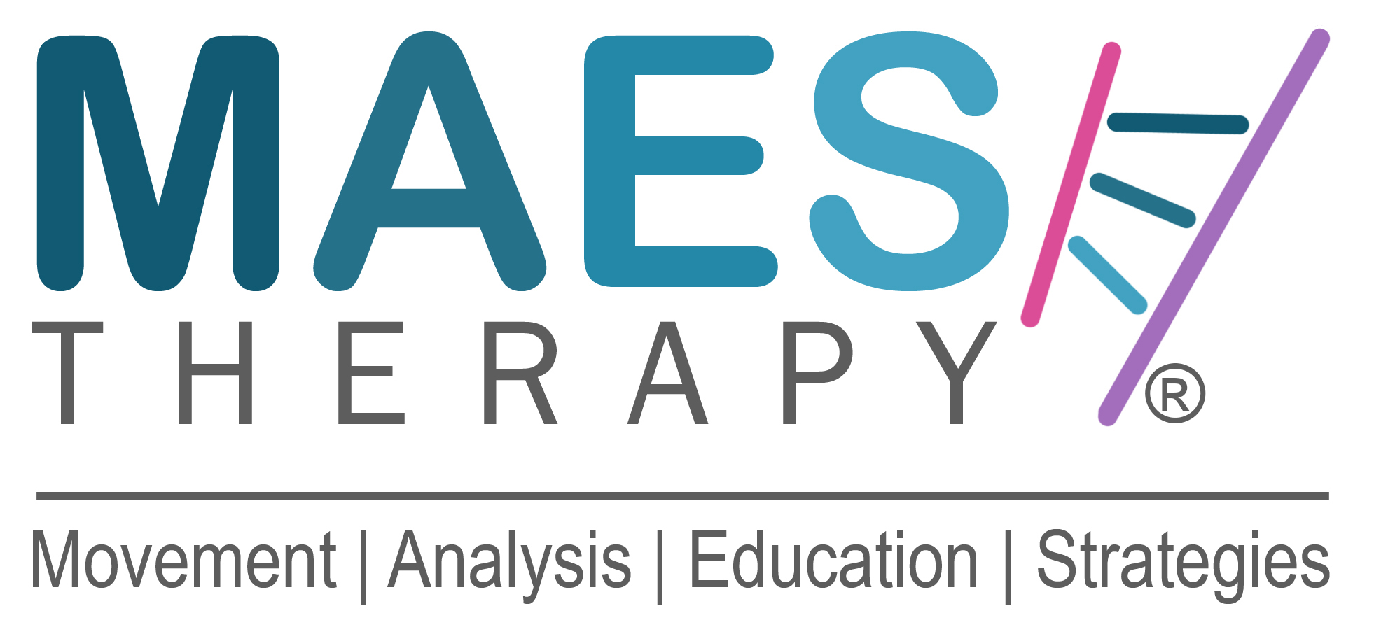
APPLICATION FORM

Name: First Name: Family Name:

Profession (PT, OT, SLT, Doctor) :-

Work Place:

Home Address:

E-mail ( Private )

Mobile No:

M.A.E.S. Therapy Introduction Course - Online

‘A better understanding of children with Cerebral Palsy
and principles to improve their coordination’

With this 2-Day Course, you will be introduced to M.A.E.S. Therapy and have an overview of the content that is developed during the 4-Week Foundation Course and gain an understanding of the clinical reasoning that defines the M.A.E.S. Approach.

For the benefit of paediatric Therapists new or experienced (PT, OT, SLT) who wish to gain new knowledge and insights that open the opportunity to further develop excellent clinical reasoning and treatment skills, for the treatment of children with CP and similar neurodevelopmental conditions.

Dates: Thursday 25 & Friday 26 February 2021 2-Day Course
09.00 –17.00 Hours UK time

Venue Online via Zoom, London, UK Time

Course Leaders: Jean-Pierre Maes MSCP, Consultant Neuro-Developmental Physiotherapist,
Director MAES Therapy International & M.A.E.S. Team

Course Participant Criteria:
Participants must be qualified Therapists (PT, OT, SLT) or medical Doctors who are preferably already working in paediatrics/ with children with CP or similar neurodevelopmental conditions.

Course Participant Attendance:
Course Participants are aware that they must attend the 2 days in full. Part attendance is not allowed.

Course Fee: £195 GBP / €215 Euros
Payment due by 20 February 2021

Application:

Places on the course are limited and allocated on a first come first served basis.
To apply for a place on this course, please complete this Application Form and e-mail to:

Course Organiser:

Jonathan Salsbury MIoD, Development Director
M.A.E.S. Therapy International

T: 0044 (0)7787 435790 E: jsalsbury@maestherapy.com

How to Pay: Receipt of a completed Application Form and then payment will secure a booking.

Upon receipt of the full Course Fee, you will receive an email confirming your Registration and place on the course.

Bank Details and Payment instructions:

Payment Method 1 – £ GBP
For clients paying in £ GBP, please make payment to the following UK account:

Name of Account: Mr J. Maes

Bank: Lloyds Bank

Address: 841 High Road,
North Finchley
London, N12 8PX
UK

Sort code: 77-91-36
Account number: 66749968

IBAN (International Bank Account Number): GB86LOYD779136667499 68

BIC (Branch Identification Code): LOYDGB21J36

Important:
Please put a clear Reference (ideally family name or organisation name), so that we can easily identify the payment.

Bank Charges & Exchange Rate Fees:
Please consider the costs of Bank Fees and any Exchange Rate currency conversion charges you will need to pay when making the payment.

The cost of bank charges/fees need to be added, so that the amount received is the amount due.
The amount received into the account should not less because bank costs have been deducted from the payment being made.

Payment Method 2 – € Euros
For clients who wish to avoid paying currency exchange rates and transfer fees, and prefer to pay from a Euro account, please make payment to the following Belgian Euro account:

Name of Account: Jean-Pierre Maes

Bank: BNP Parabis Fortis

Address: Gemeenteplein 1
3560 Lummen
Belgium

IBAN (International Bank Account Number): BE52 0012 2048 4009

BIC (Branch Identification Code): GEBABEBB

Important:
Please put a clear Reference (Child’s First Name, Family Name), so that we can easily identify the payment.

www.maestherapy.com

