

###### AHP Leadership

08

**Fall**

*Two final year physiotherapy students from the University of Brighton currently on a leadership placement at SCFT have been working collaboratively on a project looking at journeys into leadership. They conducted interviews with physiotherapists now in senior leadership positions and asked them about the moments in their careers that had the greatest impact on their decision to step up into leadership roles. This newsletter explores their experiences and also shares their advice for anyone considering a leadership career.*

|  |
| --- |
| Leadership Leadership is the art of facilitating a group towards a common goal through articulating visions, embodying values and creating an optimal environment that inspires others.  Effective healthcare leadership improves major clinical outcomes in patients and improves the well-being of staff by promoting workforce engagement and reducing burnout. Which is vital as “Engaged staff are the greatest asset to an NHS trust” (The King's Fund, 2018).  Compassion is a vital component of leadership in healthcare and is a core value in the NHS. Compassionate leadership enhances the intrinsic motivation of staff and reinforces their fundamental altruism by promoting a culture where risk taking in learning is accepted within safe boundaries (West, 2017). Compassionate leadership also helps to create psychological safety for staff where they will feel safe to raise concerns and implement ideas (West, 2017).  Leaders work to influence a team/organisation towards a vision or common goal. They work towards making visions a reality. Leaders need to not only motivate others but consider the impact of their actions on those around them. Leaders should also be attentive to others and understanding of what can cause distress to others, be empathetic and helpful (The Kings Fund, 2017). A good leader sets an example which motivates others to follow.    First of all, it is important to note that whilst you can lead in a managerial position, leadership does not occur only as a manager. Leadership can occur at any level and at any position. “You can be a leader as a student; you can be a leader as a B3/4 member of staff. It is about making things better, being able to observe and take in information and to be able to empower and engage people in making a difference. I think it is a skill set, it’s a mind-set, it’s a set of values that isn’t necessarily about being at the top of an organisation” - ***Sandra Speller, 2020****.*  Leadership can even occur within yourself “Know your strengths, know your weaknesses. A leader must know themselves as you are who you lead” – ***Stuart Palma, 2020.***    Although you can lead at any level, sometimes you will have to intentionally put yourself in a leadership role to have the influence to make a change. “I would say you need to strongly differentiate between leadership positions and leadership skills. Leadership skills can be exhibited by anyone at any level, in any organisation. Leadership positions are about the hierarchy. In hindsight, I’d exhibited leadership skills in other jobs, I’d taken on things I’d never done before, I think I was a really good communicator. But I realised I needed to get into positions of influence to really make the change” - *Karen Middleton, 2020.* PIC2 Values and Attributes We then asked the interviewees about values and attributes they believe are important in leadership. Notable responses included: being authentic, resilient, accessible, accountable, having integrity, being role models to others and identifying your strengths and having that external scaffolding around yourself so you’re able to pick yourself up after a bad day and come back fighting the following day.  cid:RKX8et4cCSA6mzkZKSI4An overarching value that emerged when asked about the qualities that enabled effective leadership was compassion. Recognising compassionate leadership is a vital component in developing our NHS to become a world class health care service. Tanya Brown-Griffith told us that taking time to recognise that everyone is different and valuing this difference is key, having diversity in the workplace permits creativity and the ability be effective, providing a supportive environment to allow your team to develop. |

## Lightbulb Moment

The interviewees were asked about the moment in their career which led them to step up into their leadership position.

An experience of receiving non-compassionate care during the birth of her child led Sandra to want to drive compassionate care from the top down. “During the latter stages of pregnancy for my second child, I became very concerned that he wasn’t moving much. Everyone told me I just knew too much being a paediatric physio. But deep down, I knew something was not quite right. Later on, they found out my son was breached and I was booked in for a C-section and they later on discovered he had a cardiomyopathy which wasn’t compatible with life. I was lying there as he was rushed over to the incubator where they worked on him. After 15 minutes with no communication a nurse whispered to the doctor “You need to say something to the parents”. So, the doctor who was about 10/20 feet away from me shouted across the operating theatre “This baby is very abnormal and we can’t save him” and at that point I had a complete out of body experience. The impact of the lack of compassionate care in how we were dealt with as parents really resonated with me. It made me passionate that at all times our staff were supported to be compassionate with their patients. It really brought home to me compassion, which has to come from the top.”

A moment of failure led Ishmael Beckford to question his leadership career after being rejected from a role he applied to. Instead of giving up, this rejection propelled him into applying for another leadership role in which he was successful. “I was unsuccessful following interview in getting the first leadership role I applied to. At the time it made me question if I was doing the right thing. That failure spurred me on and I was successful in getting the next opportunity which came up” - *Ishmael Beckford, 2020.*

Whilst working as a physiotherapist, Lloyd Barker witnessed some potentially unsafe practice and despite raising this with his manager on multiple occasions, there was no inquiry or resolve. He was told to stay out of other people’s working lives and it was from this experience that he decided he would never be that kind of manager. This incident was the lightbulb moment that gave him the confidence to realise he could go into leadership and make a difference.

## Barriers

We asked the interviewees if they had encountered any barriers during their career development and if they could now reflect on where it has brought them in their leadership journey.

Whilst working as a band 6 MSK specialist, Stuart Palma expressed an interest in leadership and came across a course online through the leadership academy. Unfortunately, this was met with resistance by his line manager who stated they would not be supportive in this development; this caused Stuart to leave the job. Stuart Palma went on to join the CSP as a professional advisor and says he met some brilliant people there that encouraged him to think about healthcare systems which he claimed was a game changer. This allowed him to then see how systems interact with each other and the parts you can play in influencing them to support and reach goals.

During her time at college, Karen faced some discouragement from tutors because of her accent. “When I first left college one of the tutors said to me “Your career is blighted because I came from Essex and that my first job wasn’t going to be in a London teaching hospital. That has such an impact on you as a 21-year-old. But in some ways, I think it did me a favour, because I thought, you just wait” - *Karen Middleton, 2020*.

A barrier faced for Adam Doyle was his social class background and sexuality. However, he knew he had to stay true to himself to fully be happy in his role. “Coming from a working-class background and being a white gay man, I didn’t feel I would fit in. I felt you had to be a particular type and go to a very particular university. I definitely didn’t see people of colour or people speaking about their sexuality, so I had a view that I had to be a certain way. For the first bit, I tried not to be myself and I was very unhappy. I had to work through this and realised in the end that people want a leader that is authentic” - *Adam Doyle, 2020*.



|  |
| --- |
| Preconceptions Across the interviews, we noted some preconceptions that these individuals had about leadership before they got into their roles and how they feel now.  Sandra noted that clinicians saw management/leadership as the ‘dark side’ and didn’t see leadership as an area of interest to them. “People perceive management/leadership as the dark side” and that there is a lot of work that can be done to demonstrate that actually, these roles are absolutely key in improving things for patients and staff and for driving the team ethos, values and behaviours. Leadership isn’t something hugely talked about or seen as important until something goes wrong.  Both Stuart and Karen had preconceived notions that people in leadership positions knew everything “I thought leaders knew everything” - Stuart Palma, 2020; “I thought as I’ve gone up the hierarchy that the further up you go, the people in those positions must know everything and then you get there and you think blimey I’m one of them and I don’t know everything and that’s the imposter syndrome, that’s when that kicks in” – Karen Middleton, 2020.  However, Karen is now able to reflect back and realise that this isn’t the case. "What I learnt is just because people are in certain positions; I’m no different from them. They don’t know everything, nor do I know everything. I think a leader is in a very dangerous place if they think they know everything. If they can’t show their vulnerability, it makes it very hard for people coming up to look up to you because they have this impression that in order to be a senior leader you have to have some sort of extraordinary power” - Karen Middleton, 2020.  *Tanya Brown-Griffith* felt a larger pressure on her being from a BAME background and being a mother. “I felt the expectation on me going into a leadership role as a black female and as a mother was greater than that of others, I felt I had to work more hours to prove I could do the job. At one point I was working 55 hours a week just to prove that I can do this job and I can have children and manage my time.” However, from the results of a 360 review she was able to realise the impact this had on her team and that she didn’t have to overwork herself to do well.  Over time, the realisation came for some that leadership isn’t just something you do, that it is an ever-evolving process. Others felt that their views of leaders had changed, initially not considering the importance of leadership and possibly due to witnessing and experiencing being shot down during times where opportunity for growth and development was apparent. They now recognise the impact that passionate leaders have on influencing others and their organisations in a positive light, but also the effects that can occur through leaders that are inhibiting and disingenuous. |

Despite the barriers encountered and perceived, these individuals went on to secure successful leadership positions and are to this day motivating and inspiring others to identify the strengths within them and to ensure workforces are both diverse and innovative.

## The Meaning of Leadership

We asked the interviewees: ‘What does leadership mean to you?’

* Lloyd Barker (Deputy COO and Area Director of Children’s and Specialist Services, SCFT): Credibility, you have to be empathetic and you have to hear what people are telling you, not just listen but really hear it. It’s about unblocking challenges to enable people to get on and providing clarity, so people aren’t impeded by lack of clarity about their priorities.
* Ishmael Beckford: (Director, MSK and Mental Health Provider & CSP Council Member): Supporting, developing and facilitating a group to achieve a common goal or vision. Leadership is doing this in a way that is authentic and with integrity and taking on the weight of occasionally making difficult decisions.
* Adam Doyle (CEO, Sussex Health and Care Partnership): Leadership means to me working with people. In my job today, I have to work with my own team. If you haven’t got a great team around you, you could be the best person in the world but you won’t be successful and they won’t be successful.
* Leon Ghulam (BAME population and workforce lead, Hampshire & Isle of Wight STP): Guidance and encouragement to others around you, to give a voice to those around you perceived not to have one.
* Tanya Griffith-Brown (Programme Director for the BAME Covid-19 Disparity Response Programme, Sussex Health and Care Partnership): Leading people, leading myself, leading on policies, supporting as well as facilitating. It must be inclusive.
* Beverley Harden (Deputy CAHPO, AHP Lead at NHS Health Education England): Creating the optimal environment in which everyone can give of their best and co-create a vision to deliver for populations.
* Karen Middleton (Chief Executive, CSP): Enabling others to perform, for their talents to come through, leaning in, going the extra mile, doing the right thing even it feels really uncomfortable.
* Stuart Palma (Head of Allied Health Professions NHSE/I): Providing that vision, that strategy, that direction but more than that, providing hope.
* Sandra Speller (Professional Head of Therapies, SCFT): Leadership is not something that is only done at the top and that is important for everyone to realise. We all have a leadership role to play in improving the lot of our patients and staff.

## Final Advice

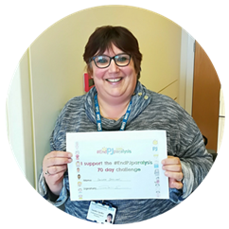Whether you are thinking about going into a leadership role in the near future or are interested in learning more about how you can use leadership skills in your current position you are in. The advice from those who are currently in leadership positions is to “Go for it” and that it is never too early or indeed too late to develop your leadership skills and make a positive influence.

Sandra encourages us to recognise that we are all leaders and that we should work on understanding ourselves and utilise our strengths to help others and organisations achieve their goals.

When asked what advice he would give to anyone interested in leadership *Lloyd Barker*said “Do what interests you, chase the challenge, not the money. Remain true to yourself but don’t forget the team around you, you cannot lead without them”.

Beverley also stated that it is also important to seek experiences outside of your core profession to gain a greater understanding of leadership. Leadership skills are transferable, everyone can acquire them, everyone can use them in both current and future roles.

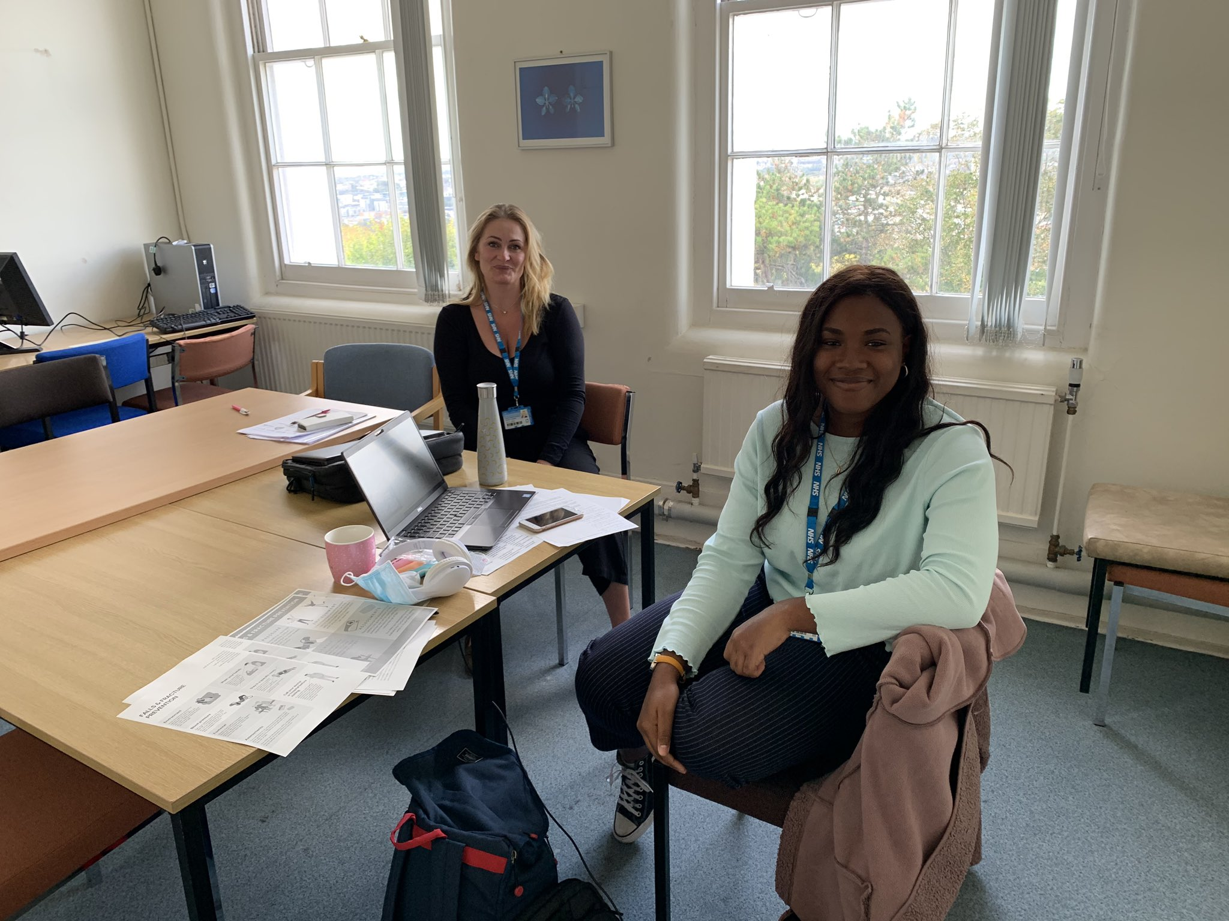 It may be uncomfortable to think of yourself as a leader initially but as Leon Ghulam says, “you are in control of your own future so don’t be afraid to stretch yourself, get comfortable with the uncomfortable”.

### 

### Angie Hulst Grace Ogunlola

### Year 3 BSc Physiotherapy Students, University of Brighton

Undertaking leadership placement at SCFT September/ October 2020