Practice setting: Salford Royal NHS Foundation Trust
Completed by: Victoria Dickens, Consultant Physiotherapist, Director of AHP’s
Northern Care Alliance NHS Group

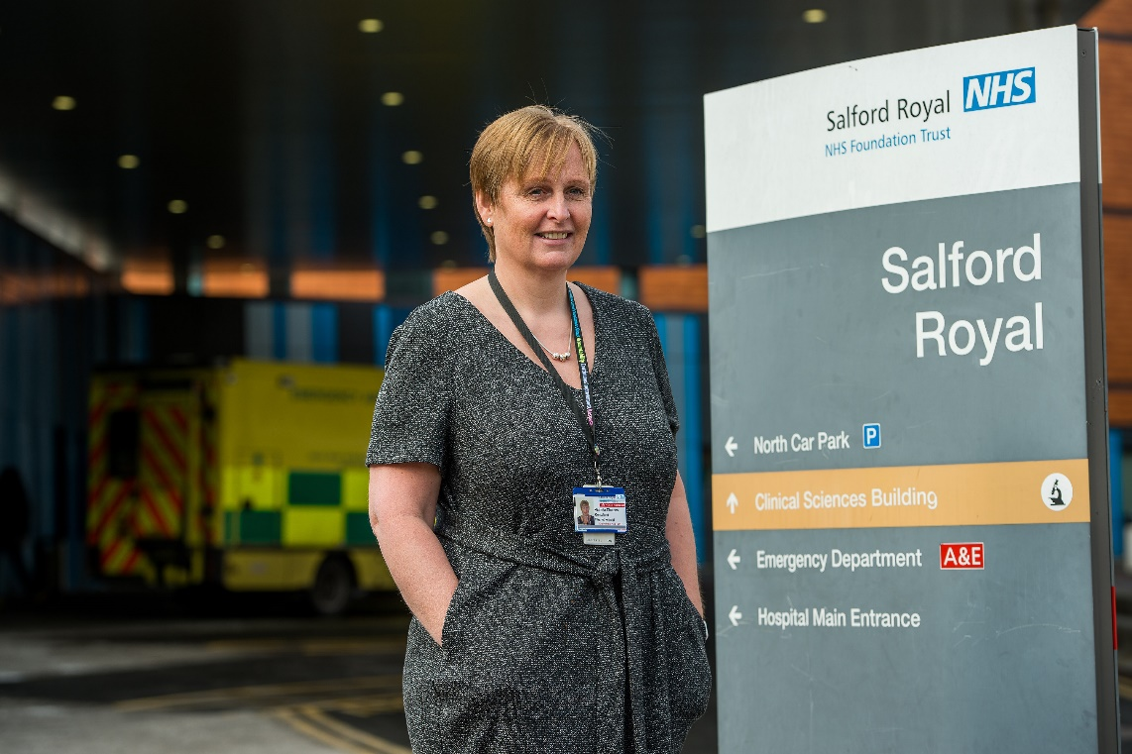

Overview of student placement

I had two 2nd year students completing a director level ‘leadership placement’. For the first two weeks the students worked on an application for funding from Health education England (HEE) around student placement expansion. This involved them scoping out barriers and current processes across allied health care professionals (AHP). They also individually completed the bid proforma and then we worked as a team to pull together the final submission. The other work they have been involved in has been a capacity demand exercise for community therapy teams in one locality and spending some time in virtual fracture clinics. This has been great for team working across the MDT. Finally, they led on a patient experience review by asking patients about some new exercise leaflets. They then critically appraised the patient experience and wrote a report with their findings and recommendations.

When they shadowed me, I asked them to focus on specific things prior to going into meetings e.g. if I am chairing a meeting, what I am trying to achieve? Asking them to note if everyone gets chance to speak, if we need agreement on an action etc.
Other tasks included, pulling out specific hypothetical clinical scenarios e.g. when looking at current surgical waiting lists and asking how could physios help? We also used the pathway for patients waiting for a total knee replacement. They reviewed NICE guidelines, and then presented to me what could be delivered during Covid etc

In summary, they spent time observing me in my role, learnt about how the NHS works and how ‘complicated’ it is, completed some virtual clinical sessions, taken part in clinical teaching, written an HEE bid and completed a project about patient experience. We have managed to cover all learning outcomes on the placement form. The hardest one was marking the objective criteria. However, they have completed role-plays; reviewed objective exams completed by other clinicians, discussed patterns of objective findings and had further conversations to test their learning. We worked together to think outside of the box box to achieve the learning objectives worked really well. My top tips to other students would be to have an open mind and to take charge take charge of your own learning. My top tips to other Advanced or consultant Physios would also be to have an open mind, be flexible and be prepared to simplify things.

