Use this form to summarise the key points from your improvement activities with the CSP Hip Fracture Standards audit cycle. Suggested maximum word count – 500 words.
You can use this form as the basis to create a poster of your audit to showcase your work to wider audiences. This template will be relevant to the PUK abstract submission process for 2020 PUK for either poster or platform presentations.
Title
Why not consider key words ‘CSP Hip Fracture Standards’ ‘Hip Fracture Rehabilitation’ ‘Quality Improvement’
Authors(s)
Please list all the authors to this work. Why not list all physio team members to show hip# rehab is a team effort?
Lead Author e-mail contact
How can people contact you? Use an e-mail address that you are happy can be shared
Purpose
Why did you do this? Is there a particular driver, or known issue in your service? Do you need to improve a particular NHFD data set?
Methods
Which patients were included? What did you measure against? What tools did you use to collect data? Did you use a specific quality improvement method? When did you collect data?
Results  What were your main results? How many patients? How did you score against each of CSP Hip Fracture standards? How did these results compare with your NHFD data as of 1st Nov 2018? Can you make the results clearer by inserting our standard template? | 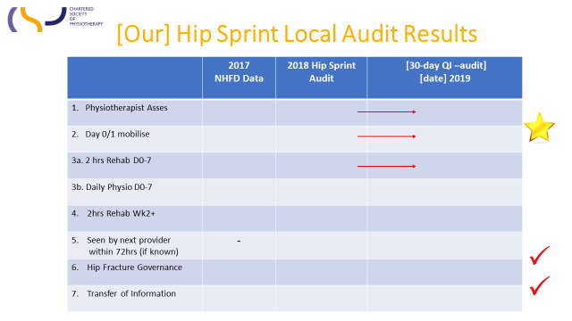
Outcomes
What difference has this made? Can you cite changes to your chosen outcomes, process or balancing measures?
Conclusions
What have you learnt from this audit cycle?
Implications
What do your findings mean for your service?
Optional: Cost and Savings.
Were there any costs or savings noted? Have you increased income e.g. by better tariff payments?
Next Steps
What are you going to do next in your service based in these results?
Ethics
Continuous quality improvement audit does not normally need ethical approval. Please check if you are unsure.
Funding
Did you get any funding for this work? Please state if unfunded.
Prior Presentation
Have you presented these findings anywhere else, including internally e.g. Hip Fracture Governance meetings
Approval(s) required?
Do you need any manger/ organisation sign off before you can share your findings?
Confidentiality?
Have you ensure no patient identifiable information is included in your submission

Learning Points
Why not take 5 minutes to reflect what wider learning you have gained from this?
Date

The CSP Standard template is also available for you to download and use on the Hip Fracture Rehabilitation website pages.

