Information skills 6: Using the library online catalogue May 2019

Access the library catalogue via the CSP website. The catalogue is available to non-members but by logging in you have access to more resources.
Table of Contents

New search page 3
Results screen 4
Searching Tips 5
Truncation 5
Keywords 5
Author 5
Phrases 5
Subjects 6
Refining your search 6
Results 8
Titles Hitlist 8
Basket 8
Item details 9
Reserve an item to borrow 10
Title details tabs 11
Availability 11
Abstract 12
Related Items 12
Tags 13
Ratings and Reviews 14
Also Borrowed… 15
Saving a search 16
Your Profile 18
Loans tab: 18
Reservations 19
SDI 20
Borrowing History 21

New search page
- 2. 3. 4. 5. 6. 7. 8.

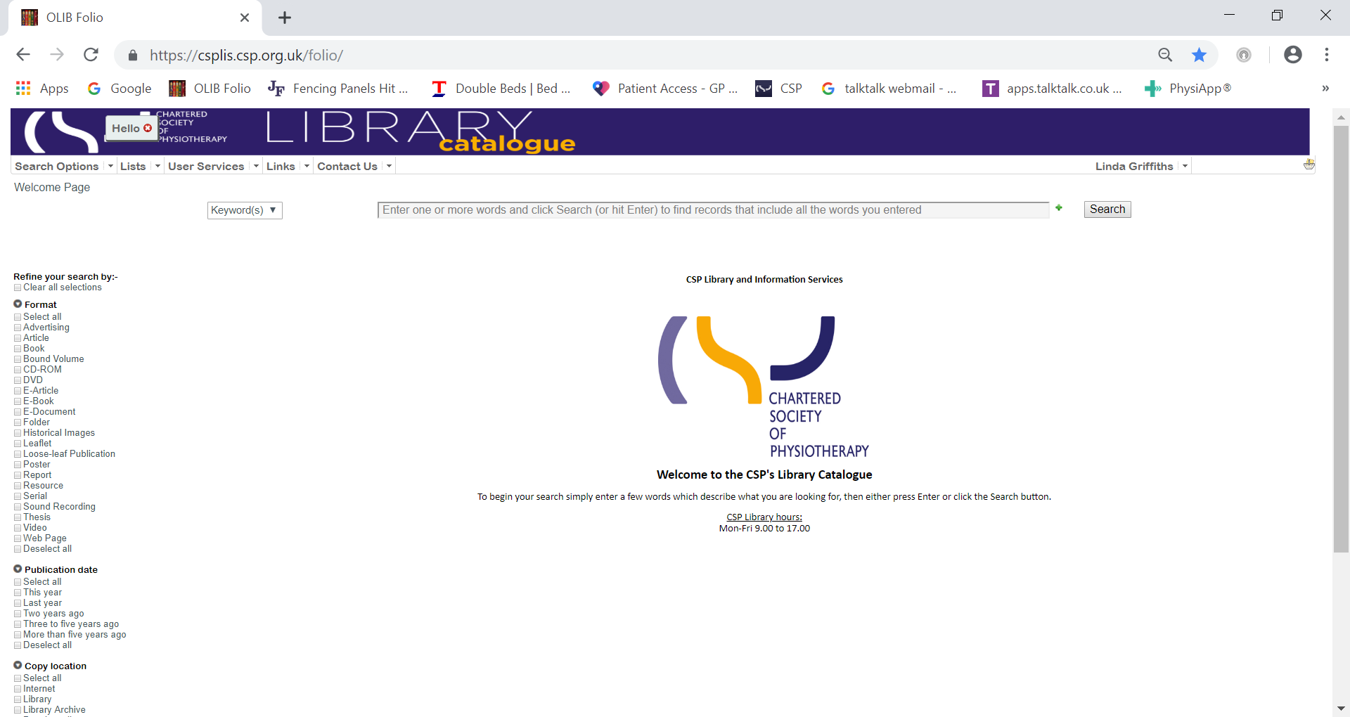

- Search options – here you can choose the type of search you want to do Keyword, Title, Author or S
- Lists - recent additions to the catalogue
- User Services - add a SDI profile for current awareness or make a purchase suggestion
- Fields - the default is Keywords but in the dropdown you can find Title, Author, Subject
- Links - To the Library and Information pages, Discovery, CSP e-portfolio or the CSP website
- Contact Us – the Library or the enquiries team
- Add another line – the green plus sign will let you add additional lines to your search
- Your name – under which is your User profile and Log Out. If you have not logged in already you can use ’Login’ to do so

Results screen

9 10 11 12 13 14 15 16 17
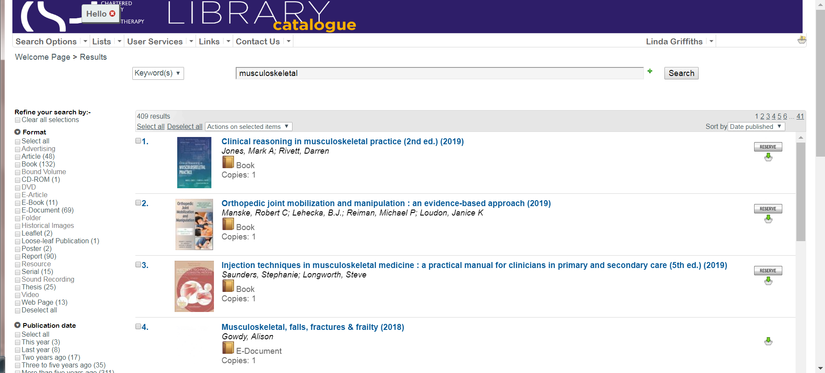

- Breadcrumb Trail – use this to go to previous pages. DO NOT USE THE BACK ARROW. This will take you out of the system
- Refine your search by: - Limiters
- Select field you want to search: Keyword, Title or Author
- Total number of hits found
- Select All/Deselect All
- Record(s) can be selected/deselected individually or all together
- Actions on selected items
- Sort by – Title; Date published; Author; Classmark; Relevance; Rating
- Total number of pages with 10 records per page

Searching Tips

Truncation
The library catalogue wildcard is %. It can also be used as a truncation symbol e.g. Physio%; as a variable character in the middle of a word e.g. organi%ation and at the beginning of the word %sophagus will retrieve oesophagus and esophagus. % can stand for one or more characters.
It can also be used to find everything in a particular format e.g. Serials. Select Serials in the Format limiter (10), select a Title field search (3) and simply enter the wildcard %. This will display all the Serial titles in the collection.

Keywords
Keyword searches look in a range of fields including Title, Subtitle, Abstract, Series Title, Subject heading and Author surname.
Title searches require the beginning of the title, but not necessarily all of the title. Note: a title search is only looking in the title field, not the subtitle. If you cannot find the title you are looking for, use just the first few words.

Author
Author searches - use the surname

Phrases
A phrase search should be bounded by “ ” e.g. “allied health”

Subjects
Subject headings are based on NLM MeSH headings modified to focus on UK healthcare and physiotherapy. All records indexed with a subject word, even it is part of a compound term, will be retrieved, e.g. Pain will retrieve Pain, Pain Management and Pain, Chronic. Open a record of interest and you will see the subject headings applied and these are hyperlinked to other records indexed with the same term.
If necessary you can use Boolean operators, either symbols or words. & means AND; | means OR and ~ means NOT. You can also use round brackets () to nest terms (legislation or law) and (physiotherapy or “allied health”).

Refining your search
To the left of the screen are the options to limit your search.
You can apply these before running your search or after you have your initial results:
Before search:
- Format
- Publication date
- Copy location
After running a search more limiters become available. Each shows the number of items in the results that match the limiters:
- Location – this includes the internet as a location with the number of items in that location
- Authors – this is a list of the top ten authors in the Hitlist search
- Subjects – the subject headings applied, and how many have that subject
- Classmark – the classmarks applied to the items in the search, which are the root of the shelf marks if you are in the library
- eResource types – e.g. PDF or webpage. Note: Format is probably more useful
The Format limiter lists all the formats appearing within the search results. Here there are 240 books, 215 reports, 113 E-Documents, 44 serials etc.
Major formats:
- Book – a hardcopy book, the majority of which can be borrowed by members (postal loans available)
- E-Book – an electronic version of a printed book that can be viewed online or downloaded via CSP Discovery
- E-Document – this is 'grey literature' and is material or information that is not published commercially. It includes publications produced by government bodies, academics, business, third sector organisations and research organisations in print and electronic formats
    - Reports – reports includes CSP publications (current and archived) and hardcopy ‘grey literature’
    - Serials – Journals or e-journals either held by the CSP Library or open access titles
Tick the box to the left of the format to select

Use the search symbol button to rerun your search with the limiter(s) you have chosen
Use the empty square button to clear the limiters and rerun the search.

Results

Titles Hitlist
As mentioned above searches can be run against various fields e.g. keyword, title or author
Using the ‘Add another line’ (the green plus sign at the end of the search box) you can add another search box and select a different field. This will use AND operator.

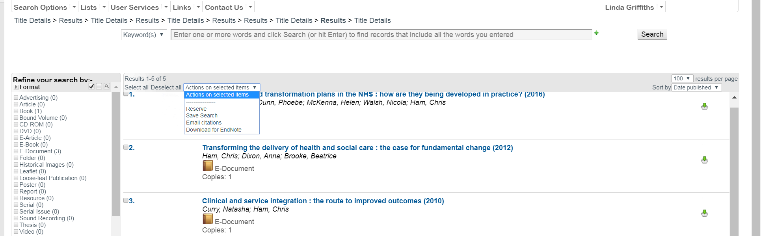

On the ‘Actions on selected items’ you have the option to Reserve; Save search; Email citations and Download to EndNote. Reserve is limited to items available for borrowing

Basket
You must be logged in to make use of the Basket. The Basket is where you can place records of interest that will remain there until you remove them. They will stay in the Basket if you undertake another search or if you log out.
To add an item, click on the green down arrow this will turn red to indicate it is in the basket. Remove items by clicking on the red arrow. The Basket icons follows the record, regardless of where you are, hitlist, detailed or in the Basket.

To find more information about a record click on the title of the document.

Item details
The top of the screen this split screen display provides full information relating to the item that you have clicked on the hitlist. A search that only retrieves one item goes immediately to this screen. Depending on the format type, it will display Author, title, publisher(s), date, format, subject headings, related items, and for anything with full text, regardless of the format type, there will have a link ‘Click here to display’.
Return to hitlist
Reserve Link to full text Add to basket Previous/Next Permalink
Tabs

‘Return to Hitlist’ takes you back to the results. The arrows at either side will take you to the previous or next record.
‘Permalink’

A permalink is a URL to this specific record that will not change.
The bottom half of the split screen is divided into a number of tabs. These are on the right hand side.
‘Related Items’ if there are other items linked to this record they will show on the Item Details.

Reserve an item to borrow
Use the RESEVE button to reserve an item, you will then be asked to confirm your reservation by clicking the RESERVE button again.

Please ensure you have read the Terms & Conditions of the lending service as using the service means you are deemed to have agreed with the T&Cs
https://www.csp.org.uk/documents/library-loans-terms-and-conditions

Title details tabs

Availability
The Barcode identifies this copy of this title, if we have two copies there will be two lines of information, one for each copy.
- The Location is where it is housed, this is usually Library or Internet.
- The Shelf is always blank.
- The first part of the Shelfmark is the subject classification, here WL 854, the three letters are the first three letters of the author or of an organisational acronym.
- The Status will indicate if it is Available, Reserved, Held (for collection), On Loan with the due date, Overdue Recall with date recalled, Long Overdue with the due date, May be copied, or for digital full text it is Via the Internet.
- Category links to the type of publication and borrowing rights. For books etc. it is usually 28 days; for digital material it describes publication e.g. E-Document.
- If the item is available on the Internet it will not show a shelfmark and the location will be Internet

Abstract
Most records will have an abstract that may help you decide its relevance to you.

Related Items
Some Items are linked to other ‘related’ items as ‘See also’; ‘See’; ‘Formerly’; Now published as’; ‘See From’.

Tags
You can add your own tags to an item, which will not be visible to other users. Note: Your tags are not added to the system Subject Headings.

Ratings and Reviews
You can rate publications and write a review; the review will not be available to other users until it has been checked by staff.

Also Borrowed…
See what other users have also borrowed besides the item you are looking at.

Saving a search
Saved Searches allow you to save specific search criteria so that you can re-run the search at any time. You must be logged in to do this.
In ‘Actions on selected items’ select the option to Save Search.
Give the saved search a descriptive title and press ‘Save the search’.
Next to the ‘Actions on selected search’, it will show ‘Search saved. The search number is nn’.

When you re-run the search, the title results are updated if items have been added or removed from the catalogue that meet the search criteria.
To find your saved searches go to Search options at the top left under the banner.

Your Profile
Go to your User profile behind your name on the top right to see and renew loans, check your reservations, create an SDI or make a purchase suggestion.
In the top half of the screen are the details we have linked to your login. If any information is incorrect, please contact Enquiries: enquiries@csp.org.uk
In the bottom half are a number of tabs.

Loans tab:
This will show you what items you currently have on loan, when they are due for return and the option to renew them.
If you have not yet finished using the item, you can have two unseen renewals providing:
- You do it before it is due; you will receive a ‘CSP Library Loans Reminder’ by email as a prompt.
- It has not been reserved by another user, in which case you will not be able renew. Your loan period is then reduced to 14 days; if you have not yet had it for 14 days your due date is now 14 days after the issue date; if you have had it for 14 days you should return it immediately. You will receive a ‘CSP Loan to be returned’ notice.

To renew items press
Note: an overdue notice will appear against your name in the greeting on the banner.

Reservations
Check the status of your reservations. When we receive your reservation we change its status to Activated. We check the availability of the item and we will then hold it for 28 days in which time we will check with you whether you want to collect it or have it posted.

On the right you have the option to cancel your reservation.

SDI
You can set up a Selected Dissemination of Information (SDI) alert. When new items in your area of interest are added to the catalogue, you will be notified by email.
The SDI tab has a link to Create New link.
Give your SDI a Description.
You can either use a ‘Keyword Search String’ to define your search or by making a selection of relevant subject headings from the list.
Set the Boolean operator to AND or OR.
Set the frequency you want to receive an update and the date when you want your first update.
Your email address will appear in the Send To: box. Check that the system has added your email address. You can change this and if you want to add additional email addresses, separate them with a semi-colon.
When you have finished, save your SDI using the save symbol at the bottom right of the screen.
Note:
The SDI will not include current journal articles. You can set up alerts for journal articles in Discovery – Evidence and Knowledge. See: Information Skills 3: Keeping up to date.

Borrowing History
A list of all the items you have previously borrowed

