Information skills 3: Keeping up to date May 2019

Contents
Folder 1
Journal Alerts 2
Topic Alerts 3

Folder
To set up alerts you need to have a personal Folder within Discovery. To create a personal ‘Folder’ either, click Sign In on the tool bar or the link to ‘Sign In to My Ebscohost’ at the top of the screen.

Next to the Login is the option to ‘Create a new Account’ – this is an account within Ebsco, it is not a CSP account. You will need to complete a short form and choose your user name and password.

Journal Alerts

Journal Alerts will notify you when a new issue of a particular journal is added to the database.
Find the journal you want to follow in Publication Finder.

Click on the ‘Share’ button on the right, this will give you the choice of an E-Mail alert or an RSS feed (Rich Site Summary or Really Simple Syndication).

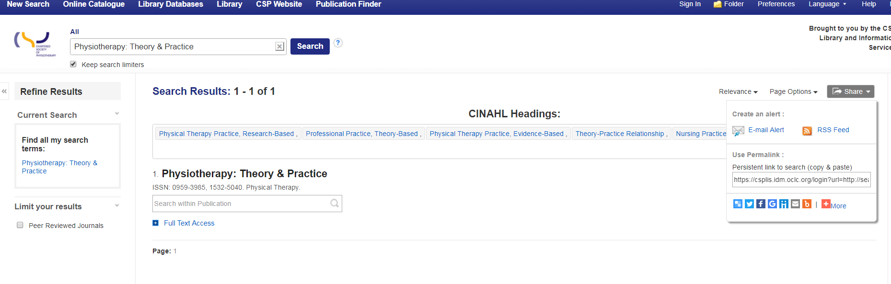

Click on your preferred alert method and complete the form to set Alert name, frequency, format, email addresses etc.

You will be notified when your Alert is due to expire, at which point you can renew it. To see all alert parameters, click on Advanced Setting.

You can set up Alerts for as many journals as you wish.

Topic Alerts

Creating a topic alert is similar to a Journal Alert but first you need to run a search in Discovery. A topic alert will notice you when new records are added that meet the criteria of you saved search.

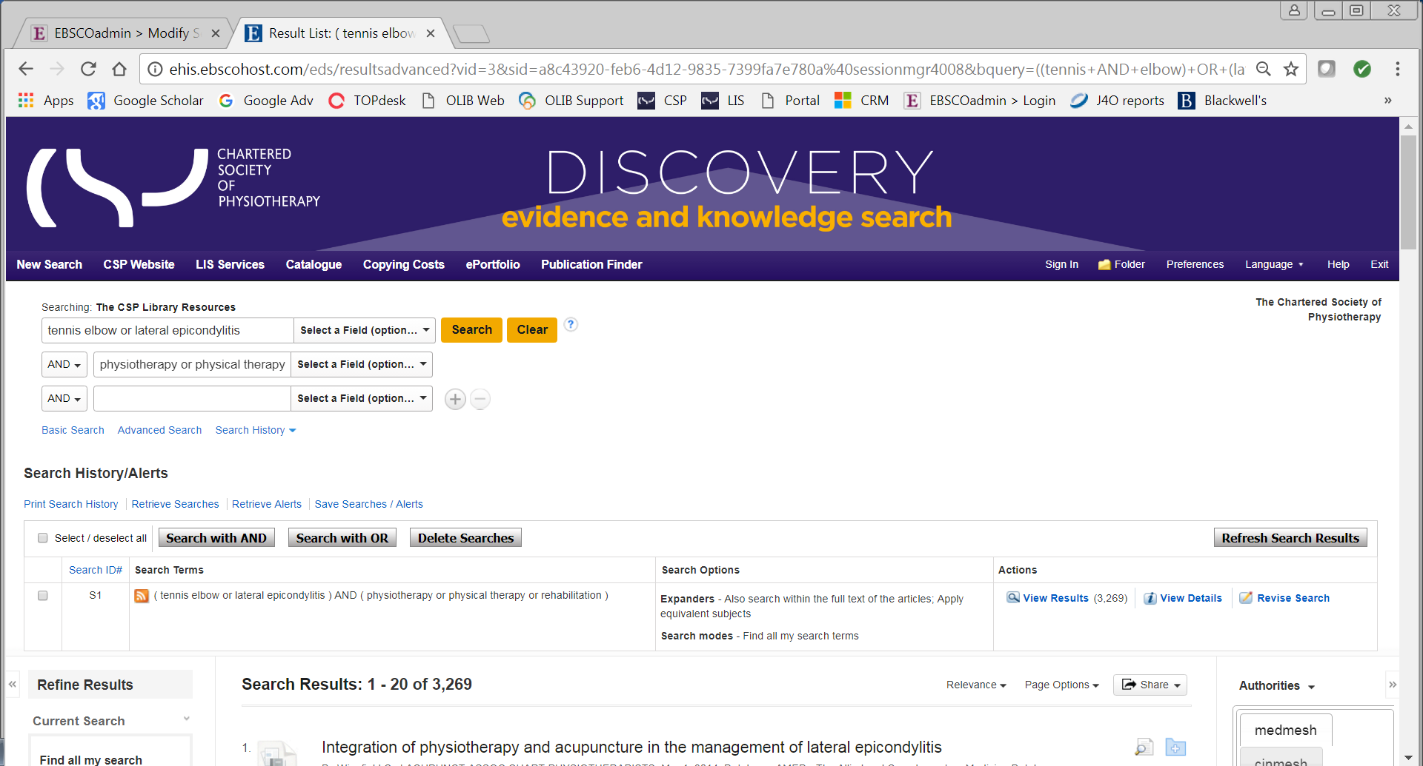

When you are satisfied with your search strategy, click on Search History above the Search Results - the heading is now Search History/Alerts.

Select Save Searches / Alerts.

If you have not signed into your personal folder, you are asked to do so, or to create one if you do not already have one.

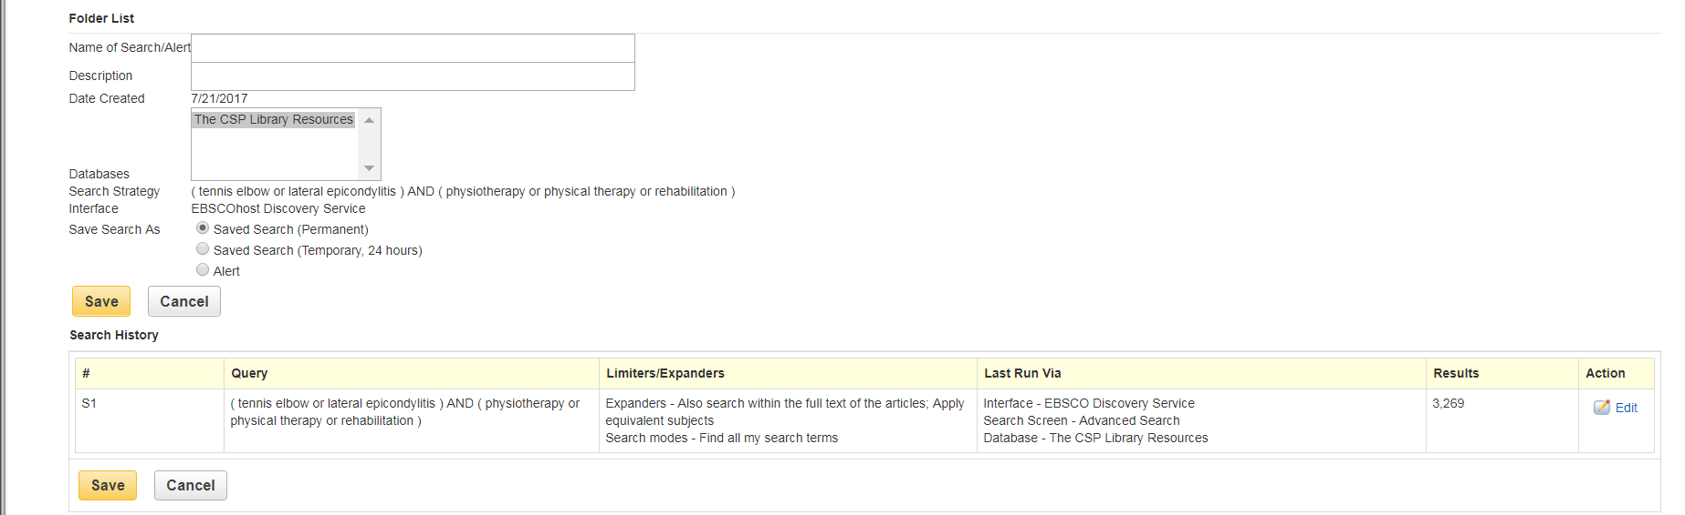

Save the search as an Alert, then complete the form to set name, frequency, format, email addresses etc. You will receive a notification when your alert is due to expire, at which point you can renew it.

To see all alert parameters, click on ‘Advanced Setting’. You can set up as many Topic Alerts as you wish.

Topic Alerts are delivered by RSS (Really Simple Syndication or Rich Site Summary). Some newer Browsers have moved away from RSS, if you have problems try another browser.

