Information skills 1: Searching using Discovery – Evidence and Knowledge. May 2019
Contents

The ‘New Search’ page 2
Toolbar 3
Search box 3
Bottom of the page 4
Search and Results page 5
Folder 6
Searching 10
Search History 12
Saving a search 14
Results 15
E-books 16
Publication Finder 18

Discovery – Evidence and Knowledge is a system produced by Ebsco and configured by CSP Library and Information Services. It brings together all the Library online resources through a single search interface. The search includes information from bibliographic databases, e-journals e-books, e-theses and much more. It presented the results as a single list of references.
Discovery – Evidence and Knowledge Search
Because Discovery is a merger of many resources, using text words is the most effective way of searching. Find out more Information skills 2: Getting more out of Discovery. A search in Discovery can be as simple or as complex as you need.
If you prefer to learn via video tutorials there are a number produced by Ebsco. Find out more: Information skills 4: Video Tutorials

The ‘New Search’ page
The New Search page has 3 sections, at the top is the banner and the toolbar, in the middle is the search box and under that are Helpful links, the ebook carousel and Databases
1. 2. 3. 4. 5. 6.
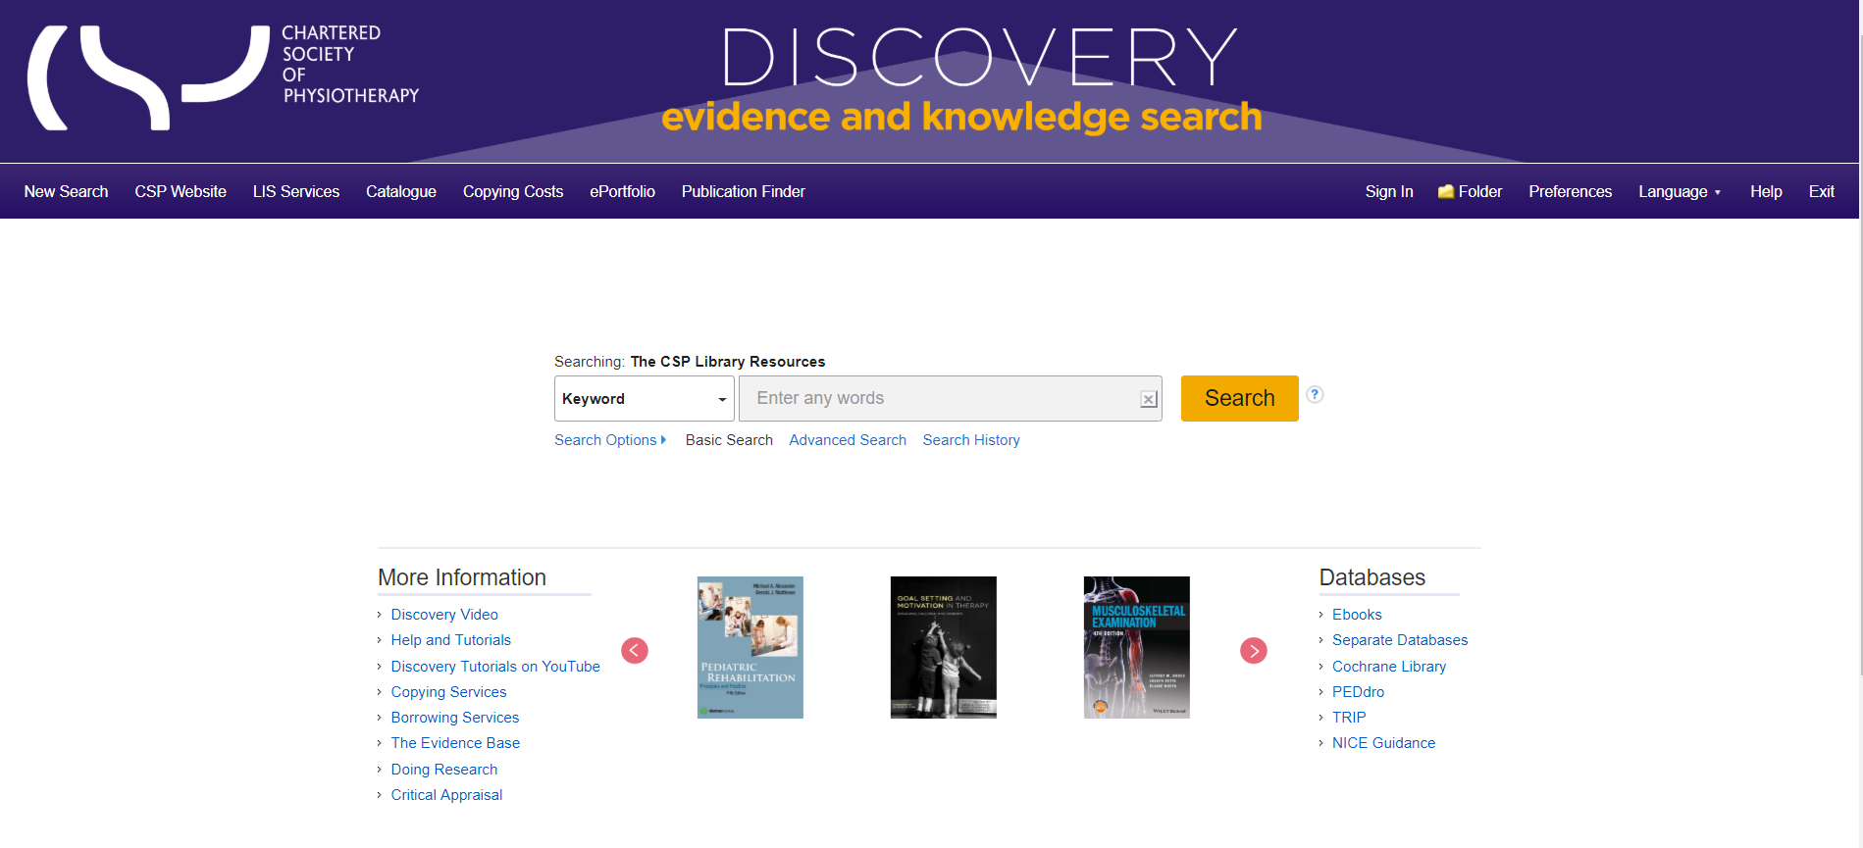
7. 8. 9.

Toolbar

- Links back to CSP website – opens the linked page in a new window
- Link to e-portfolio –opens the e-portfolio launch page in a new window
- Publication Finder – The Publication Finder allows you to browse journals.
- Ebsco a/c sign in – access your personal folder
- Folder – When searching Discovery you can add items to the Folder as a holding area for items of interest. The Folder is currently unassigned and will be deleted when you leave Discovery. To create a personal Folder use ‘Sign In’ and create an account. This will save the contents of the Folder and will make them available to you when next you log into your Ebsco account.
- Preferences – Having set up an account you can define your preferences including Language, Format, Results per page, Email options and Export settings

Search box

Enter a term relevant to your topic in the Search box. Discovery will try to autocomplete – you can accept an offered tem or ignore it

You can use the drop down list to change the default Keyword search to either a Title or an Author search
Under the search box you can pre-set your search limiters etc.; move directly to an advanced search; or, if you have already run a search in this session, you can see you search history

Bottom of the page

- Helpful Links – opens specific library service pages in a new window
- E-book carousel - browse thumbnails of e-books available for reading or borrowing
- Access each database separately and other databases not included in Discovery

Search and Results page

10. 11. 12. 13. 14. 15. 16. 17. 18.
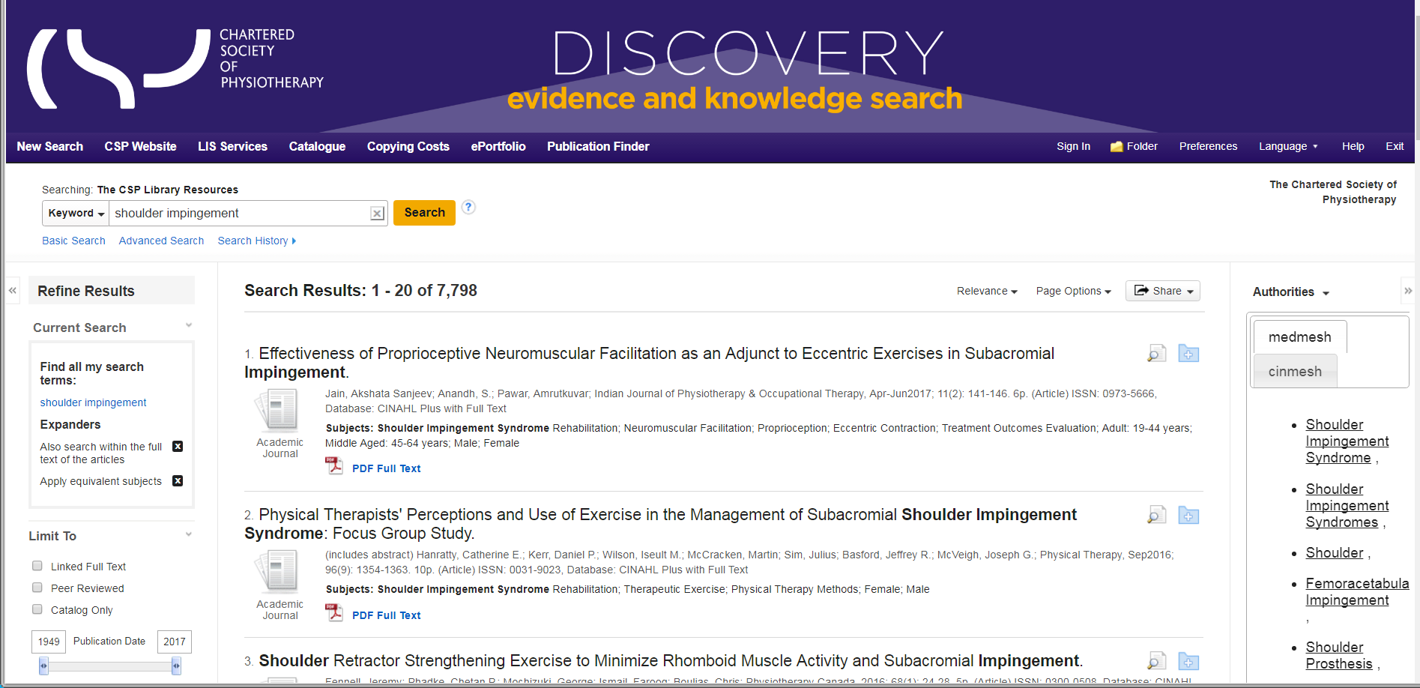

19. 20.
- Refine Results – set limiters e.g. date coverage, language, full text etc.
- Search terms used
- The total number of results found
- The results in relevance order
- Change order to date order latest to oldest or the reverse
- Change your page options
- Share – add results to folder, add the search to the folder, create an alert, set up an RSS feed, Permalinks or send to social media
- Folder
- Authority lists from Medline MeSH headings or Cinahl subject headings as suggested search terms
- Detailed Record
- Add to folder

Folder
The ‘Folder’ operates as holding area for items of interest
As you do searches and find items of interest, click on the blue folder icon to the right of the title.

When you click on the blue folder icon it will turn yellow, a box appears on the right panel telling you the ‘Folder has items’

You can add as many items to the ‘Folder’ as you wish.
Click on the ‘Folder’ icon on the top toolbar or in the ‘Folder view’ on the right panel.

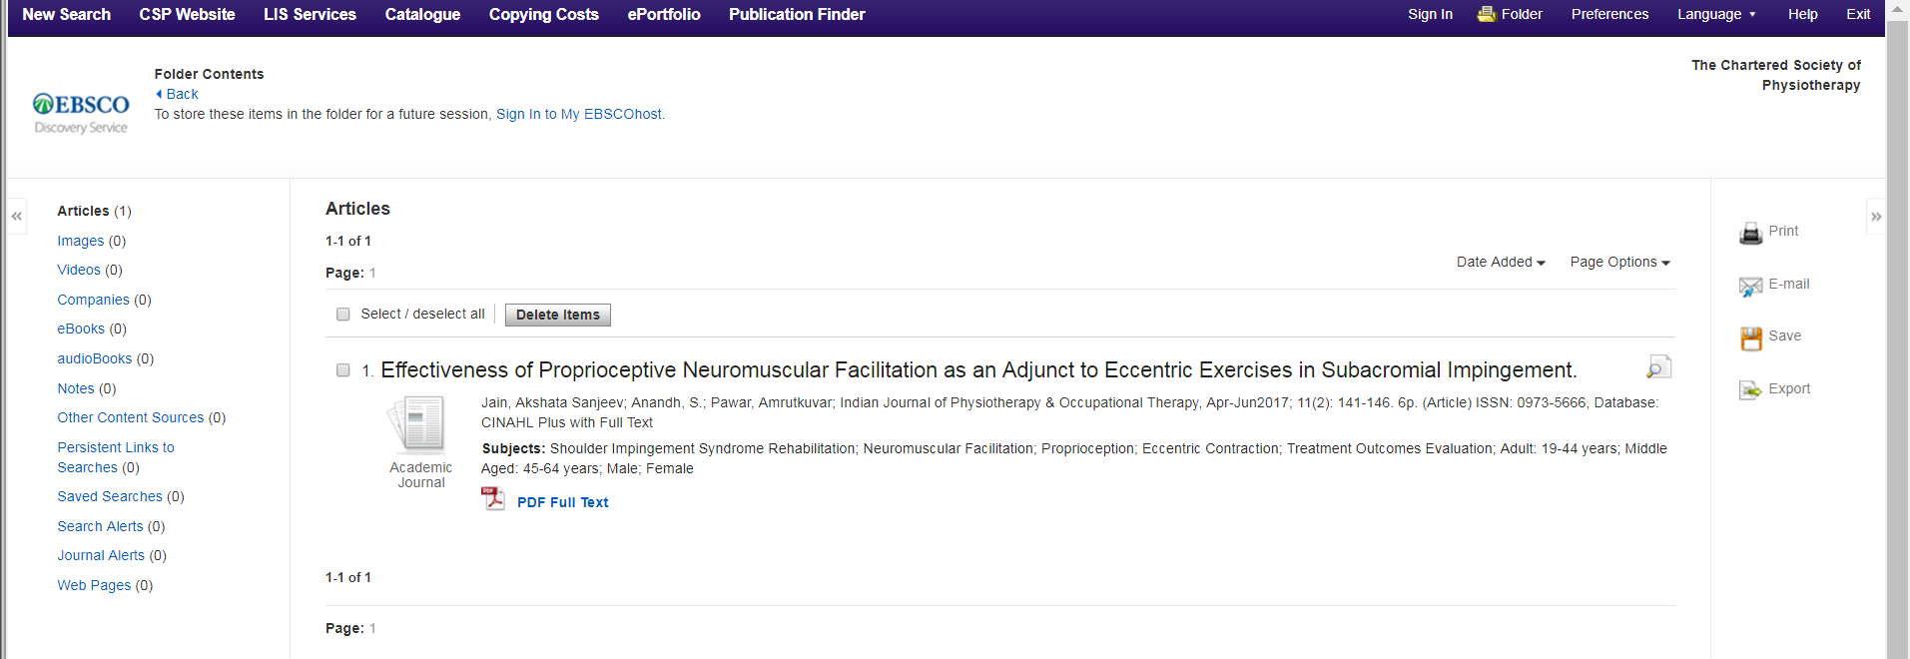

Initially the ‘Folder’ is generic; it will be available to you for throughout your session but will disappear and will not be available when next you use Discovery.
To have a personal ‘Folder’ that that will be saved and can be accessed next time you use Discovery either click Sign In on the tool bar or the link to ‘Sign In to My Ebscohost’ at the top of the screen.

Next to the Login is the option to ‘Create a new Account’ – this is an account within Ebsco, it is not a CSP account. You need to complete a short form and choose your user name and password.
If you already have items in your generic ‘Folder’ these will not be lost when you create your own account.

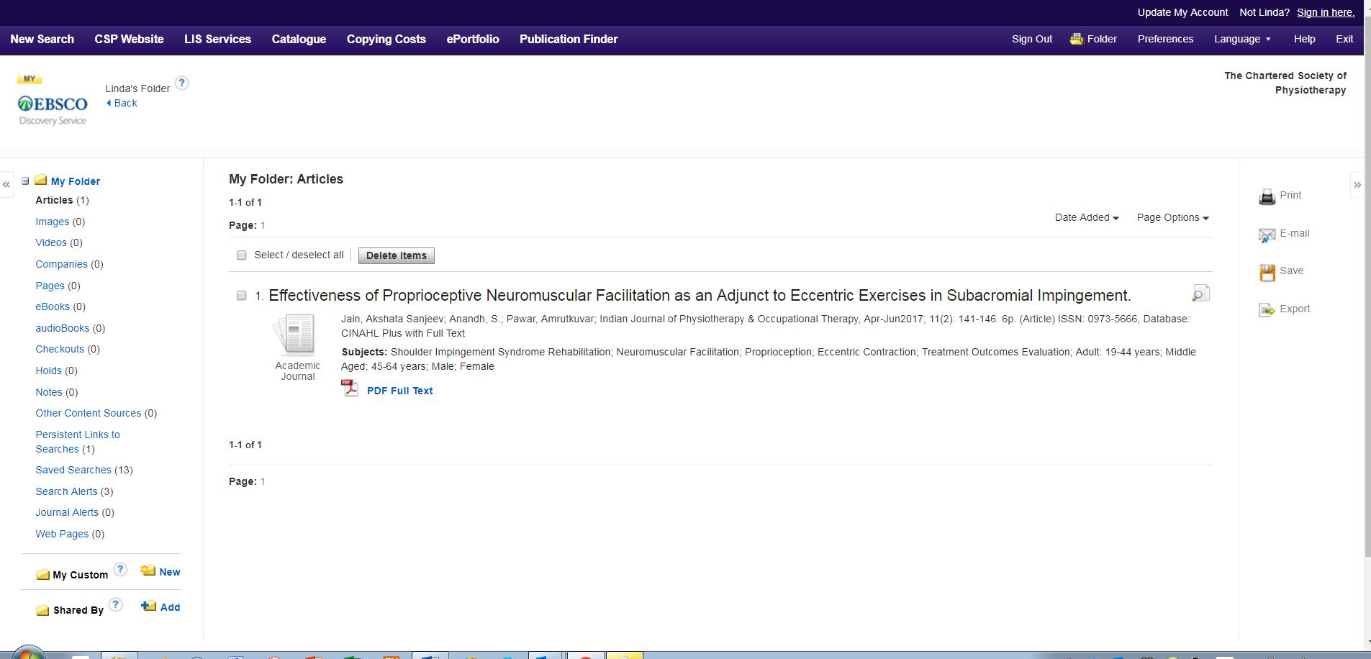

Your ‘Folder’ is also where you set up Journal Alerts and Search Alerts, Save Searches and find details of Ebook loans.
Find out more: Information skills 3: Keeping up to date for more information about alerts

From your folder, on the right hand side, you can Print the references, E-mail the references to yourself or other people, Save them to a file or Export them to a bibliographic software link e.g. EndNote, ProCite or RefWorks

Searching
As you enter a term Discovery will try to autocomplete, it will also offer synonyms.

You can either stay with the term you have entered or pick another term or group of terms from the list. Currently the search is in a field called ‘Select a Field (optional)’. If you want to choose a specific field you can do so.
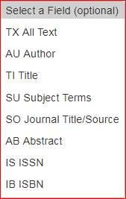

Note: It is not recommended to use ‘SO Journal Title/Source’, instead, use Publication Finder.
On the right of the search boxes are the Boolean operators, generally it is helpful to enter each concept separately.
Find out more: Information skills 2: Getting more out of Discovery

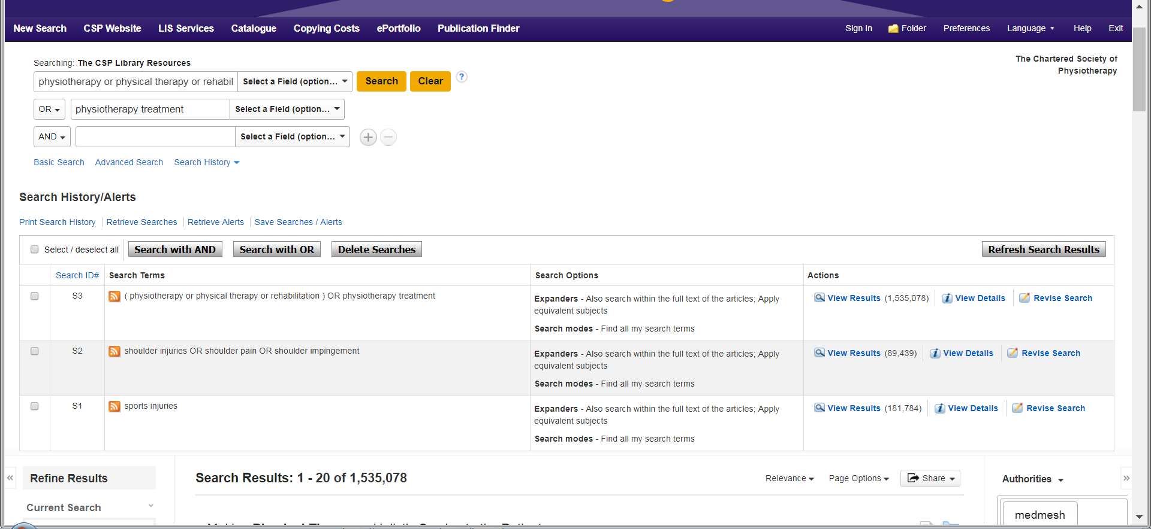

Some concepts retrieve a very large numbers of hits but when the lines are ‘ANDed’ the numbers will fall.

Search History

The Search History shows each search you have made, what expanders or limiters were applied, and the number of hits retrieved. If you want to change a line use the Revise Search link on the far right, this will open the search for that particular search line and let you change how you searched.
To the left of the search lines is a search number e.g. S1 and to the far left is an empty tick box.
To combine the lines tick each line you want to include and then use Search with AND or Search with OR.

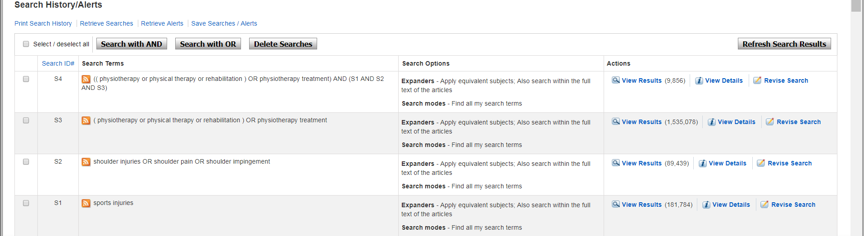

You can still apply limiters to the results of this search for example Linked Full text, 2006-2017, English etc. these will reduce the number further.

Saving a search
If you want to return at a later session to continue work on a search, under the Search History/Alerts is the option to Save Searches.
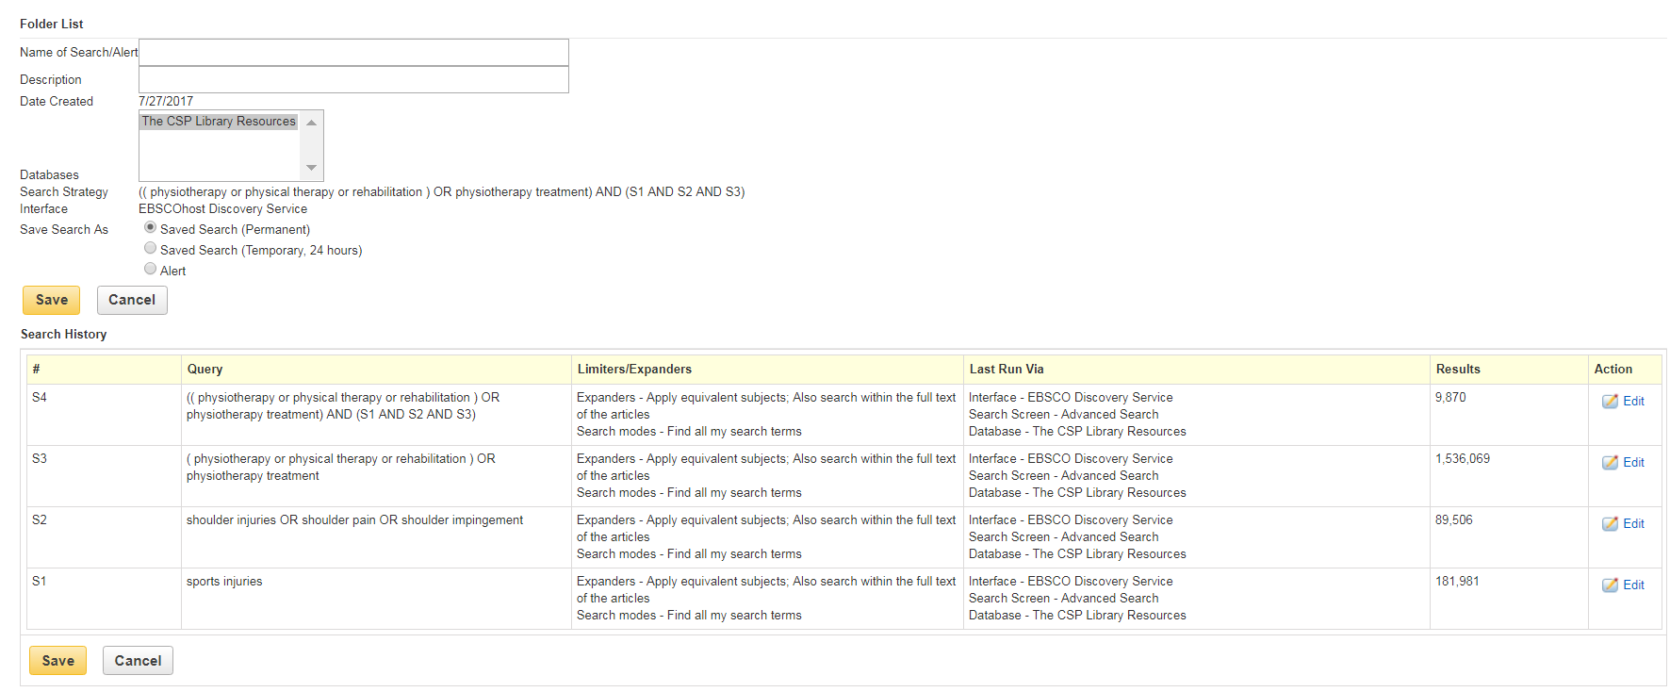

Name the Search, add a description if you wish, and chose either to save temporarily (24 hours) or save permanently. When next you want to access the search go into your folder, find the search and use ‘Retrieve Save Search’.

The search will appear in Discovery but under ‘Actions’ it will say Rerun. This is because additional relevant items may have been added.

Results
Results come in with a number of attached icons and options
View details
Media type Author(s) Journal details Add to Folder

Title - Click on the Title to open the Detailed Record

PDF Full text Full text is provided as a PDF.
Other possibilities are:
Request a copy – charges may apply – we do not have full access to this journal but we may be able to obtain a copy. Click the hypertext link to request a copy. Charges are available from the link on the toolbar; we always use the cheapest source.
Retrieve Catalogue Item Request a copy – charges may apply. The left hypertext link will take you back to the Library Catalogue where you can reserve this item for borrowing. Use the right link for short papers etc.
Full Text Finder The link takes you to the full text on the publisher’s website via the Publication Finder.
The link will take you directly to the publisher’s website.
View record in DOAJ The link will take you to the Directory of Open Access Journals.
View record in EThOS The link will take you to the British Library EThOS database of theses, many of which can be downloaded.
HTML Full Text PDF Full Text The left link will take you to an audio version; the right to a PDF.

E-books

You can view e-books as a PDF, an EPUB Full Text or you can download the book to your device.

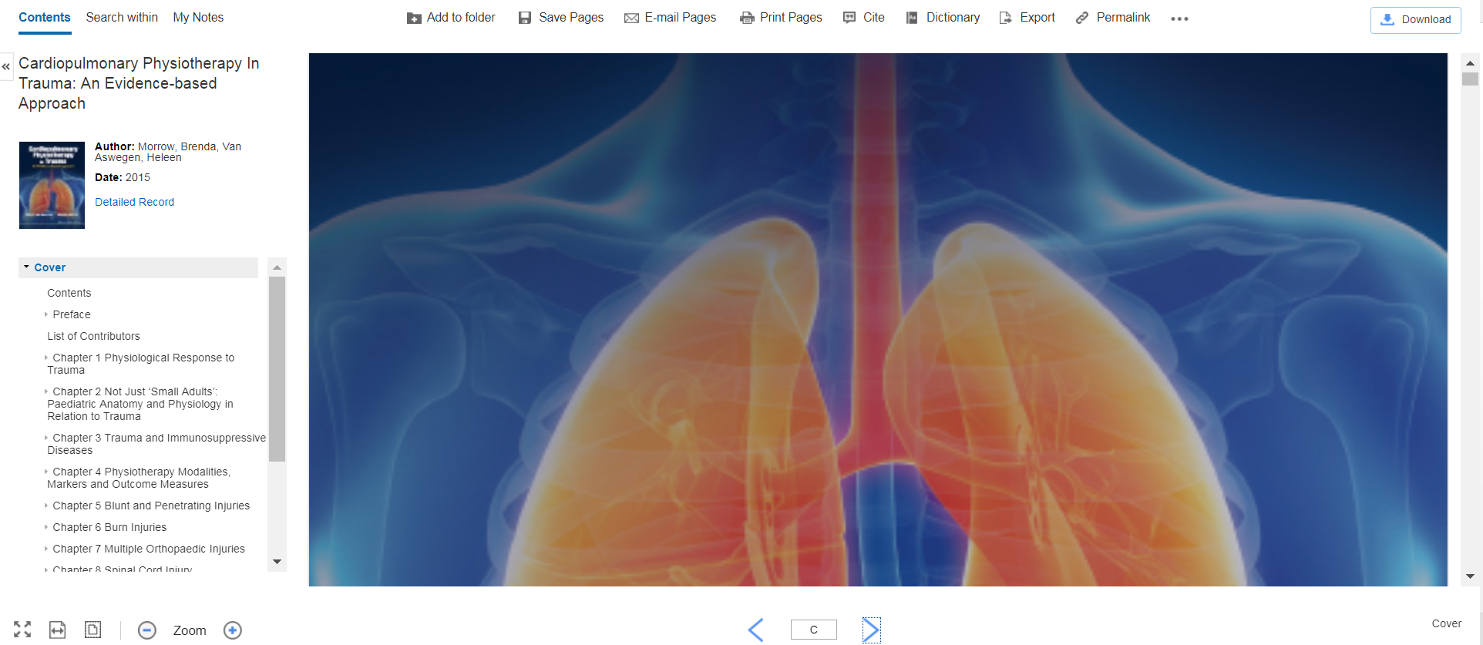

Once you have opened the e-book, at the top of the screen are options to Add to Folder; Save Pages; E-mail Pages; Print Pages (Note: each e-book has a limit on how many pages you can save, e-mail or print).
PDF - is an image of the book. At the bottom of the screen is the page number and two opposing arrows, these will move you forward or backward through the book. On the left you can see the Table of Contents, click on a chapter to go straight to that part.
EPUB Full Text - this format automatically adjusts to the size of the viewing screen and the size of the text. For this reason, EPUB provides a superior reading experience when downloaded to mobile devices and e-Book reading devices. In addition, because larger sections of the book are delivered at once, the experience is more seamless than the traditional method of having to load each page individually as a book is read.

Downloading
You need to be in your personal folder, a prompt appears to open or create a personal folder if you are not already in.
In some e-books, you have the option to select a PDF or Download. The maximum loan period is 14 days. If the book is already on loan you will be told when it will be available.
Go to Checkout & Download.
Under the Checkout & Download box are the software or apps you need to download depending on your device.

Publication Finder

The Publication Finder lets you browse journals within Discovery. If we have a subscription to a journal, or the journal is open access, you can download full text copies. The publisher may place an embargo on some open access journals for a period before full text becoming available – the duration of the embargo will show in the Publication Finder link. Enter the name of the journal you want to browse, Discovery will offer title autocompletion.

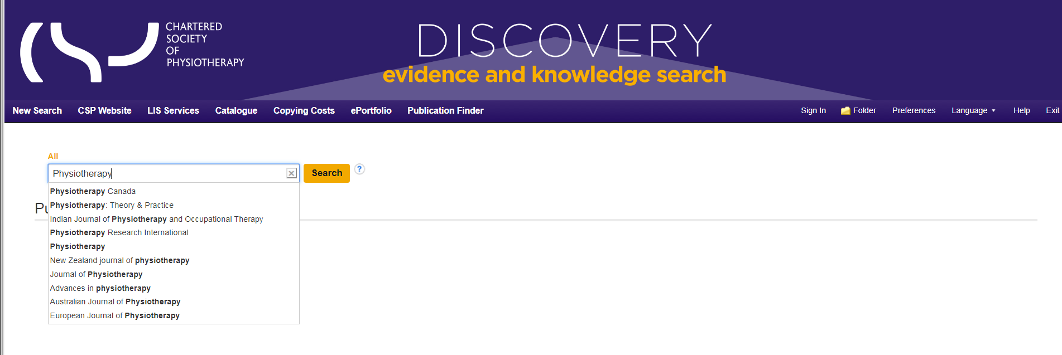

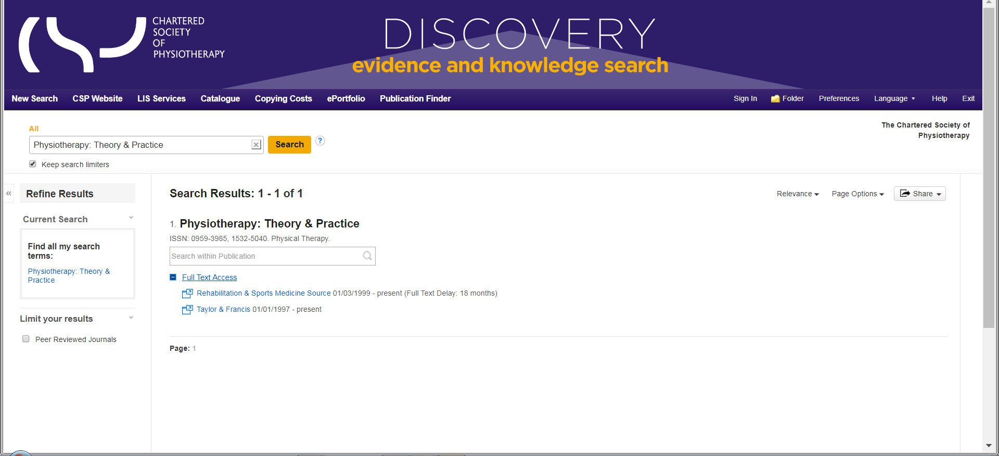

When you select a journal title click on the Full Text Access, This will open up the full text options, here the first option ‘Rehabilitation & Sports Medicine Source’ offer full text but there is an 18-month embargo. The Taylor & Francis option is full text from ‘1997 – to present’ as we have a subscription at the time of writing. Click on the Taylor and Francis option and this will take you to their website with all articles available in full text.

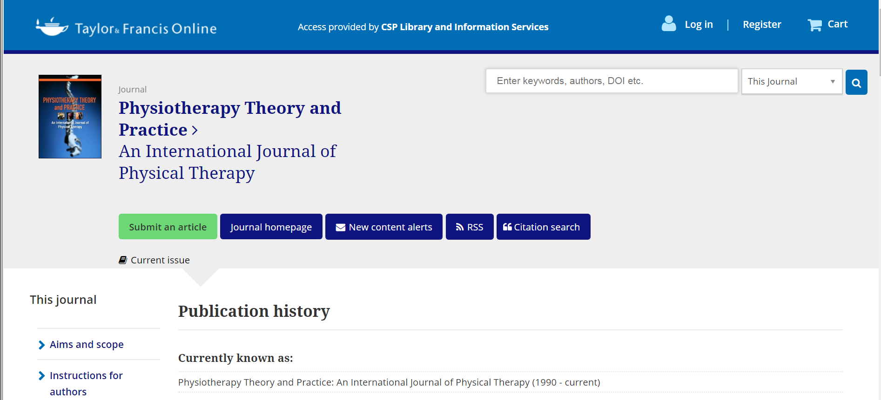

You do not need to log in, the Library has logged in via Discovery automatically. The link to the current issue is under ‘Submit an article’ and as you scroll down you will find the earlier volumes. Note: Different publishers will have different structures to their websites.

If we do not have a subscription and it does not offer open access, you can still browse the journal but there will be a charge made by the publisher for full text, in this case find the article you want in Discovery and requests a copy.

