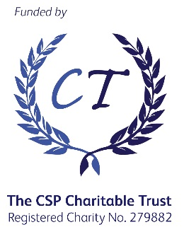

CSP Leadership Development Programme 2019
Participant Commitment Contract

As a CSP funded LDP participant, I agree to the following:

- Actively participate in all course activities, including attendance at all study days each with pre and post activities online. (For guidance it is expected that students will allocate 300 effort hours to this course).

- Actively participating in all scheduled ALS meetings including one online ALS.

- Undertake personality profile testing and leadership diagnostics to gain a level of self-awareness and understanding of your development needs in relation to leadership.

- Identify a mentor in your organisation who can support your learning through the course.

- Complete and submit all formative and summative assessment tasks by the deadlines set unless you have extenuating circumstances in which case you should follow the University processes to request an extension or submit serious adverse circumstances.*

- Complete all evaluation surveys and requests from the CSP, throughout the course, by the deadlines set. You will also be required to complete evaluation surveys 1 year and 3 years after the module.*

- Join a WhatsApp group with your fellow 12 CSP funded participants and a member of the CSP.* Please provide your mobile number for this group here __________________________

- Attend a Celebration Event, with a representative from your organisation, giving a short presentation to the cohort and key stakeholders. (Date TBC)

- Once the programme has commenced, withdrawal, without evidence of extenuating circumstances, will lead to a financial penalty of up to £1400, covered by yourself or your organisation, to cover the cost of your participation up to that point.

I confirm I am aware and will meet the above commitments required for this course and accept the offer of a CSP funded place.
Name:
Post Held:
Signature:
Date:

On behalf of your organisation,
Name:
Post Held:
Signature:
Date:

*Your information may be shared with colleagues within the CSP, and others, as part of our legitimate business in order to process your enquiries and deliver the LDP to you, including LDP evaluation. We do not share your information with third parties for other purposes without your explicit permission unless the law requires us to do so. The CSP’s full Privacy Notice is at https://www.csp.org.uk/csp-privacy-policy.

