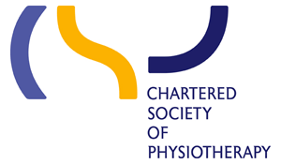
ARC TRAINLINE BOOKING GUIDE

The CSP is pleased to be working in partnership with Trainline to offer you a dedicated facility to purchase your rail tickets for ARC 2019. The key benefit to members is the ability to book online and have your travel costs directly billed to the CSP. The CSP benefits by achieving lower cost rail travel, as members have access to and select the cheapest fares so we strongly recommend that this is the only method of booking rail travel. Please be aware this facility is only available via the members’ website and NOT from the trainline.com public website. If you are unable to access the Internet, please call 0870 3333 555 quoting CORPREF200 to make your booking.
1. Log into your member’s account on www.csp.org.uk/thetrainline
2. If you have not used the CSP Trainline service before, you must first register as a ‘new user’: click on ‘Sign up to your company account’ below ‘Existing Customers’; then enter your ‘Email Address’ and ‘Business ID’ of CORPREF200 - your email address will be your user name for future visits; then click ‘Sign up’ and input your personal details; then click ‘Register’.
3. If you are an existing user, you should click on the ‘The Trainline CSP corporate log in page’ at the bottom of the page and enter your travel details*.
*The CSP expenses policy states that members should select cheapest available ticket selected and that First Class travel is not permitted. Please check single fare options and avoid expensive open returns.
4. NB: You need to add the information shown below on the “Before you continue” page.

Meeting Code: ANNRC030619
Account Code: 10-12-411-140
Reason for travel: ARC 2019

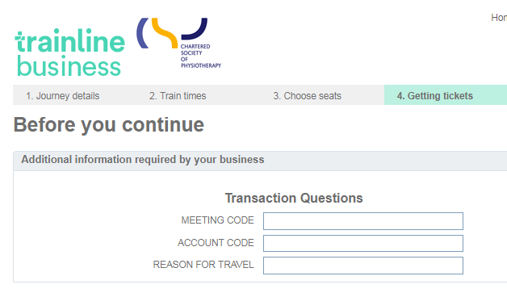
5. Click on “Continue” to check your ticket details then click on “Buy Tickets” and the booking will be charged to the CSP account but tickets will be sent to you.

If you have difficulties using the website, due to disability issues, the following alternatives are offered:
- Contact the Trainline call centre on 0870 3333 555 quoting CORPREF200;
- Ask CSP Finance Staff to process the booking by calling 020 7306 6647;
- Buy your own rail tickets and claim back the cost from the CSP using the CSP Members’ Expense Claim Form.

