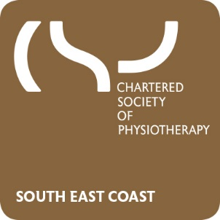
The CSP South East Coast ERN
Presents….

Dinner with CSP CEO Karen Middleton
Featuring a presentation, Q&A session and three course meal

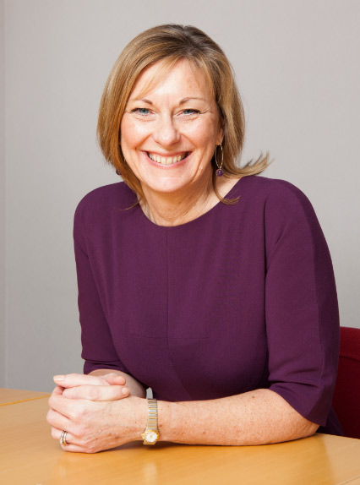

Thursday 12 July from 6pm – 10:30pm
Holiday Inn London-Gatwick Airport, Povey Cross Road, Horley, Surrey, RH6 0BA
Open to all CSP members in the South East Coast region to attend (full, associate, retired or student)
Cost per ticket: £15
To register your place email cre@csp.org.uk quoting South East Coast and your CSP membership number.

