Direct Access Physiotherapy
Dear Candidate
As a candidate in the forthcoming Assembly election, I am writing to you on behalf of the Chartered Society of Physiotherapy regarding the decision by the Health & Social Care Board not to proceed with direct access to physiotherapy in Northern Ireland. This decision is contrary to the redesign and transformation of health care services agenda and the most up to date research evidence. This decision, if implemented will result in poorer care for patients.
Direct access is a system of access that facilitates patients with a musculoskeletal condition to refer themselves directly to a physiotherapist without seeing a GP first. The known benefits include,
To Patients:
- Access to expert musculoskeletal (MSK) assessment, diagnosis and treatment
- Prevention of short term problem becoming a long term condition
- Improved patient experience
- A shorter and more streamlined pathway
- Opportunity to gain lifestyle/physical activity advice
- Quicker support to aid patients’ return to work.

To GPs:
- Freed up time through reallocating appointments for patients with MSK problems
- Reduced prescription costs
- Freed up administration time

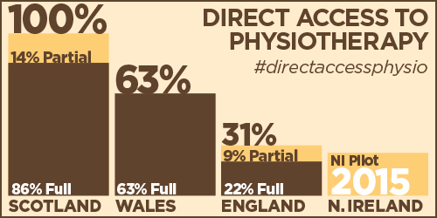
An evaluation of the direct access physiotherapy pilot, which has been operating in the South Eastern Trust since June 2015 demonstrated high levels of service user satisfaction, patient empowerment and better clinical outcomes. In addition, given the current crisis facing general practice in Northern Ireland direct access physiotherapy has the potential to significantly free up GP time and reduce waiting lists.
This decision by the Health & Social Care Board has been taken in the absence of a functioning Executive. The CSP believes that this is the wrong decision at the wrong time and is in stark opposition to the transformation of services required to meet the needs of patients in the future.
Please can you demonstrate your support for this decision to be reversed as a matter of urgency so patients in Northern Ireland can access the right services at the right time in the right location.
You can do this directly by tweeting a message of support and using the hashtag #directaccessphysio. The CSP will then retweet your message.
Thank you in anticipation for your support.
Regards
Tom Sullivan

