**Header**

**Job Description**

**Job Details**

|  |  |
| --- | --- |
| Job Title: | Community Physiotherapist |
| Band: | 6 |
| Ward / Department: | NN1 (Fakenham/Wells/holt/Sheringham core team) |
| Directorate / Locality: | CN&T /North Locality |
| Essential Qualifications: | Diploma or 1st level degree in Physiotherapy  Current HPC registration  Clinical Educators course |

**Job Purpose**

To deliver high quality Physiotherapeutic interventions and health care to patients within a variety of community settings, which may include in-reaching on to community in-patient units as needed. To provide proactive, holistic case management and rehabilitation whilst working with patients to help them set realistic goals. Utilising health coaching skills to effectively engage with the patient and their family to ensure that expectations are appropriately managed.

**As part of transformation, you will be required to:**

* Engage with mobile working
* Engage with SystmOne optimisation
* Engage with referral to discharge process
* To be aware of the demand and capacity model which will reflect workload needs at any given time.

**Key Areas of responsibility:**

* To assess and prescribe care programmes for patients with, but not exclusive to, long term conditions, the frail and elderly, palliative care and rehabilitation needs, to achieve quality of life and independence where possible
* To work within the integrated team to facilitate early discharge from hospital
* To work within the integrated team to prevent unnecessary admission to hospital
* To work with all health care professionals, and statutory and non-statutory agencies to provide a seamless integrated service to our service users

**Organisational Arrangements**

|  |  |
| --- | --- |
| Accountable To: | Clinical Lead |
| Reports To: | Clinical Lead/Clinical Operations Manager |
| Responsible For: | Supervision of band 5 physiotherapists, band 4 Community Assistant Practitioners and band 3 Therapy Assistants |

**Structure Chart**

**Main Duties & Responsibilities**

**Professional/Clinical Responsibilities**

* To be wholly accountable for own professional practice as determined by the Health Care Professions Council code of conduct. Take every reasonable opportunity to sustain and improve own knowledge and professional competence. To continue any development highlighted through the appraisal process and attend mandatory and specific training sessions.
* Undertake comprehensive, holistic physiotherapy assessments of patients (including those with a complex presentation) using investigative, analytical and clinical reasoning skills to form a differential diagnosis.
* Plan and assess programmes of care with realistic physiotherapeutic goals with the consultation of the patient, family, multidisciplinary team and other agencies.
* To ensure that informed consent is obtained prior to initiating all interventions and to be respectful of patient needs with regard to privacy, dignity and courtesy.
* Provide information and education to enable patients to make choices regarding a healthier lifestyle, as appropriate.
* Where there are barriers to understanding, such as hearing impairments, mental capacity impairments and other difficulties in comprehension, consider alternative methods to facilitate understanding, consent and concordance.
* Promote effective communication within the multi-disciplinary team, with GPs, Social Services and other outside agencies, including Voluntary services and to work collaboratively with these services, as appropriate..
* Recommend innovative changes in clinical practice to enhance patient care.
* Demonstrate an understanding of Assistive Technology and make referrals for this as required.
* To participate in multi-disciplinary meetings/multi-agency meetings eg Gold Standard Framework meetings; as well as attending and contributing to team meetings.
* To participate in audit processes and to action outcomes.
* Be responsible for ensuring workload for self and others is planned and prioritised according to service needs and targets, and to participate in the central triage roster and allocation of patients.
* Inform Line Manager/Clinical Lead of circumstances which may affect safe and competent practice.

**Management and Leadership**

* To provide clinical supervision to other team members and participate in meetings for own clinical supervision as per Trust policy
* Comment on draft policies
* To assist with the induction of new staff and students and act as Clinical Educator where appropriate
* Act as a role model giving guidance and support to other staff and students.
* Support all team members within the team, respecting them, their roles and contributions.
* To be responsible for the safe use of equipment and supplies.
* To make own travel arrangements to patients’ home, base, meetings and training as required.
* Ensure effective and efficient use of all team/ward resources
* Provide leadership to all members of the team, promoting effective team work
* Be aware of the budget and ensure all efforts are made to work within this.
* Contribute to the requisitioning of supplies and equipment via the electronic ordering systems used within the teams
* Be accountable for work delegated to others
* Participate in problem solving related to work organisation
* Maintain a positive approach to achievement within the team
* Undertake personal development plans for more junior members of staff
* Ensure absence reporting is undertaken as determined by Line Manager and Trust Policy

**Information Management**

* Ensure clinical records are kept confidential as per Trust policy and that computer security is followed
* Ensure Information Governance training is updated annually
* Ensure all information is shared on need to know basis only and report any breaches appropriately to Line Manager
* Ensure that all patient care is documented accurately, legibly and that information systems are maintained in a timely manner

**Education and Professional Development**

* Ensure all Mandatory Training is up to date
* Maintain own continuous professional development
* Remain accountable for own professional actions in line with professional bodies guidelines
* Provide mentorship for students undertaking pre/post registration courses
* Mentor existing staff and provide training in specialist area, as appropriate
* Demonstrate own duties to students, new staff and/or less experienced staff as required
* Participate in personal development review process

**•**

**Risk and Governance Management**

* Be required to undertake risk assessments and act upon them appropriately
* Report all incidents and risks in line with Trust policies

**Trust Values**

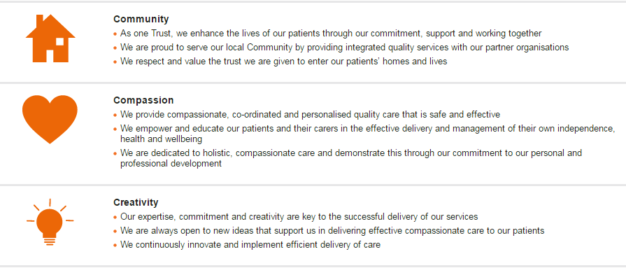

**Trust Behaviour Framework**

* All post holders are required to adhere to the Trust’s Behaviour Framework in the undertaking of their duties.

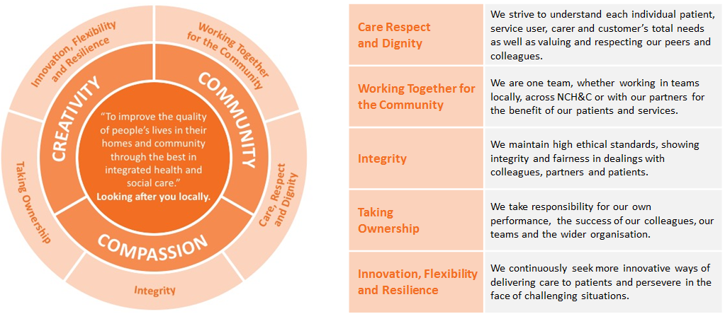

**Research & Development**)

* May be required to undertake surveys or audits, as necessary to own work; may occasionally participate in R&D, clinical trials or equipment testing.

**Safeguarding Clause**

* Norfolk Community Health and Care NHS Trust is committed to safeguarding and promoting the welfare of children, young people and vulnerable adults, and expects all staff and volunteers to share this commitment. Rigorous recruitment checks are carried out and where applicable to the role successful applicants will be required to undertake a criminal records check via the Disclosure and Barring Service (DBS).

**Infection Control**

* Norfolk Community Health and Care NHS Trust staff are responsible for protecting themselves and others against infection risks. All staff regardless of whether clinical or not are expected to comply with current infection control policies and procedures and to report any problems with regard to this to their managers. All staff undertaking patient care activities must attend infection control training and updates as required by Norfolk Community Health and Care NHS Trust.

**Health and Safety**

* Employees must be aware of the responsibilities placed upon them under the Health and Safety at Work Act (1974), to ensure the agreed safety procedures are carried out to maintain a safe environment for employees and visitors.
* To ensure that the Trust’s Health and Safety Policies are understood and observed and that procedures are followed.
* To ensure the appropriate use of equipment and facilities and the environment is maintained in good order.
* To take the necessary precautions to safeguard the welfare and safety of themselves, patients, staff and visitors, in accordance with the Health and Safety at Work Act.
* To undertake appropriate Health and Safety training to support safe working practice including, where appropriate, its management.

**General**

* All staff are required to respect confidentiality of all matters that they learn as a result of the employment with the Trust, including matters relating to other members of the staff and members of the public/patients.
* Maintain appropriate patient and clinical records in line with the Trusts policies and procedures, and in line with the agreed service specification.
* The post holder will be expected to participate in an annual appraisal of their work where the job description will be reviewed and objectives set. In line with the annual personal development plan the post holder will be expected to undertake any training or development required to fulfil their role.
* Ensure that all patients, clients and colleagues are treated at all times in an equitable manner, respecting diversity and showing an understanding of diversity in the workplace.
* The post holder must carry out their responsibilities with due regard to the Trust’s Equality and Diversity Policies, Procedures and Schemes and must ensure that equality is promoted at all times.

This job description is not exhaustive and may be amended from time to time in consultation with the post holder. The post holder will be required to undertake any other duties as may be required for the effective performance of the post.

**Person Specification**

**Essential** defines the minimum criteria needed to carry out the job and the job cannot be done without these.

**Desirable** refers to criteria which are not essential and which successful applicants would be expected to acquire during their time in post. The desirable requirements are not taken in to consideration in a job evaluation panel.

|  |  |  |  |
| --- | --- | --- | --- |
| **Criteria** | **Essential** | **Desirable** | **Method of Assessment**  (Certificates / Application Form / Interview / References / Document Check) |
| Qualifications | * Diploma or 1st level degree in Physiotherapy * Current HCPC registration | * Clinical Educators course or equivalent | Certificates, academic records |
| Experience | * Evidence of working at band 5 level across a variety of settings and specialities such as Orthopaedics, Neurology, Care of the Elderly, musculo-skeletal in acute and community settings * Experience of undertaking falls assessments and gait analysis * Experience of working with multidisciplinary teams and partner organisations * Experience of working with patients with multiple pathologies and managing holistic patient centred care |  | Application form, interview,  References,  Certificates |
| Skills, Abilities and Knowledge | * Ability to organise and prioritise workload independently; within a team and within wider integrated team * Knowledge of safeguarding issues relating to the care of adults and older people * Ability to work on own initiative * Good computer skills and ability to work on information management systems * Evidence of attendance on short courses and/or in house training related to physiotherapy post-registration | * Relevant safeguarding training * Working knowledge of SystmOne * Experience of audit/research | Interview; application form; certificates; references |
| Communication | * Excellent verbal, written and interpersonal skills appropriate to supporting other team members essential for quality MDT working |  | Interview/reference |
| Personal and People Development | * Evidence of own personal development and experience * Ability to support the development of others through supervision and teaching * Supporting patients in self-management through health coaching | * Clinical Educators qualification will be essential but can be gained whilst in post * Health Coaching training | Certificate; interviews |
| Personal Attributes / Behaviours  (linked to the Trust’s Behaviour Framework) | * Able to identify with the Trust’s commitment to safeguarding and promoting the welfare of children and young people/vulnerable adults. * Value and respect the privacy and dignity of patients * Able to work collaboratively as part of a team * Enthusiastic and able to work under pressure * Flexible/positive approach to work to meet the needs of the service |  | **I**nterview |
| Other | * The post holder will be required to work standard hours Monday – Friday between the hours of 9 am and 5 pm, but may need to be flexible in extenuating circumstances when there may need to be flexible with working hours * The post holder will need to be passed as fit to perform full duties of the post through Occupational Health, with any reasonable aids and adaptations if necessary * Must hold full and valid and driving licence and have access to a vehicle (if applicable) * Able to communicate effectively in written and verbal English Language |  | Interview; documentation check |

Post Holder’s Signature ………………………………………..

Manager’s Signature ………………………………………..

Date Job Description Agreed ………………………………………..

**DISTRIBUTION:** One copy to member of staff, one copy to personal file.

**Please ensure Job Description is agreed and signed by both manager and employee**