Hours: Part-time, 23 hours per week with potential to increase.
Department: Therapy Department
Reports to: Clinical Lead
Accountable to: Clinical Lead and Merlin MS Centre Manager

Job Role
To provide a high-quality physiotherapy service to clients at the Merlin MS Centre with a range of neurological, musculoskeletal (MSK), and neurodevelopmental conditions. Working within the clinical team, supporting the effective delivery of clinical services with the opportunity to contribute to ongoing service development.

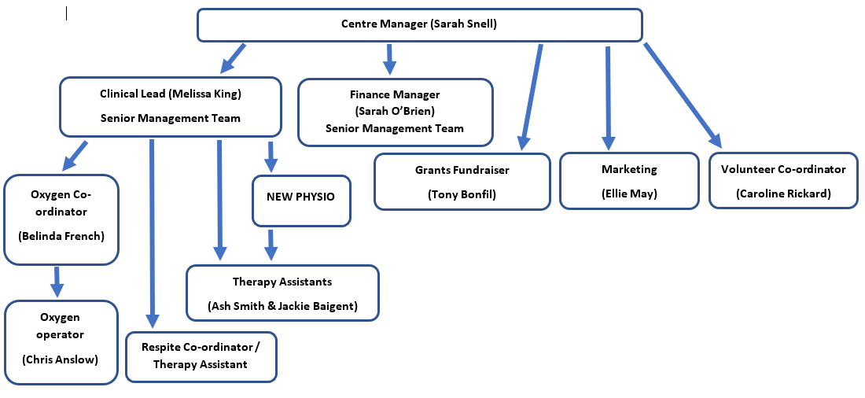
Organisational Chart
Summary
Our therapy department, which focuses on treating individuals with long term conditions, is recruiting for a part time physiotherapist. We are looking for a compassionate, hardworking therapist with experience of working in both neurological and MSK settings to join our team, delivering therapy both in our therapy gym and hydrotherapy pool. You will be required to perform physiotherapeutic assessment of patients with diverse and complex conditions, to provide a physiotherapy diagnosis and to develop and deliver a patient focused treatment programme. You will be responsible for your own caseload working with and without direct supervision. All aspects of clinical duties will be undertaken as an autonomous practitioner. Access to advice and support and clinical supervision from senior colleagues is available when required. Opportunities for training in sensory integration and neurodevelopmental therapies will be provided by the Merlin MS Centre for suitable applicants. Time and opportunities for continuing professional development (CPD) will be encouraged to support the physiotherapist in maintaining their own CPD.
Physiotherapist qualifications and skills
Role requirement | Essential | Desirable

Education / Qualifications / relevant experience
Current professional registration (HCPC & CSP) | Y
BSc Hons in Physiotherapy. | Y
At least 3 years professional experience, preferably including rotations within the NHS. | Y
Experience of working in neurology and hydrotherapy. | Y
Experience of providing MSK physiotherapy |  | Y
Experience of working with individuals with neurodevelopmental conditions (training will be provided). |  | Y
Evidence of further formal study e.g., post graduate course / CPD in neurological rehabilitation / relevant courses. | Y
Evidence of participation in research / audit | Y
Evidence of supervision of students |  | Y
Evidence of supervision of physiotherapy assistants |  | Y
Evidence of CPR / first aid and Manual handling training. | Y

Skills and Aptitude
Highly developed clinical assessment, treatment, and evidence of clinical reasoning. | Y
Experience of working with multidisciplinary team members. | Y
Positive attitude to CPD and professional development. | Y

Knowledge and abilities
Ability to motivate, encourage and work collaboratively with physiotherapy assistant staff. | Y
Ability to motivate clients with their treatment and education and appropriately manage their expectations. | Y
To demonstrate application of knowledge to client’s living with complex and life-long conditions | Y
Ability to work autonomously and manage their own caseloads and those of others if required. | Y
To demonstrate awareness of their level of skill, knowledge, and competence, to include appropriate risk assessment and liaison with senior clinicians where necessary. | Y

Personal Qualities
To work well as part of a team, showing leadership when required. | Y
To be empathetic, reassuring, and motivational. | Y
To be punctual and hard-working. | Y
To be an excellent communicator, being able to adapt their communication style for clients, families, support workers and professionals as appropriate. | Y

Other
Own transport |  | Y
Ability to carry out manual handling procedures | Y
DBS clearance | Y
Basic computer skills | Y

