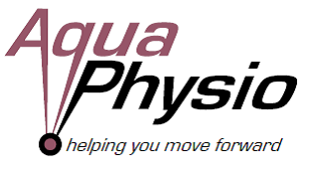
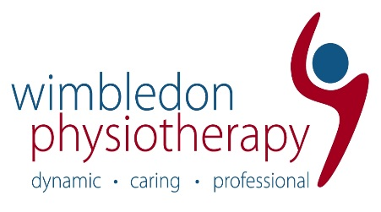

Do you want to specialise in MSK physiotherapy? We are seeking 2 dynamic, highly motivated Musculoskeletal Physiotherapists, who have a positive attitude, a sense of humour and a willingness to learn to join our expanding team.
2 FULL-TIME positions available
About us:
Wimbledon Physio & Sports Injury Clinic is a dynamic, fun, fast-paced clinic providing first-class private physiotherapy services to Wimbledon and the surrounding area. We offer a variety of services including Physiotherapy, Sports Massage, Shockwave Therapy, Muscle stimulation and Aquatic Physiotherapy at our sister site AquaPhysio. The available positions involve working at both centres. We have a well-established team of therapists who prioritise patient progress within a varied caseload. We are a forward-thinking company, with a supportive team atmosphere to work within.
The successful candidates must be able to demonstrate:
- Enthusiasm, ambition and drive
- Proven ability to maintain a flexible and organised approach
- Good communication, IT, organisational and time management skills
- HCPC and CSP registration
- Qualification in sports massage is desirable but not essential
- Previous experience of working in MSK and / or hydrotherapy either as a Band 5 or even just on placement is desirable, but not essential
- Will enjoy learning and being stretched
- The ability to become an integral part of our team.

For the right candidate, we offer:
- A competitive salary
- An extensive in-house CPD program and external course funding
- Annual appraisals and personal development plans
- 5.6 weeks annual leave
- Workplace pension.
We are looking for a newly qualified physiotherapist’s or a few years qualified physiotherapist who wants to specialise in MSK to join our growing team.
Candidates must be prepared to work evenings and/or Saturdays. Please only apply if you have a valid working visa.
Next Step: If this sounds like you, then please send your CV and cover letter recruitment@wimbledonphysio.co.uk
Closing date: 30th June 2021

