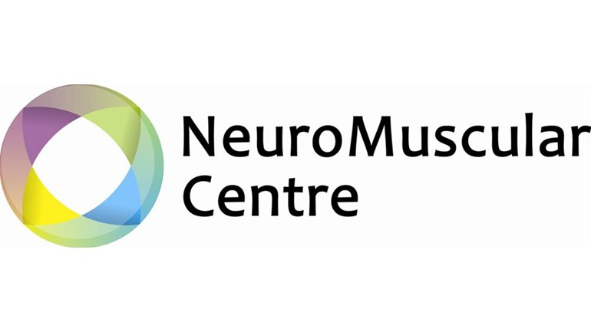
NMC Employment Opportunity
Junior Physiotherapist
36 hours per week
Salary £22,500
Closing Date for applications is 13th Dec 2020

There is a fantastic opportunity for 2 Junior Physiotherapists to join the team at the Neuromuscular Centre in Winsford.
The NMC is a national centre of excellence for adults with neuromuscular conditions from across the UK and abroad. We offer a broad variety of holistic treatments including acupuncture, gym-based exercise, and hydrotherapy. We encourage therapists to explore new therapies to contribute to our offering with the ability to attend courses and conferences.
As a team we will provide you with regular in service training and CPD opportunities, expert tuition and supervision, and regular appraisals. You will be supported closely by Senior Physiotherapists and the other team members. You will also be able to get involved in other areas of the centre such as fundraising and transition and be fully engaged throughout our amazing community.
Working hours are Monday to Friday 9.00am to 4.45pm with 30 minute lunch and evening hydrotherapy sessions.
The application will involve 3 steps. A CV and Cover letter submitted to Bryn Edwards, An interview in front of a small panel, and a trial shift. These will be arranged individually to allow for work and study.
Below you will find a Job Description and Person Specification.
Should you have any more questions contact Bryn Edwards via phone on 01606 861799, or email nmc.physio@nmcentre.com.
To start your application submit a CV and Cover letter to nmc.physio@nmcentre.com or via post to
FAO Bryn Edwards
Neuromuscular Centre
Woodford Lane West
Winsford
CW7 4EH

Closing Date for applications is 13th Dec 2020
Neuromuscular Centre
Job Description

Job Title: Junior Physiotherapist
Full-time permanent contract
Accountable to: Therapies Manager
Responsible for: Therapy Assistants, volunteers and physiotherapy students on clinical placement.
Base: The Neuromuscular Centre, Winsford.
Hours: 36 hours per week
Overtime is not paid but Time Off in Lieu may be given.
Holiday entitlement: 5 weeks pro rata + bank holidays
Pension: A company pension is available after the first six months of employment.
Term: Permanent with review after 6 months

Role Purpose:
- To assess and treat patients attending the Neuromuscular Centre in an effective and caring way, and to provide information and advocacy support to both patients and their carers.
- To be a committed team member in both physiotherapy and the wider Neuromuscular Centre.

Major Tasks / Responsibilities:
1. Clinical
- To work as an autonomous practitioner, to be professionally and legally responsible and accountable for all aspects of own work, including the management of patients in your care.

- To gain consent and undertake a comprehensive assessment of patients referred for physiotherapy. To provide information, advice and support in areas connected with activities of daily living.

- To formulate and implement individual physiotherapy treatment plans, based on a sound knowledge of evidence based practice and treatment options. This includes the treatment of complex patients in a manner that respects people’s choice, privacy, dignity and individuality.

- To accept clinical responsibility for a caseload of patients, and to decide priorities. To organise and manage this efficiently and effectively according to the clinical and other needs of the patients and the service. This will include moderate to intense physical effort throughout the working day.

- To evaluate patient status, re-assess and change treatment programmes when indicated, giving explanations and gaining consent from patients, or carers, where appropriate.

- To maintain accurate, comprehensive and up to date documentation in line with legal, professional and Neuromuscular Centre requirements and to communicate assessment, treatment and review information to the appropriate Healthcare professional in the form of reports and letters.

- To provide spontaneous or planned advice, teaching and instruction to patients, relatives, carers and other professionals including students.

- To ensure effective two-way communication with patients, their relatives and carers and all other Health Professionals, Education and Social Care Professionals regarding all aspects of patient care, respecting confidentiality of the information at all times.

- To ensure risk assessments are carried out during clinical assessments, treatments and therapeutic handling to ensure safe and effective patient care and safe working.

- On occasions, to work as a lone practitioner in patients’ homes, without the support of colleagues, providing appropriate physiotherapy for patients suffering from acute respiratory symptoms.

- Clinical Governance
- To comply with the Health and Safety policies of the Neuromuscular Centre, including the assessment and management of clinical risk within own work area and to attend any mandatory training eg. Manual Handling, Fire Safety, Hydrotherapy Evacuation.

- To work within agreed clinical guidelines, protocols and procedures, and have a good working knowledge of national and local standards, and monitor own and others quality of practice as appropriate.

- To gain informed consent prior to therapeutic interventions.

- To ensure that any equipment, furniture or building in need of repair, is reported to the Therapies Manager or Site Manager as necessary.

- To be responsible for the safe and competent use of all physiotherapy equipment, patient appliances and mobility aids used by patients in your care.

- To comply with the Chartered Society of Physiotherapy Standards and Codes of Professional Conduct.

- To undertake the measurement and evaluation of your work and current practices through the use of evidence based practice projects, audit and outcome measures, either individually or with more experienced physiotherapists.

- To comply with the Data Protection Act and Caldicott recommendations.

- To participate in the in-service training programme.
- To participate in the annual review process, agreeing a performance plan with the Head of Physiotherapy, identifying a personal development plan.

Training and Development

    - To maintain an up to date Continuous Professional Development portfolio, including evidence of experiential learning, reflective practice and any relevant training or experience. This should demonstrate responsibility for maintaining own competency to practice (in accordance with HCPC).

    - To give specialist advice, teaching and training to patients, carers and other healthcare professionals to ensure provision of good patient care.

    - To maintain and develop current knowledge of evidence based practice, developing specialist knowledge of particular conditions and patient type.

    - To contribute to the training and assessment of Physiotherapy Assistants and volunteers, as appropriate.

    - To assist in the training and supervision of undergraduate Physiotherapy students on clinical placement, with the possibility of progressing into the role of Clinical Educator, following attendance on the appropriate training course.

Organisational and Leadership

  - To be responsible for organising and planning own caseload to meet service and patient priorities in an unpredictable environment.

  - To be responsible for the supervision and co-ordination of Physiotherapy Assistants and Students on a daily basis as required by the Head of Physiotherapy.

Working Conditions and other Factors

- Possible contact with blood, sputum or saliva.

- Daily contact with patients with long term disability, progressive conditions and a long term patient – therapist relationship.

- Many times each day to carry out manual physiotherapy treatments often involving bending, static postures, cramped conditions and support of patients or their limbs. To give physical support to patients while sitting, standing, walking or transferring.

- Regularly throughout the day to use hoisting equipment, push or manoeuvre wheelchairs, furniture and equipment. To position highly dependant patients.

- Health & Safety
- To ensure that they comply with all relevant statutory Health & Safety requirements to satisfy the Centre’s Health & Safety and risk management strategic framework.

Person Specification
Job title: Junior Physiotherapist

FACTOR | ESSENTIAL | DESIRABLE
Qualifications & Education | Degree in physiotherapy  Registered to practice as a Physiotherapist with HCPC  IT skills | Member of the CSP  Previous experience of working with Neuromuscular patients
Knowledge & Experience | Working with the general public  Broad range of student placements  Previous work experience  Knowledge of current best practice & evidence based practice.  Knowledge of Clinical Governance, including Health & Safety issues | Experience of team work  Previous experience of treating patients with Muscular Dystrophy  Experience outside of NHS settings
Skills & aptitudes | Able to undertake physiotherapy assessment  Able to use clinical reasoning to diagnose and formulate treatment plans  Able to maintain strict confidentiality regarding patient information  Able to present information, answer questions and teach exercises.  Able to manage own time.  Able to keep accurate and legible patients records.  Ability to prioritise workload.  Able to communicate & relate to other professionals, patients and carers. | Able to present information clearly in a formal setting.  Able to write clear discharge/progress reports.
Personal attributes | Flexible, punctual, reliable & enthusiastic  Self-motivated & confident  Capable of managing own workload without direct supervision  Ability to be an effective team member | Current driving licence + access to a vehicle  Comfortable with face to face interactions with service users

