ST RICHARD’S HOSPICE
JOB DESCRIPTION

Job Title: Specialist Physiotherapist
Responsible to: Therapy Team Leader
Accountable to: Head of Living Well Services
Pay Point: 14-19
Hours: 37.5 hours per week

Our Values:

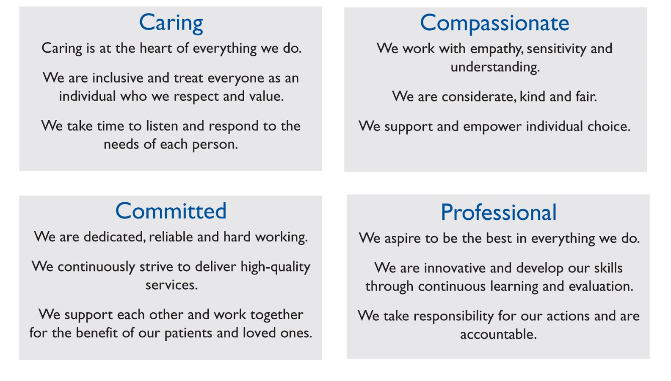
Job Summary:
- To work as part of St Richard’s Hospice specialist multi-disciplinary palliative care team, contributing to the effective provision of rehabilitation and therapy services, in Living Well Services, In-patient Unit and the community.
- To undertake holistic Physiotherapy assessment and treatment of palliative care patients as an autonomous practitioner, with support from colleagues, for patients with complex needs.
- To work within quality standards of St Richard’s Hospice.

Main Duties and Responsibilities:
Clinical
With the support of the other physiotherapists and and the Therapy Team, the post-holder will:-
- Undertake comprehensive Physiotherapy assessment and implementation of therapy intervention for patients with progressive and life threatening diseases. This includes using analytical skills, clinical reasoning and the use of appropriate outcome measures as required.
- Tailor holistic therapy assessment and treatment, with attention to patients’ multi-faceted individual needs and preferences spanning physical, emotional, social and spiritual dimensions.
- Continually assess the on-going Physiotherapy needs of the patient, adapting therapy input in response to changing needs.
- Identify patients with complex clinical needs and draw on support from the Multidisciplinary team to ensure these are best managed.
- Be responsible for managing a case load of patients across In-patient and Living Well Services in close liaison with the Therapy Team leader and other Physiotherapists.
- Work with patients to develop their mobility, independence and autonomy with functional activities as part of their rehabilitation goal, involving patient, carer, therapy volunteers and other team members in the treatment plan.
- With support of other members of the multi-disciplinary team, undertake group work to enhance the function of patients.
- Provide advice, education and support to patients and carers to self-manage symptoms such as fatigue, breathlessness and other symptoms relating to their condition.
- Provide advice, education and training to patient, carer and therapy volunteers regarding safe use of recommended aids to promote independence in ADLs and as part of rehabilitation programme.
- Liaise with community Physiotherapy colleagues and other health services to promote a cohesive service to patients.
- Work with Physiotherapy colleagues to be a source of expertise, providing advice on managing patients’ functional ability and moving and handling needs.
- Work with patients, families and other members in guiding safe and timely discharge planning as appropriate.
- Provide spontaneous and planned advice, teaching and instruction to relatives, carers and other professionals in order to promote safe moving and handling and to maximise rehabilitation potential, ensuring a consistent approach to patient care.
- Participate in multi-disciplinary team, professional and family meetings and offer specialist input and advice and advocate for patients when appropriate.
- Support the rehabilitation agenda across Living Well Services and the In-patient Unit.

Communication
- To use effective communication with patients and carers/families in emotionally charged situations, using tact and empathy to communicate difficult and challenging information.
- To be responsible for and proactively initiate effective communication with other members of the Therapies team.
- Encourage client participation in therapy by using negotiation, reassurance and support.
- Communicate effectively with carers, external agencies and other statutory and voluntary organisations to ensure effective care, continuity and discharge.
- Participate fully in the multi-disciplinary approach to rehabilitation and discharge planning, attending team meetings, case meetings and family meetings.

Administration/Management
- To take responsibility for planning own caseload to meet service and patient priorities and to adjust plans in response to changing circumstances.
- Maintain accurate and up to date documentation for all patients, consistent with St Richard’s Hospice documentation, Chartered Society of Physiotherapy and Health Care Professionals Council standards.
- Actively contribute to the achievement of the Physiotherapy and Therapies strategic plan, working with the therapy team and line manager to identify opportunities for service development.
- Assist in the direction and guidance of the Therapy Assistant(s) and volunteers.

General
- Be responsible for the safe use of equipment used in the course of duties and report any hazards or defects to the line manager.
- Attend and contribute to team, multi-disciplinary and external meetings as required.
- Undertake and keep updated with mandatory training as required.
- Take responsibility to access clinical supervision and other professional development opportunities
- Abide by St Richard’s Hospice policies and procedures, including confidentiality, equal opportunities and data protection.
- Take responsibility for own continued professional development and undertake annual Individual Performance Review with line manager, responding to agreed action plan

This job description is not exhaustive and may be reviewed on agreement of the post holder and Line Manager.
Signed……………………………………………………Date………………………………..

