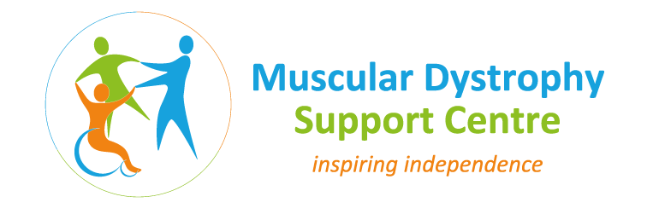
Registered Charity Name and number Neuro Muscular Centre Midlands (NMC Midlands) - 1148855

JOB DESCRIPTION
Job title: Physiotherapist
Accountable to: Lead Physiotherapist
Place: MD Support Centre, based at Hereward College, Tile Hill, Coventry, CV4 9SW
Hours: 14+ hours per week part-time or full-time with flexible arrangements and
potential increase in future if part-time
Term: On-going, employed or self-employed basis
Main purpose of post:
To provide service-users with neuromuscular conditions with a physiotherapy service appropriate to individual needs.
To assist service users to achieve their maximum functional independence.
Responsibilities:
- Act independently to assess, plan, implement, evaluate, treat and progress service user care to maximise their potential.
- Communicate and make recommendations to other physical therapists and support services provided at the Centre to maximise service user care and to promote Multidisciplinary team work.
- Maintain accurate, comprehensive and up to date documentation, in line with legal, professional and departmental requirement.
- To ensure effective internal and external communication with service users, carers and all other Health care professionals regarding aspects of patient care ensuring the service users’ safety.
- Carry out service user’s manual handling and mobility assessment and risk assessment.
- Be responsible for developing and maintaining skills and knowledge to competently perform own role through research and training as identified during the appraisal process.
- Comply with college policies and procedures.
- Carry out any other reasonable duties requested by Lead Physiotherapist/supervisors.

PERSON SPECIFICATION
JOB TITLE: Physiotherapist
FACTOR | ESSENTIAL | DESIRABLE
Qualifications & Education | - Member of the CSP  - Diploma/Degree in Physiotherapy.  - Registered to practice as a Physiotherapist with HCPC  - Basic IT skills | - Post graduate professional Diploma or equivalent in a related subject preferred
Experience |  | - 3 years post graduate experience.  - 2 years experience in neuromuscular or neurological physiotherapy.
Skills & aptitudes | - Ability to deal with difficult situations, requiring developed communication skills to a variety of individuals.  - Problem solving skills.  - Well developed presentation skills.  - Able to write clear reports, plans and papers.  - Up to date clinical management skills in order to assess, formulate treatment plans and deliver care packages.  - Good time management skills.
Knowledge | - Knowledge of or access to current Best Practice and evidence based care for the conditions managed by the Neuromuscular Physiotherapy Service.  - Knowledge of Health & Safety legislation and risk assessment.
Personal Attributes | - To have maintained an up to date Continuous Professional Development Portfolio in line with HPC Guidelines.  - To have a good understanding of the Professional Codes of Practice and legislation around maintaining confidential records.

