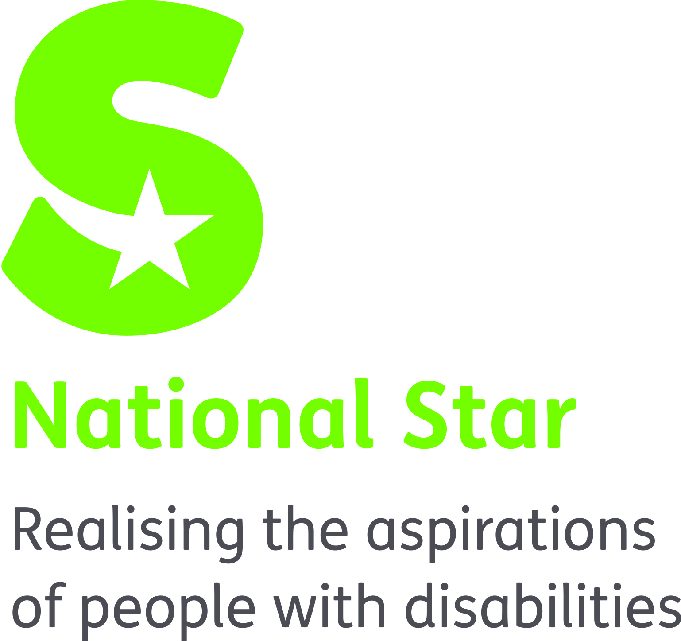

JOB DESCRIPTION

Junior Physiotherapist

ORGANISATION RESPONSIBILITIES:

Reports to: Senior Physiotherapist

Liaises with: Students/parents/carers
Residential and Educational staff
College Therapy and Medical Teams
External Agencies

Supervises: Therapy Assistants

MAIN PURPOSE OF JOB:

To work as an integral member of the Physiotherapy team, delivering high quality therapy and contributing to positive outcomes for learners.

PRIMARY TASKS:

- To assess, plan, implement and evaluate physiotherapy programmes to ensure students’ ongoing health and wellbeing and promote students learning. Ensuring interventions are safe, effective and meeting individual’s needs.
- To work as part of a multi-disciplinary team to meet the needs and improve the outcomes of students with varied physical and learning difficulties.
- To be responsible for the ongoing management of your own caseload and quality assuring practice.
- To keep accurate and timely records in accordance with organisational and professional legislation, protocols and guidelines.
- To comply with all National Star policies and procedures and professional codes of practice as defined by the Chartered Society of Physiotherapy (CSP).
- To undertake relevant training to maintain and develop best practice and meet professional registration and student needs.
- To contribute to training, coaching and mentoring of staff in developing best working practices across National Star and meet organisational goals.
- To communicate information in an understandable format for students, their carers, members of the multi-disciplinary team and outside agencies.
- To create, maintain and enhance productive working relationships with: students, the multi-disciplinary team, internal and external agencies, voluntary organisations and families and carers.
- To work with students, carers and members of the multi-disciplinary team to integrate therapy programmes into learning or other activities wherever possible. To undertake other duties that may be within the scope of the role function.

Safeguarding
National Star takes seriously its responsibility for safeguarding and is committed to safeguarding and promoting the welfare of adults at risk and children. Therefore we require that all staff share this and act accordingly by applying organisation policy and procedure and attending annual safeguarding training.

Equality & Diversity
Through personal example and clear action demonstrate commitment to equality and diversity ensuring equality of access and treatment in employment and service delivery to all.

Health & Safety
Promote National Star’s Health and Safety at Work Policy and Procedure and ensure these are implemented effectively within the department.

This job description sets out a summary of key features of the role. It is not intended to be exhaustive and will be reviewed periodically to ensure it remains appropriate to the role.

NATIONAL STAR
PHYSIOTHERAPIST
ATTRIBUTES | ESSENTIAL | DESIRABLE
QUALIFICATIONS AND REGISTRATION | - BSc Physiotherapy,  - HCPC Registered  - Member of CSP
EXPERIENCE | - Effective Management of own work load/client group  - Day to day delivery of a therapy service  - Keeping written and electronic records of therapeutic interventions | - Post registration specialist experience in appropriate spheres of practice:  - Paediatrics  - Respiratory  - Rehabilitation  - Neurology  - Special needs  - Post-qualification experience in a range of clinical areas  - Support and guidance to physiotherapy assistants  - Application of supervision processes  - Involvement in service development  - Familiarity with residential and/or educational settings  - Training staff  - Working with young adults with complex physical and learning difficulties  - MDT working
KNOWELDGE & SKILLS | - Ability to autonomously assess, plan, implement and evaluate therapy programmes  - Ability to manage diverse, complex therapeutic interventions to meet the needs of clients with complex physical and learning difficulties  - Ability to prioritise work load  - Ability to be proactive and creative as a practitioner  - IT literate, able to use Microsoft Excel, Outlook, PowerPoint and Word | - Specialist knowledge and skills in topics related to scope of practice  - Knowledge of Quality Assurance systems and processes  - Competencies in:  - Moving and Handling  - Risk Assessment  - Use of IT equipment  - Organising and Developing Group Therapies  - Lateral Thinking  - Motivation Techniques
PERSONAL | - Good team player  - Excellent communication skills (verbal and written)  - Punctual, reliable and organised  - Positive and proactive  - Practical an creative problem solver  - Flexible and adaptable  - Able to work under pressure  - Physically fit to meet the requirements of the role.  - Commitment to Equality & Diversity Support the ethos of the organisation & be suitable to work with adults at risk and children.
OTHER | - Able to meet the travel requirements of the post

