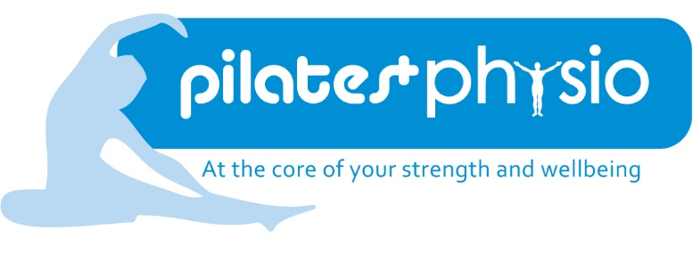

MSK Physiotherapist and Pilates Specialist- Profile

Post: MSK Physiotherapist
Salary: Negotiable
Hours: 30 per week (negotiable hours and working days, must include one evening)
Accountable to: Pilates Plus Physio Partners
Base: Mainly (but not exclusively) Physio Plus, 12a Howe Street, Edinburgh, EH3 6TD
Contact: laura@pilatesplusphysio.co.uk
Closing Date: 17th June 2019

Job Summary

- To work as an autonomous practitioner in providing musculoskeletal physiotherapy and 1:1 Pilates assessments and treatments, and report to self- paying patients and insurance companies.
- To participate in CPD and other developmental activities for both Physio Plus and Pilates Plus
- To assist in the management, recruitment and training of other physiotherapists, Pilates instructors and non-clinical staff
- Assist with the day-to-day smooth running of the business including answering general enquiries regarding Pilates class booking and Physiotherapy appointment scheduling
- Assist with general development of Pilates Plus Physio
- Teach Physiotherapy led Pilates classes as required (based at a variety of locations)
- Provide cover for Physiotherapy led Pilates classes as required (based at a variety of locations)

Job Requirements

- HCPC Physiotherapist with a minimum of 5 years’ clinical experience and preferably experience as a Band 6 MSK physiotherapist
- CSP member
- Formal Pilates Training
- UK citizen with right to work in UK
- Current driving licence
- Basic IT skills

About Pilates Plus Physio

Pilates Plus Physio is an independent company which was founded in 2010. We run Physiotherapy led fitness classes (Pilates/Yoga/Barre/Nordic Walking) in the city of Edinburgh at a variety of locations. At the time of writing we run around 36 classes weekly in varying locations across Edinburgh. All instructors are physiotherapists.
We also have a small clinic in the New Town of Edinburgh which is where we run a physiotherapy and Pilates service.
We pride ourselves on quality of service- ensuing that both our Pilates and Physiotherapy clients meet their goals. We are a constantly evolving company which focuses on continual improvement of our services.
We have a robust CPD commitment and also have a keen interest in education of both our own team and the wider Pilates and Physiotherapy community.
We consider ourselves to be a highly dynamic company.

Clinical Responsibility

- To provide musculoskeletal physiotherapy input to people with a variety of musculoskeletal conditions.

- To provide comprehensive assessment reports in compliance with CSP standards through TM2 software

- To monitor, evaluate and modify treatment in order to measure progress and ensure effectiveness of intervention.

- To discuss services and treatment options to potential clients.

- To ensure that clients are involved in the planning and prioritisation of their rehabilitation plans.

- To adapt practice for each individual patient, including due regard for cultural, social, and linguistic differences in addition to any disabilities.

- To demonstrate high level of clinical effectiveness by use of evidence based practice.

- To commit to developing skills beyond one’s own professional training.

Staff Management

- To provide supervision, advice and support to physiotherapy and Pilates staff and non-clinical staff

- To maintain excellent relationships between staff.

- Oversee other non-clinical roles as appropriate such as audits and service development as determined by the Partners

- Assist in the recruitment of physiotherapists and Pilates Instructors.

- Induction of new therapists and Pilates Instructors where appropriate.

Teaching, Training and Professional Development

- To assist with the education and training of physiotherapy and Pilates staff as appropriate including leading on specific topics related to this specialist area

- To act as a mentor to others within the service.

- Attend in-house and external courses. Assist in arranging in-house courses/study days

- To participate in the teaching and training of staff and other professionals as agreed.

- To develop a Clinical Professional Development Portfolio and a Personal Development Plan, according to professional standards, that documents the progress of gaining knowledge in areas of clinical expertise required for improving standards for self and service.

Service Development and Improvement

- To have an active role in planning, delivery and evaluation of the current musculoskeletal physiotherapy service.

- To have an active role in the planning, delivery and evaluation of the current Pilates service

- To implement clinical policies and protocols.

- To make recommendations for, and lead service development and improvements.

- To be responsible for ensuring a high level of quality assurance over all clinical services.

- To advise Partners on issues of service delivery

Communication
- To use appropriate methods of communication with patients to maximise rehabilitation potential and their understanding of the condition. Communication skills of persuasion, motivation, explanation and gaining informed consent will be used with a wide variety of patients.

- To provide specialist spontaneous and planned advice, teaching and instruction to patients to promote understanding of the aims of physiotherapy and Pilates to ensure a consistent approach to patient care.

- To work in collaboration with/refer to other health professionals in response to identified patient need.

- To contribute to regular goal planning and ensure that information is shared/ communicated on a frequent basis.

- To have excellent written communication skills in order to provide reports where required to a number of different organisations and professionals.

- To communicate effectively with other members of the team and partners to fully update them on any problems or issues that may be essential for the smooth running of the business.

Professional

- To comply with the Chartered Society of Physiotherapy codes of professional conduct at all times.

- To be responsible for personal continuous professional development by the use of self- education, reflective practise, active participation in the in-service training program and attendance relevant courses as agreed in your appraisal and to maintain a CPD portfolio.

- To further develop the integration of evidence based practise, specialist musculoskeletal treatment techniques, therapeutic handling skills and specialist knowledge of particular conditions.

- To participate in the appraisal system as appraise, and an appraiser and be responsible for fulfilling your own agreed objectives and personal development plan.

Organisational

- To demonstrate effective time management and organisational skills during management of own workload and to be able to adapt to an unpredictable work pattern on a daily basis. This includes making patient’s appointments and liaising with other professionals.

- To ensure timely communication of assessment findings, treatment, outcomes and provision of exercise programmes through relevant software.

- To keep accurate and up-to-date patient records, reports and statistics at all times in line with departmental, professional and legal standards through the use of TM2 software.

- To be responsible for complying with all mandatory training requirements.

- Achieve non-clinical deadlines.

- To work flexibly as required to meet the needs of the musculoskeletal service.

- To individually plan your working week to ensure you meet deadlines for non- clinical responsibilities

This job description is not meant to be exhaustive and reflects only the current and anticipated responsibilities of the post. The successful applicant will be expected to work flexibly in order to meet the overall needs of the position which may include one evening a week.
If you have any questions regarding the job description, please contact Laura on 0131 226 5009 or email laura@pilatesplusphysio.co.uk
Closing date 17th June 2019.

