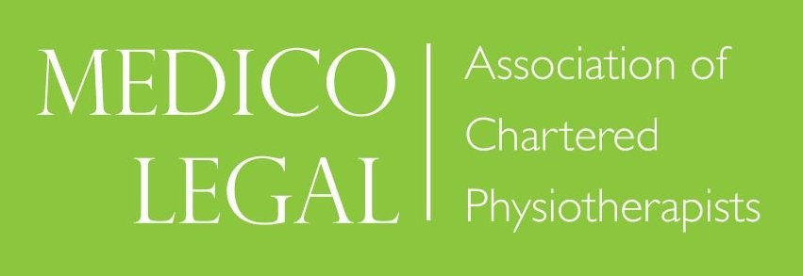

VIRTUAL AGM & WINTER CONFERENCE 2021
PERIPHERAL NERVE INJURIES

Friday 19th November 2021

Course Leaders: Lisa Knight, Will Winterbotham, Sue Paddison

09.30 – 10.00 Welcome / AGM
10.00 – 11.00 Surgical Management of Peripheral Nerve Injuries
Mr Tom Quick, Consultant Peripheral Nerve Surgeon
Royal National Orthopaedic Hospital (RNOH)

11.00 – 11.15 Break

11.15 – 12.15 Pain Management in Peripheral Nerve Injuries
Dr Nofil Mulla, Consultant in Pain Management
Luton and Dunstable University Hospital / Bedfordshire Hospitals NHS Foundation Trust

12.15 – 13.00 Break

13.00 – 13.45 Physiotherapy Management of Peripheral Nerve Injuries of the Upper Limb
Suzanne Oxley, Physiotherapist
13.45 – 14.30 Orthotic Management of Peripheral Nerve Injuries (Upper and Lower Limb)
Jon Turner, Orthotist, London Orthotics Consultancy

14.30 – 14.45 Break

14.45 – 15.30 Medicolegal Case Study (Lower Limb)
Lisa Knight, Physiotherapist
15.30 – 16.00 Questions & Close.

