Posture Management
4 Day Course
^{6 - 9th October 2020}
Details (Please complete a new form for each applicant. Photocopies are acceptable)
Dr, Mr, Mrs, Miss_______ First name ______________________________Surname _______________________________________
Job title _____________________________________________ Department ____________________________________________
Organisation _________________________________________ Address ________________________________________________
______________________________________________________________________________Postcode _____________________
Mobile ______________________Work Tel________________________Fax _____________Email ___________________________

Please specify if you are a vegetarian or have any special dietary requirements ___________________________________________________________________

Any other special requirements_________________________________________________________________________________

___________________________________________________________________________________________________________

___________________________________________________________________________________________________________

Venue:

St Hugh’s Education Centre
Holy Cross Hospital, Hindhead Road, Haslemere. Surrey. GU27 1NQ
Tel: 01428 647649
Fax: 01428 644007

Course Fee:
£410, payment must be received before the course.
The fee includes lunch and refreshments.

Cancellations:
A refund, less a 20% administration fee, will be made if cancellations are received in writing at least four weeks before the course. We regret that any cancellation after this time cannot be refunded, and that refunds for failure to attend the course cannot be made.

Confirmation of booking
All bookings will be confirmed in writing. Please do not book accommodation or travel until email confirmation is received from Holy Cross Hospital

Accommodation
If required, on confirmation of your booking you will receive details of accommodation available around Holy Cross Hospital.

Cheque
A cheque for £ ________________ is enclosed.
Please make cheques payable to: Holy Cross Hospital

BACS
For payments in POUNDS: Please send to the following Natwest Bank

Sort code
60-50-94

10023836
Account no.

Please send your BACS remittance form as confirmation of payment.

Your BACS reference _____________________________________________________________

Invoice
Please send an invoice to __________________________________________________________
_______________________________________________________________________________
_______________________________________________________________________________
Purchase Order No. if available _____________________________________________________
Authorised signatory for contracted place_____________________________________________
PLEASE ENSURE PAYMENT IS CLEARED BEFORE THE COURSE DATES
How to book
Post or email applications to
Joanna Phillips,
Holy Cross Hospital,
Hindhead Road,
Haslemere.
GU27 1NQ

Tel: 01428 643311 ext: 1228 Fax: 01428 644007
E-mail: j.phillips@holycross.org.uk

Map of Holy Cross

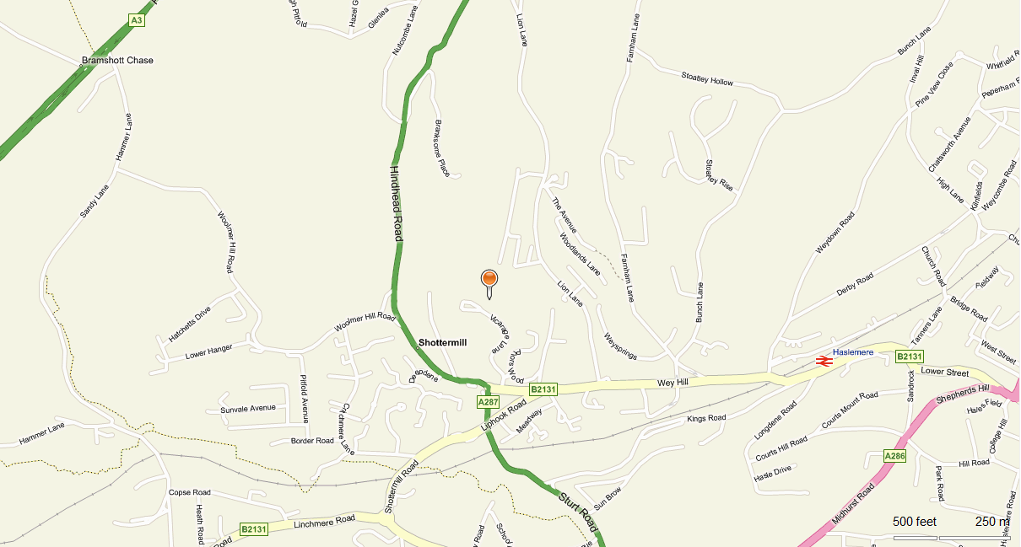
To Hindhead
A3 Hindhead tunnel
TESCO
Station
Holy Cross Hospital GU27 1NQ

By Car
If travelling from London or Portsmouth on the A3, turn off on the A287 at the Hindhead traffic lights, following signposts for Haslemere. Descend a steep and winding hill for approximately 2 miles. The hospital drive entrance is on the left, 100 metres after Church Road , a right hand turn signposted to Midhurst (this is Church Road, Shottermill, it should not to be confused with Church Road in Haslemere town centre).

By Train
Haslemere station is 20 minutes walk and has regular services to Guildford, London and Portsmouth.

By Bus
The following Stagecoach bus routes pass close to the Hospital, all of them also pass the train station:
- No 18 - Aldershot to Haslemere via Bordon
- No 18X - Haslemere to Alton College (college days only)
- No 19 - Aldershot to Haslemere via Churt
- No 70 - Guildford to Midhurst

