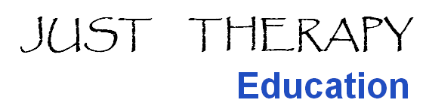

FOUNDATION ACUPUNCTURE COURSE

M-Level Accredited (15 credits) upon application

22/23 January 2022
29/30 January 2022
12 March 2022

Venue: Darent Valley Hospital, Dartford, Kent DA2 8DA

Fee: £500

Tutor: Justine Munur BSc(hons) MSc MCSP MAcS

A five day foundation course for physiotherapists and other health care professionals who wish to integrate acupuncture within their practice.

For further information please refer to the website www.alied.co.uk

For booking or any further information please contact the course tutor via email contact@alied.co.uk

M-Level Foundation Acupuncture

Darent Valley Hospital
22/23 January 2022
29/30 January 2022
12 March 2022

Booking Form

Full name.

Address.

Tel. no.

Email

HCPC number Profession

Payment to be made with application:
Please make cheques payable to Just Therapy Education
For BACS payment please tick here □ and make payment to account number 49473860 and sort code 30 98 97. Please advise by email once payment has been made.

If you require an invoice, please supply the details below

Please ensure that you return the completed health questionnaire with this form and agree to the conditions (separate document attached) by signing below.

Name Signed Date

Send to Justine Munur, 98 Canterbury Avenue, Sidcup, Kent DA15 9AS
Or email to Justine@alied.co.uk

