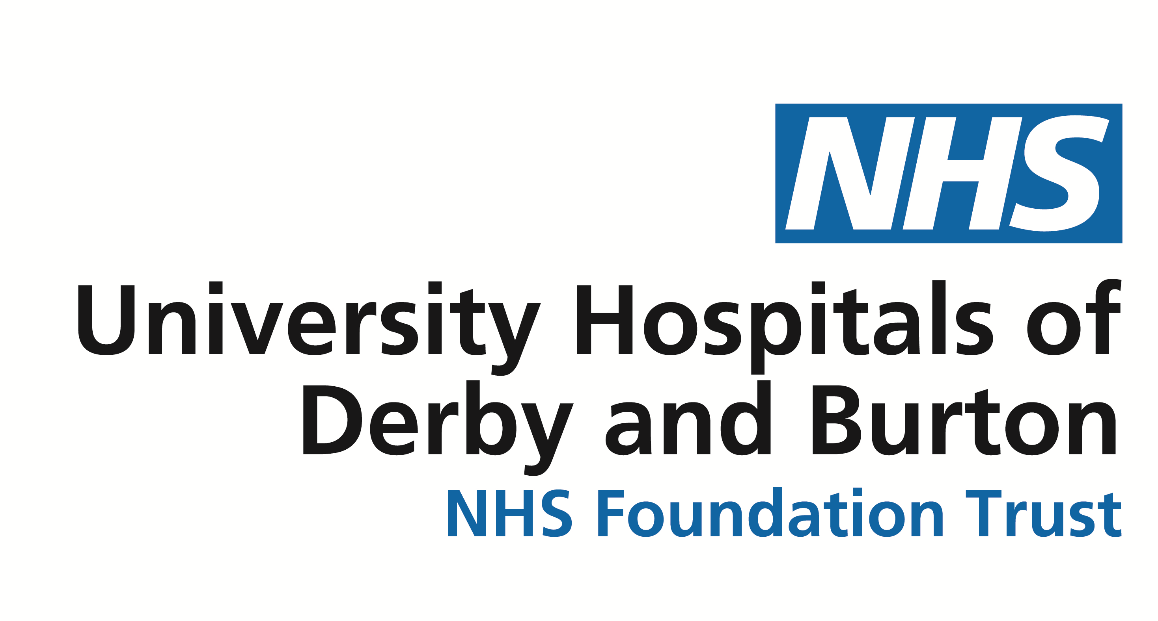
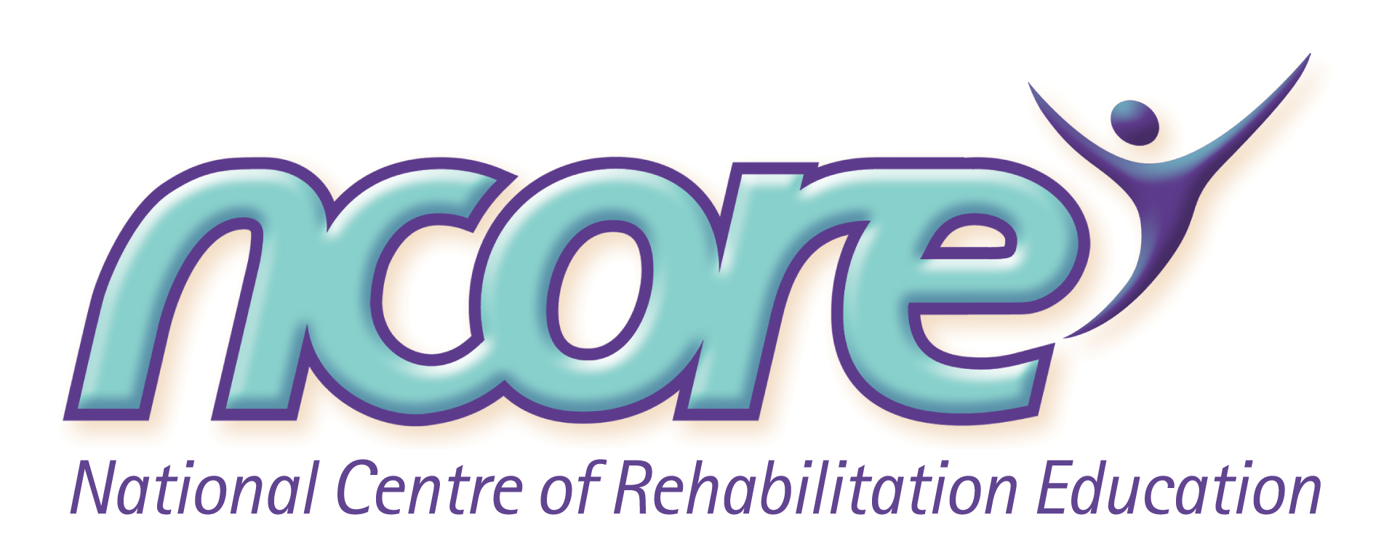
NCORE Booking Form

Event Date Event Ref.

Full Name of Delegate

Job Title and Department

Normal Workplace Address

Post Code

Tel No. Mobile No.

Email Address

Organisation/Trust’s Name
Please advise us of any special access, dietary requirements or support needs for this event

Sector e.g. Acute, Community etc. Profession

Areas of interest e.g. Older People, Rehabilitation etc.

Where did you see this course advertised?

Authorising Manager’s Email

GDPR (General Data Protection Regulation)
- Please confirm your consent for NCORE and third party organisations associated with the management of this event (e.g. relevant course material, pre-reading etc.) to contact you via email. Please tick: YES NO
- Please confirm your consent for NCORE to keep in touch via email with information on new upcoming courses and special offers. Please tick: YES NO

* PLEASE CONTACT NCORE ON 01332 254679 SHOULD YOU HAVE ANY OVERNIGHT ACCOMMODATION QUERIES *

PAYMENT DETAILS * Please quote Event Reference on all correspondence *
 WWF funded place authorised via local workforce lead

 Invoice - we can only invoice if a Purchase Order number is supplied with booking form P.O. No.
If the invoice address is different from that above please supply on a separate sheet.
 BACS transfer: Lloyds Bank, 43 Irongate, Derby DE1 3FT (Please quote Event Reference)
Sort Code 30-92-59 A/C No. 03542470 A/C Name: University Hospitals of Derby and Burton NHS Foundation Trust
 Internal Budget Transfer from UHDB budget code

 Debit or Credit Card Payment (please complete the following)

Visa/Mastercard . Start Date on Card debit card credit card

Name on Card Amount to be deducted £

Security Code (the last three digits on your Card’s signature strip) Expiry Date on Card

Card Number Signed

TERMS OF BOOKING & CANCELLATION: Substitution of delegates may be made at any time, without cost, by writing to the organisers. Cancellations must be received in writing. A refund of the course fee, less a processing charge of £25, will be made if you cancel your reservation SIX weeks prior to the date of the course booked. No refunds can be given after this date and you will be liable for full course fees. Full refunds will be given if the organisers cancel the course but the organisers are not responsible for any costs, other than course fees, which may be incurred by attendees (including travel and accommodation costs). Information concerning your registration will be passed on to the delegate’s employing authority and HEEM in relation to the booking and is also held on the NCORE database under the terms of the Data Protection Act 1998. The purpose for which this information is held is Direct Marketing, Education, Training and Administration. This information is not passed to third parties.

Booking forms to be returned to: NCORE, Room 216, Junction 3, Level 3, London Rd Community Hospital, London Rd, Derby DE1 2QY or Email uhdb.ncore@nhs.net. If receipt of your booking has not been confirmed by email within 14 days, please call the office on 01332 254679

