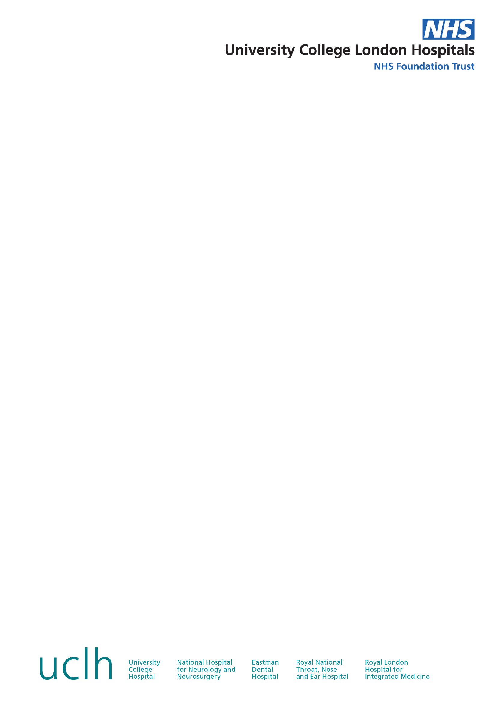

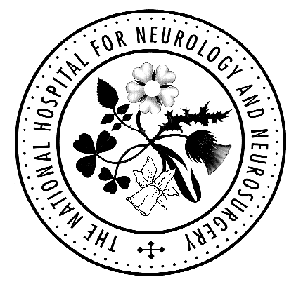
Therapy and Rehabilitation Services

Queen Square Division
Introduction to Neurology – Course for
Rehabilitation Assistants and Support Workers

Saturday 10TH October 2020

The National Hospital for Neurology & Neurosurgery

Queen Square, London WC1N 3BG

Name: ……………………………………………………… |  |  | Professional Title: ……………………………………..
Work Address: ………………………………………………………………………………………………………………..
……………………………………………………………………………………………………………………………………..
Postcode: ……………………………………………
Email: ……………………………………………………………………………………………………………………………
Contact Tel No: ……………………………………
Do you have any special requirements? | Yes/No | If yes, please specify: ……………………………………..

Payment: £95.00 Online Payment
PAY ONLINE ON OUR NEW WEBSITE: http://www.uclhcharitycourses.com
or
Cheque for £90.00 to be sent with application form*, made payable to:
“0529 UCLH Charity Fund”,Acknowledgements and receipts will be sent on confirmation of booking.
or
BACS Payment details: Coutts, 440 Strand, London WC2R 0QS, Account Name: UCLH Charity Fund,
Fund reference: 0529 Education Fund, Sort Code: 18-00-02, Account No: 03505480,

Registered Charity Number: 1165398 (Remittance Advice to address details below)

Return application form and payment to: Alkida Domi, Therapy Services, Box 113,
The National Hospital for Neurology and Neurosurgery, Queen Square, London, WC1N 3BG or by email

(uclh.enquiry.therapy.courses@nhs.net ph: 020 3448 3476, fax: 020 3448 3711)
*Places will not be confirmed until an application form and payment have been received

PLEASE NOTE: | Cancellations are unlikely to be refunded except in exceptional circumstances, when a handling fee of 10% will be deducted. However, it is possible to send an alternative course participant.

