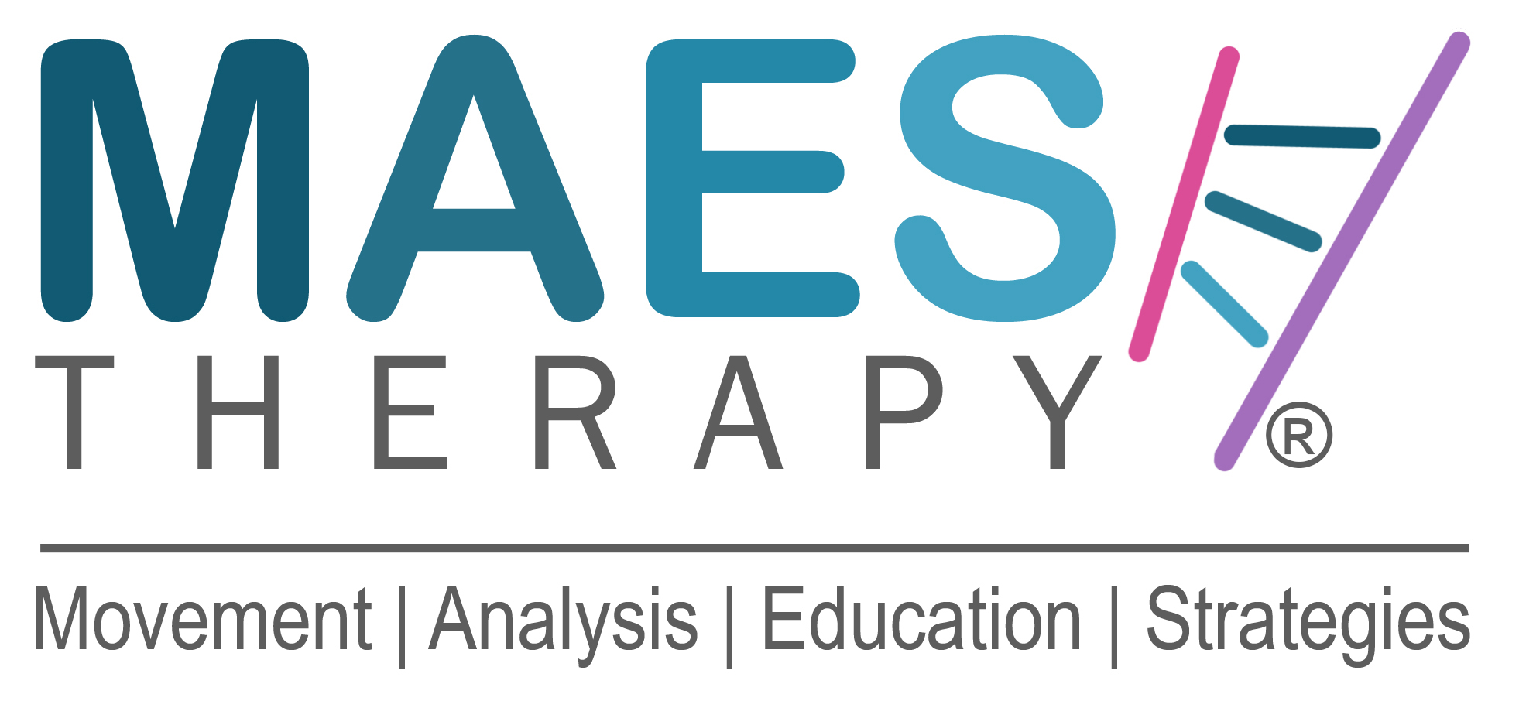
APPLICATION FORM

Name: First Name: Family Name:

Profession & Job Title (PT, OT, SLT, Doctor) :-

Full Home Address:

Name of Place of Work:

E-mail Work: Work Mobile No:

E-mail Private: Private Mobile No:

Insurance statement:

“By submitting this Application Form, I confirm that I am the person named on this form and I will be covered by my own Professional Liability Insurance if I attend this course”.

Full Name ( Print your name ) :-
_______________________________________________________________

M.A.E.S. Course:
‘Movement Analysis & Education Strategies Course for children with Cerebral Palsy and similar neurodevelopmental conditions’

Length of Course: 20-Days (4-Weeks) Post-graduate course in two parts of two weeks.

Dates: Part 1: 13 – 24 July 2020 Weeks 1 & 2
Part 2: 17 - 28 August 2020 Weeks 3 & 4

It is very helpful for Participants’ learning to plan and make arrangements to use the period between Part 1 and Part 2 to put into practice the knowledge and skills gained in Part 1, before returning for Part 2.

Venue: Gwyn Jones Primary School, Leytonstone, East London E11 1EU

Course Participants Criteria:

Participants must be Paediatric Therapists (Physiotherapists, Occupational Therapists, Speech Therapists) or medical Doctors (paediatricians, neurologists), with at least two years’ experience in treating children with Cerebral Palsy and similar neurological conditions. The course will appeal to therapists who are about to take their first postgraduate course in the field of Cerebral Palsy as well as to very experienced therapists who have already taken several specialist courses (e.g. Conductive Education, Vojta, NDT-Bobath, Sensory Integration).
M.A.E.S. is a completely different way of thinking and approach to treatment, compared to Bobath-NDT.

Course Lead by:
Jean-Pierre Maes Consultant Neurodevelopmental Physiotherapist, Director M.A.E.S. Therapy
and M.A.E.S. Team UK:

Course Fee: Early Bird: £2,250.00
Late/ Regular Registration: £ 2,650

5% Discount per person for any two or more work colleagues that register together.

First come first served and a non-refundable* deposit of £500 secures your place.

Early Bird Ends 1 April 2020. Late/ Regular Registration full amount due by 5 June 2020

*The deposit can only be refunded if a suitable replacement participant is found and that person pays their deposit. Suitable; i.e. meets the Course Participants' Criteria.

Application:

1. To apply for a place on the course, please complete this Application Form
and together with your CV, e-mail to:

Course Organiser: Jonathan Salsbury MIoD, Development Director,
M.A.E.S. Therapy International
E: jsalsbury@maestherapy.com

2. C.V.
Please also attach your full Curriculum Vitae, including your full professional work experience.

3. How to Pay:
Once this Application Form and accompanying CV have been submitted and accepted, details about how to make the payments will be provided.

You will be sent an e-mail asking you to make payment of the Non-Refundable Deposit and later the Balance, with details of how to make the payments and into which bank accounts.

4. Confirmation: Upon receipt of the full Course Fee, you will receive an email confirming your Registration and place on the course ( subject to receipt of full payment by the deadline date).

© 2013-2020 Copyright M.A.E.S. THERAPY International. All rights reserved.

